Medical Definition of Brain stem
Brain stem: The stem-like part of the base of the brain that is connected to the spinal cord. The brain stem controls the flow of messages between the brain and the rest of the body, and it also controls basic body functions such as breathing, swallowing, heart rate, blood pressure, consciousness, and whether one is awake or sleepy. The brain stem consists of the midbrain, pons, and medulla oblongata.
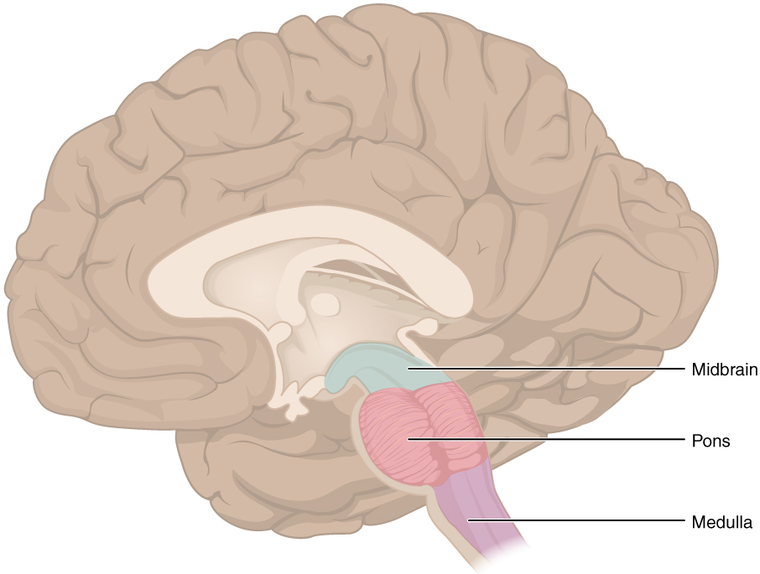

Cerebellum
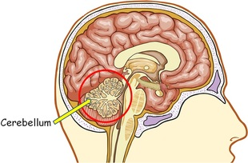 | The Quick Facts  Location: Lower area of the brain, below the pons  Function: Responsible for balance and coordination of muscles and the body
The cerebellum is one of the most identifiable parts of the brain due to its unique shape and location. It is extremely important for being able to perform everyday voluntary (done with purpose and intent) tasks such as walking and writing. It is also essential to being able to stay balanced and upright. Patients who have suffered from damaged cerebellums often struggle with keeping their balance and maintaining proper muscle coordination.

Anatomy of the Brain

Overview
The brain is an amazing three-pound organ that controls all functions of the body, interprets information from the outside world, and embodies the essence of the mind and soul. Intelligence, creativity, emotion, and memory are a few of the many things governed by the brain. Protected within the skull, the brain is composed of the cerebrum, cerebellum, and brainstem.
The brain receives information through our five senses: sight, smell, touch, taste, and hearing - often many at one time. It assembles the messages in a way that has meaning for us, and can store that information in our memory. The brain controls our thoughts, memory and speech, movement of the arms and legs, and the function of many organs within our body.
The central nervous system (CNS) is composed of the brain and spinal cord. The peripheral nervous system (PNS) is composed of spinal nerves that branch from the spinal cord and cranial nerves that branch from the brain.

Brain
The brain is composed of the cerebrum, cerebellum, and brainstem (Fig. 1).
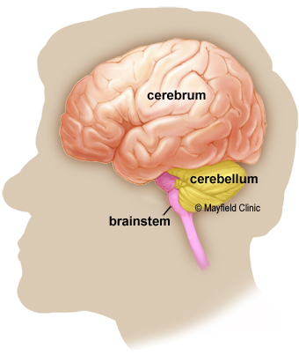
Figure 1. The brain has three main parts: the cerebrum, cerebellum and brainstem.
Cerebrum: is the largest part of the brain and is composed of right and left hemispheres. It performs higher functions like interpreting touch, vision and hearing, as well as speech, reasoning, emotions, learning, and fine control of movement.
Cerebellum: is located under the cerebrum. Its function is to coordinate muscle movements, maintain posture, and balance.
Brainstem: acts as a relay center connecting the cerebrum and cerebellum to the spinal cord. It performs many automatic functions such as breathing, heart rate, body temperature, wake and sleep cycles, digestion, sneezing, coughing, vomiting, and swallowing.

Right brain – left brain
The cerebrum is divided into two halves: the right and left hemispheres (Fig. 2) They are joined by a bundle of fibers called the corpus callosum that transmits messages from one side to the other. Each hemisphere controls the opposite side of the body. If a stroke occurs on the right side of the brain, your left arm or leg may be weak or paralyzed.
Not all functions of the hemispheres are shared. In general, the left hemisphere controls speech, comprehension, arithmetic, and writing. The right hemisphere controls creativity, spatial ability, artistic, and musical skills. The left hemisphere is dominant in hand use and language in about 92% of people.
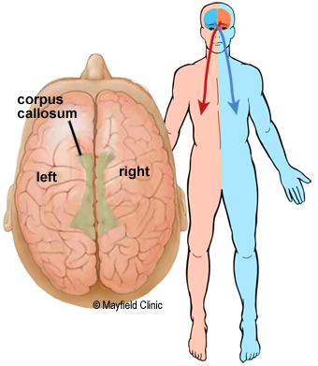
Figure 2. The cerebrum is divided into left and right hemispheres. The two sides are connected by the nerve fibers corpus callosum.

Lobes of the brain
The cerebral hemispheres have distinct fissures, which divide the brain into lobes. Each hemisphere has 4 lobes: frontal, temporal, parietal, and occipital (Fig. 3). Each lobe may be divided, once again, into areas that serve very specific functions. It’s important to understand that each lobe of the brain does not function alone. There are very complex relationships between the lobes of the brain and between the right and left hemispheres.
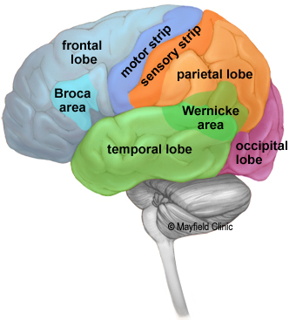
Figure 3. The cerebrum is divided into four lobes: frontal, parietal, occipital and temporal.

Frontal lobe
- Personality, behavior, emotions
- Judgment, planning, problem solving, reasoning
- Speech: speaking and writing (Broca’s area)
- Body movement (motor cortex)
- Intelligence, concentration, self awareness
- processing short-term memories and retaining longer term memories which are not task-based

Parietal lobe
- Interprets language, words
- Sense of touch, pain, temperature (sensory strip)
- Interprets signals from vision, hearing, motor, sensory and memory
- Spatial and visual perception
- Taste

Occipital lobe
- Interprets vision (color, light, movement)

Temporal lobe
- Understanding language (Wernicke’s area)
- Memory
- Hearing
- Sequencing and organization

Language
In general, the left hemisphere of the brain is responsible for language and speech and is called the "dominant" hemisphere. The right hemisphere plays a large part in interpreting visual information and spatial processing. In about one third of people who are left-handed, speech function may be located on the right side of the brain. Left-handed people may need special testing to determine if their speech center is on the left or right side prior to any surgery in that area.
Aphasia is a disturbance of language affecting speech production, comprehension, reading or writing, due to brain injury – most commonly from stroke or trauma. The type of aphasia depends on the brain area damaged.
Broca’s area: lies in the left frontal lobe (Fig 3). If this area is damaged, one may have difficulty moving the tongue or facial muscles to produce the sounds of speech. The person can still read and understand spoken language but has difficulty in speaking and writing (i.e. forming letters and words, doesn't write within lines) – called Broca's aphasia.
Wernicke's area: lies in the left temporal lobe (Fig 3). Damage to this area causes Wernicke's aphasia. The individual may speak in long sentences that have no meaning, add unnecessary words, and even create new words. They can make speech sounds, however they have difficulty understanding speech and are therefore unaware of their mistakes.

Cortex
The surface of the cerebrum is called the cortex. It has a folded appearance with hills and valleys. The cortex contains 16 billion neurons (the cerebellum has 70 billion = 86 billion total) that are arranged in specific layers. The nerve cell bodies color the cortex grey-brown giving it its name – gray matter (Fig. 4). Beneath the cortex are long nerve fibers (axons) that connect brain areas to each other — called white matter.
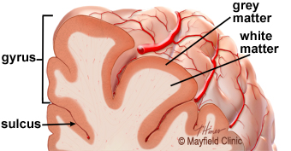
Figure 4. The cortex contains neurons (grey matter), which are interconnected to other brain areas by axons (white matter). The cortex has a folded appearance. A fold is called a gyrus and the valley between is a sulcus.
The folding of the cortex increases the brain’s surface area allowing more neurons to fit inside the skull and enabling higher functions. Each fold is called a gyrus, and each groove between folds is called a sulcus. There are names for the folds and grooves that help define specific brain regions.

Deep structures
Pathways called white matter tracts connect areas of the cortex to each other. Messages can travel from one gyrus to another, from one lobe to another, from one side of the brain to the other, and to structures deep in the brain (Fig. 5).
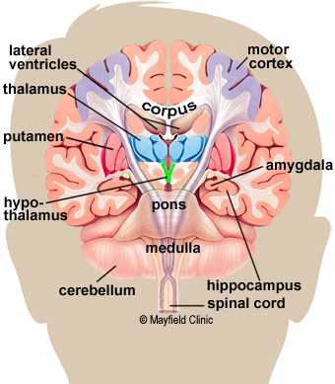
Figure 5. Coronal cross-section showing the basal ganglia.
Hypothalamus: is located in the floor of the third ventricle and is the master control of the autonomic system. It plays a role in controlling behaviors such as hunger, thirst, sleep, and sexual response. It also regulates body temperature, blood pressure, emotions, and secretion of hormones.
Pituitary gland: lies in a small pocket of bone at the skull base called the sella turcica. The pituitary gland is connected to the hypothalamus of the brain by the pituitary stalk. Known as the “master gland,” it controls other endocrine glands in the body. It secretes hormones that control sexual development, promote bone and muscle growth, and respond to stress.
Pineal gland: is located behind the third ventricle. It helps regulate the body’s internal clock and circadian rhythms by secreting melatonin. It has some role in sexual development.
Thalamus: serves as a relay station for almost all information that comes and goes to the cortex. It plays a role in pain sensation, attention, alertness and memory.
Basal ganglia: includes the caudate, putamen and globus pallidus. These nuclei work with the cerebellum to coordinate fine motions, such as fingertip movements.
Limbic system: is the center of our emotions, learning, and memory. Included in this system are the cingulate gyri, hypothalamus, amygdala (emotional reactions), olfactory bulbs (smell) and hippocampus (memory).

Memory
Memory is a complex process that includes three phases: encoding (deciding what information is important), storing, and recalling. Different areas of the brain are involved in different types of memory (Fig. 6). Your brain has to pay attention and rehearse in order for an event to move from short-term to long-term memory – called encoding.
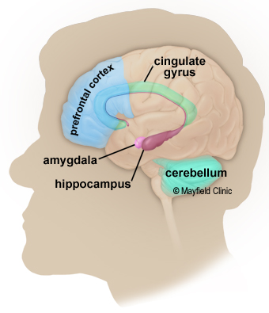
Figure 6. Structures of the limbic system involved in memory formation. The prefrontal cortex holds recent events briefly in short-term memory. The hippocampus is responsible for encoding long-term memory.
- Short-term memory, also called working memory, occurs in the prefrontal cortex. It stores information for about one minute and its capacity is limited to about 7 items. For example, it enables you to dial a phone number someone just told you. It also intervenes during reading, to memorize the sentence you have just read, so that the next one makes sense.
- Long-term memory is processed in the hippocampus of the temporal lobe and is activated when you want to memorize something for a longer time. This memory has unlimited content and duration capacity. It contains personal memories as well as facts and figures.
- Skill memory is processed in the cerebellum, which relays information to the basal ganglia. It stores automatic learned memories like tying a shoe, playing an instrument, or riding a bike.

