[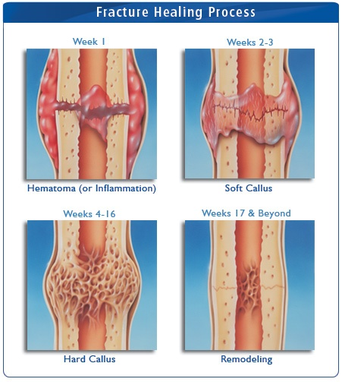](https://www.google.com/url?sa=i&rct=j&q=&esrc=s&source=images&cd=&cad=rja&uact=8&ved=0CAcQjRxqFQoTCI7h2M-b5cgCFQt6Pgod9YwJ6Q&url=https://www.pinterest.com/explore/bone-fracture/&psig=AFQjCNGmkSXblQwC2VwC0ucJKt3T-D7zVg&ust=1446123371672462)