1 – 13. Place each word listed below onto the diagram in its proper place. Draw arrows where needed as well as other object such as plants and rock layers.

Word Bank for diagram:
energy source | transpiration | precipitation | ground water
evaporation | condensation | infiltration | runoff
ocean | river | evapotranspiration | sublimation
Aquifer | hydrologic cycle

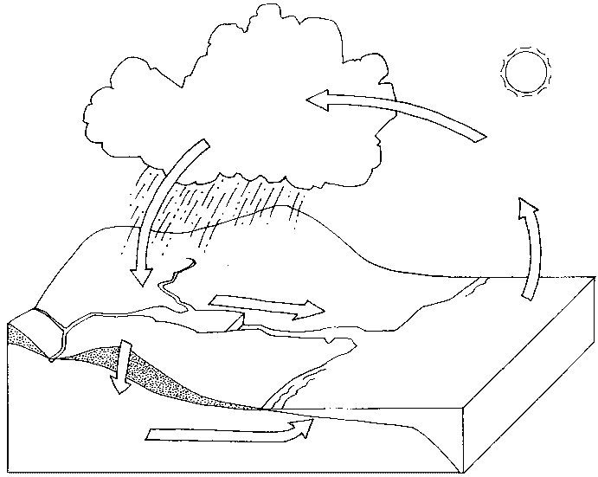

- The water cycle is also called the cycle.
- The holds 96.5% of Earth’s water is the primary pathway into the water cycle.
- is the process by which water changes from a liquid to a gas.
- An from the sun is necessary for evaporation to occur. 18.The it is the faster water changes into water vapor.
- is the process of a solid changing into water vapor without melting.
- Plants return groundwater to the atmosphere through the process of
.

- The process in which water vapor in the air is changed into liquid water is called
.
22 -25 Water released from clouds falls to the earth in these forms

- List 4 places water is stored in the water cycle.

- When water does not get absorbed into soil or evaporate into the atmosphere it becomes .
- moves water into places where it collects, like ponds, and rivers,
- is the process where water soaks into soil or porous rock. 30. is another name for groundwater stored in water bearing
formations.
31.Draw a diagram of a Watershed.

