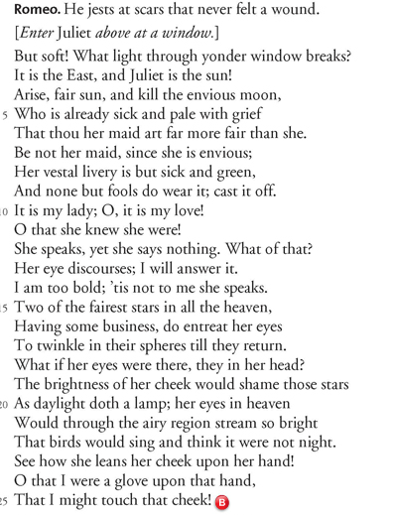

1. Is Juliet truly the sun? What type of figurative language is this? Explain your answer.
2. The moon is described as “envious” and “sick and pale with grief.” What type of figurative language is this? Explain your answer.
3. To “discourse” is to speak or argue on a topic. What type of figurative language is this? Explain your answer.
4. The brightness of her cheek even puts stars to shame. What type of figurative language is this? Explain your answer.
5. Identify and explain one more type of figurative language in the section marked.