Objective: Students will be able to identify the function of different cell structures of plant and animal cells by manipulating a computer simulation and exploring online media.
Introduction:
Understanding normal cell structures and their functions helps scientists understand what goes wrong to allow diseases, including the infectious diseases caused by microbes, to progress. Although there are many differences between cells of various organisms, such as plants, animals, and microbes, there are some key similarities in all cells.
One structure common to every cell is a cell membrane that separates it from the outside environment. Similarly, every cell has genetic material in the form of DNA, and a large number of proteins and other molecules that carry out the chemical reactions needed for a cell to live, grow, and reproduce. Some cells contain structures that are surrounded by a membrane, which creates a barrier between the inside of the structure and the rest of the cell. These membrane- bound structures are called organelles.
In this activity, you will learn about some common cell structures and their functions in the cell.

Before You Start:
In your own words, define an organelle: _________________________________________________________
__________________________________________________________________________________________

Part 1: Answer the following questions while watching the video.
- What three things do all cells have in common?
- Plants and animals are made of cells that contain organelles. What type of cells contain organelles?
- Bacteria cells do not have a nucleus and are unicellular organisms. What type of cells are bacteria cells?
- Where are ribosomes made in the cell?
- What are the sac-like structures that store materials like water?
- Cells that need more energy need more of what organelle?
- Animal cells NEVER have what structure?
- What structure is like a little tail that helps the cell move? Sperm cells have this structure.
Part 2: Fill in the following chart while manipulating the Cells Alive Simulation.

Organelle | Function | Plant/Animal/Both
Nucleus
Nucleolus
Cytosol/Cytoplasm
Golgi
Lysosome
Cell Membrane
Mitochondrion
Vacuole
Cell Wall
Chloroplast
Smooth Endoplasmic
Reticulum
Rough Endoplasmic
Reticulum
Ribosome

Part 3 : Use what you learned in the previous two parts to fill out the Venn Diagram below.

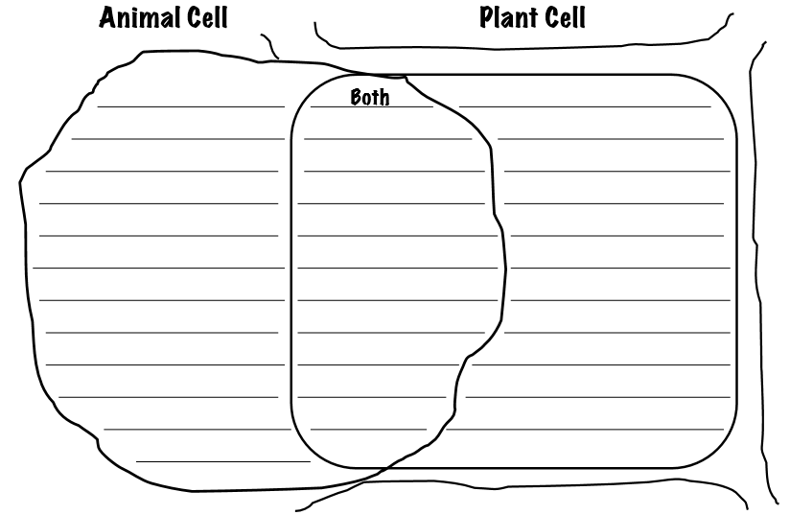

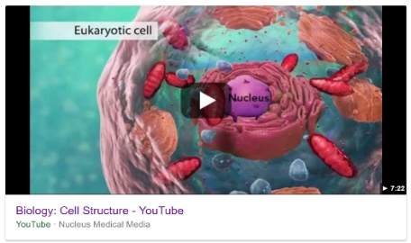
Part 1:
- Access the File Explorer File
- Find the CSD shared Drive and find the Biology folder.
- Watch the video that is in the folder and answer the questions about the Eukaryotic Cell on the Activity 4 Resource Sheet.
Part 2:
- Once you have finished the Biology: Cell Structure questions, you will then go to https://www.cellsalive.com/cells/cell_model.htm
- Click the red button that says Start the Animation->
- Choose Animal Cell
- Using the simulation, fill out the Cells Alive Organelle chart on your Activity 4 Resource Sheet. Fill out the function for each organelle found in an animal cell.
- Chose Plant Cell
- Using the simulation, fill out the Cells Alive Organelle chart on your Activity 4 Resource Sheet. Fill out the function for each organelle found in a plant cell.
- Identify where each organelle can be found in what type of cells. (Plant/Animal/Both)
Part 3:
- Using the information, you have learned today, fill out the Venn diagram comparing plant and animal cells located on the Activity 4 Resource Sheet

Part 1:
- Access the File Explorer File
- Find the CSD shared Drive and find the Biology folder.
- Watch the video that is in the folder and answer the questions about the Eukaryotic Cell on the Activity 4 Resource Sheet.
Part 2:
- Once you have finished the Biology: Cell Structure questions, you will then go to https://www.cellsalive.com/cells/cell_model.htm
- Click the red button that says Start the Animation->
- Choose Animal Cell
- Using the simulation, fill out the Cells Alive Organelle chart on your Activity 4 Resource Sheet. Fill out the function for each organelle found in an animal cell.
- Chose Plant Cell
- Using the simulation, fill out the Cells Alive Organelle chart on your Activity 4 Resource Sheet. Fill out the function for each organelle found in a plant cell.
- Identify where each organelle can be found in what type of cells. (Plant/Animal/Both)
Part 3:
- Using the information, you have learned today, fill out the Venn diagram comparing plant and animal cells located on the Activity 4 Resource Sheet

