Activity 8 – Cycles of Matter

Part I - Carbon Cycle
Molecules containing carbon regularly flow between reservoirs as part of the carbon cycle. Carbon from a plant may flow to the atmosphere, from the atmosphere to the ocean, and from the ocean into sediments and eventually into rocks. Some of this flow happens in seconds, for example from a plant to the atmosphere. Some takes much longer, such as sediments turning into rocks. The exchange of carbon between two reservoirs is referred to as a flux.
The total amount of carbon on earth, including that in the atmosphere, biosphere, and oceans, does not change. However, the amount of carbon in each reservoir does change, and changing the amount of carbon in a reservoir can impact the ecosystems that depend on it. Currently most rapid fluxes of carbon occur between the atmosphere and two reservoirs: the biosphere and the oceans (including the water and the biomass). The biosphere is composed of all living things organisms on land. Biomass refers to all living organism in an area, such as the oceans. The burning of fossil fuels also adds to the carbon in the atmosphere, but it takes hundreds of millions of years for geological process to produce new fossil fuels and return carbon to fossil fuel reservoirs.
https://store.lab-aids.com/high-school-curriculum/simulations/carbon_sim.html

Procedure:
- Start the “Learn section of the simulation. Work with your partner to explore the reservoirs that are a part of the carbon cycle. As you explore the reservoirs, fill in the attached chart labeled “Learn the Carbon Cycle”.

- When you have finished investigating the pre- and post-industrial eras, proceed to the simulation for the pre-industrial era. The simulation controls are preset to show the estimated level of carbon exchange during the pre-industrial era.

- Run the pre-industrial revolution simulation with the standard plant respiration (60) and photosynthesis (120) settings. Graph the results on the “Carbon Cycle Simulation” sheet. Answer the two questions after graphing the results.

- Move onto the Post-Industrial revolution simulation. Run the simulation wit the standard plan respiration (60) and photosynthesis (120). Increase the fossil fuel burning to the maximum (12), do the same with the land use change (4). Graph the results on the “Carbon Cycle Simulation” sheet and answer the 3 questions below the graph.

- Complete Part 2: Nitrogen Cycle using the PowerPoint Slides.

Learn The Carbon Cycle
Reservoir Name | Pre - Industrial | Post-Industrial
Rocks | How much carbon is stored? | Have humans altered this reservoir? If so, How?
Soil  and Detritus | How much carbon is stored?  How much carbon is cycled? | Have humans altered this reservoir? If so, How?
Land Plants | How much carbon is stored?  How much carbon is cycled? | Have humans altered this reservoir? If so, How?
Atmosphere | How much carbon is held? | Have humans altered this reservoir? If so, How?
Fossil Fuels | How much Carbon is stored? | Have humans altered this reservoir? If so, How?
Ocean Waters | How much carbon is stored?  How much carbon is cycled? | Have humans altered this reservoir? If so, How?
Ocean Biomass | How much carbon is cycled? | Have humans altered this reservoir? If so, How?
Carbon Cycle Simulation
Pre-Industrial Simulation Graph:
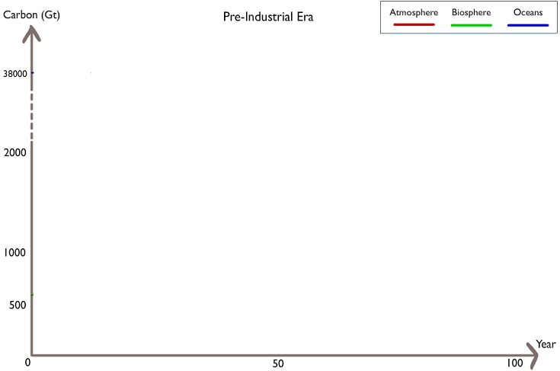
- What happened to the amount of carbon in the atmosphere, biosphere, and oceans in the simulation?

- Is the flux of carbon sustainable? Why or why not? Will any reservoir run out of carbon?

Pre-Industrial Simulation Graph:
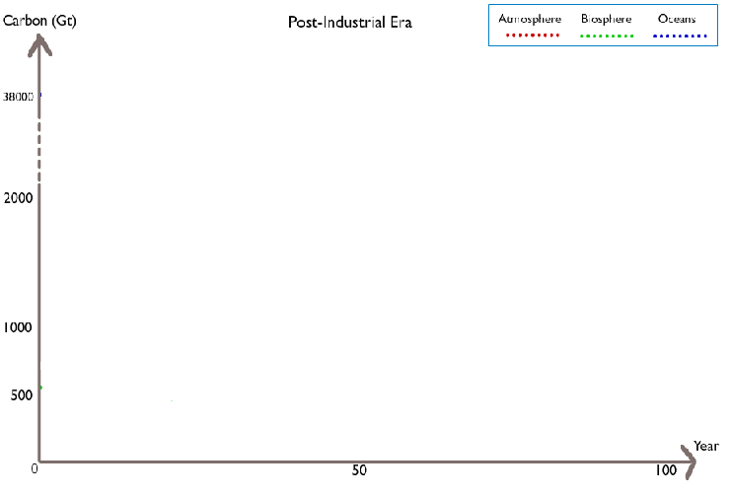
- What happened to the amount of carbon in the atmosphere, biosphere, and oceans in the simulation?

- Is the flux of carbon sustainable? Why or why not? Will any reservoir run out of carbon?

- If humans continue to burn fossil fuels and use land however they want, what will happen to the carbon cycle? What possible impacts will these changes have?

Part II : Nitrogen Cycle
- Why is Nitrogen important?

- Where does Nitrogen come from?

- What are the four processes that help cycle nitrogen through an ecosystem?

- What is the job of Nitrogen fixing bacteria?

- How do plants get nitrogen?

- How do consumers get their nitrogen?

- What do decomposers do for the nitrogen cycle?

- What is the job of Nitrifying bacteria?

- What is the job of Denitrifying bacteria?

- What must happen to atmospheric nitrogen before it is used by most consumers?

- What happens during leaching? What are the dangers of leaching?

- Now that you have learned both the nitrogen and carbon cycle, what are the similarities, what are the differences?

