- John was filling up the 150-gallon water tank for the animals. The hose he was using would fill it up at a rate of 20-gallons per minute.
  - What is the range of the function
  - What is the domain of the function
  - Write an equation to model the function using function notation.
  - Identify the x- and y-intercepts if you were to graph the function and explain what they represent in the context of the problem.

- The production assembly line attaches fasteners to filing cabinet drawers shown below. What is the correct interpretation for the average rate of change for this linear function?
Fasteners | 6 | 18 | 24 | 36 | 42 | 60 | 72
minutes | 10 | 30 | 40 | 60 | 70 | 100 | 120
- The machine attaches 6 fasteners every minute
- The machine attaches 10 fasteners every 6 minutes
- The machine attaches 18 fasteners every 30 minutes
- The machine attaches 1 fastener per minute

- The table below shows the values for the exponential function. Select the graph and the description that math the values in the table.
S | -1 | 0 | 1 | 2 | 3
F(s) | 1.5 | 3 | 6 | 12 | 24
A.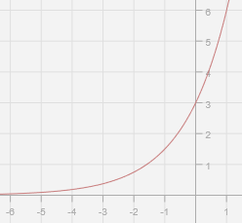 B. 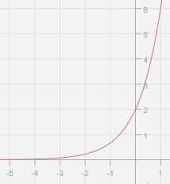

C. The value of the function approaches infinity as x approaches 2
D. As x increases, the value of the function approaches 0
E. As x decreases, the value of the function approaches 0

4. How is the graph effected if the equation y = 3x – 5 is changed to y = 3x + 2?

5. Identify the x- and y-intercepts for 6x – 8y = 24
x-intercept: (________, ________)
y-intercept: (________, ________)
6. The number of bacteria germs on the door handle could be modeled by f(n) = 100($2^{n}$), where the n is the number of seconds and f(n) represents to total number of bacteria.
Which graph best represents the relationship between n and f(n)?
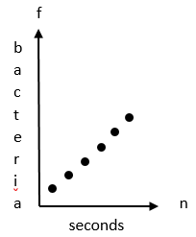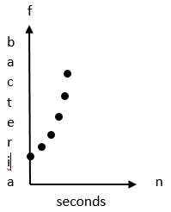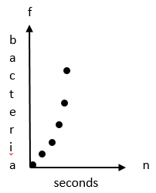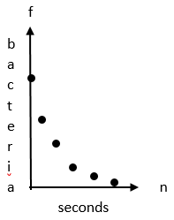
7. Look at the following functions f(x) and g(x). Use the graph to find the values below.
g(x) f(x)
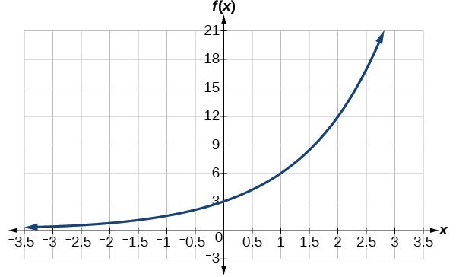
f(0) = _____________
f(1) = _____________
g(-1) = ____________
f(2) – g(1) = ______________
g(x) = 18 when x = ________________
8. Jim is running a landscaping business. It costs him $350 each week for operating expenses. Jim’s weekly profit, P, can be found by the function P = 45n – 350, where n is the number of lawns that he mows.
On the graph of this function, what does the x-intercept represent?
9. Some equations are shown below using equations, tables, and graphs. Which relationships do not show a constant rate of change over the domain?
A. f(x) = 3($5^{x}$)
B. 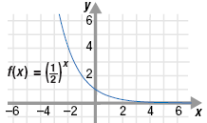 C. 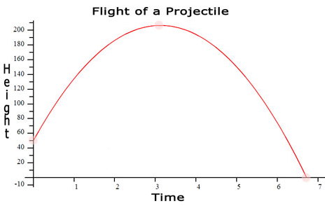

D. 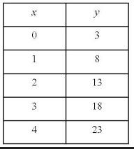 E. 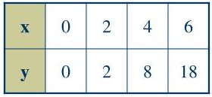

F. 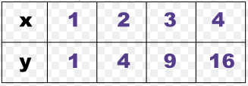 G. 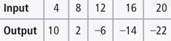
10. Select the appropriate equation for each statement below:
 | y = -$\frac{2}{5}$x + 25 | y = -$\frac{2}{5}$x – 8 | y = $\frac{5}{2}$x + 50 | y = $\frac{5}{2}$x – 12
Which equation is parallel to y = -$\frac{2}{5}$x + 4 and passes through the point (-20, 0)?
Which equation is perpendicular to y = -$\frac{2}{5}$x + 4 and passes through the point (-20, 0)?

11. Tim is ordering chicken wings for the Super Bowl. Each store charges a delivery fee in addition to the price per person. Each store gives Tim a pricing plan in a different way, where C is the total cost in dollars and n is the number of people that attend the party.
Larry’s: C(n) = 2.25n + 85
Jimmy’s:
n | 10 | 15 | 20 | 25
C(n) | 105 | 120 | 135 | 150

Carter’s:
Cost
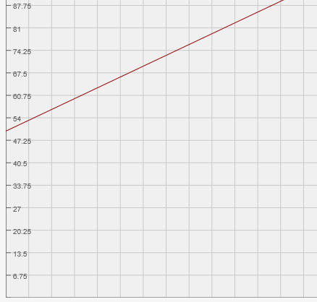
1 2 3 4 5
Who has the lowest delivery charge: Larry, Jimmy, Carter? _____________________
Which store will give Tim the best price for 20 people? ______________________
12. Which function is shown by the graph below?
