Name ______________________________ Date _____________________

Angle Addition Postulate Worksheet

1. List the three undefined terms and explain why we need them.
2. If two angles up to 180° they are _______________________ angles.
3. If two angles add up to 90° they are ____________________ angles.
4. Name at least two pairs of supplementary angles in the figure below.

(There are 4 total)

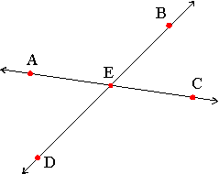

1. Use the following diagram to complete the angle addition postulate.

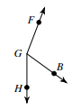

$$m∠ _________+m∠_________=m∠_________$$

1. Use the following diagram to complete the angle addition postulate.

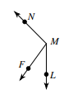

$$m∠ _________+m∠_________=m∠_________$$

1. Use the following diagram to complete the angle addition postulate.

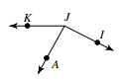Then use the given information to solve for the missing angle measure.

$m∠AJK=61°$ and $m∠IJK=153°$

$m∠ _________+m∠_________=m∠________$

1. Are the following angles supplementary or complementary?

Set up an equation and solve for *x*.

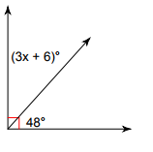

1. Are the following angles supplementary or complementary?

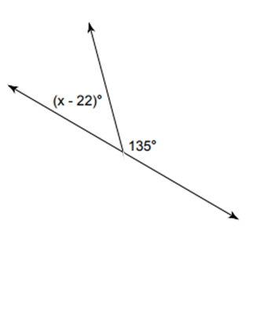Set up an equation and solve for *x*.

1. Are the following angles supplementary or complementary?

Set up an equation and solve for *x*.

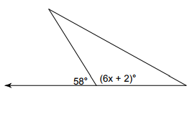

1. Are the following angles supplementary or complementary?

Set up an equation and solve for *x*.

