Name: ______________________________________________________ Date: ________
Arc Length & Area of Sector Notes
- Find the Arc Length & Area of Sector of the shaded region:

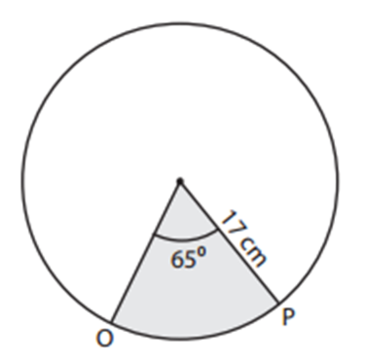

- Find the Arc Length & Area of Sector of the shaded region:
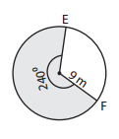

- Find the Arc Length & Area of Sector of the non-shaded region:
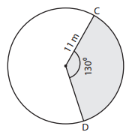

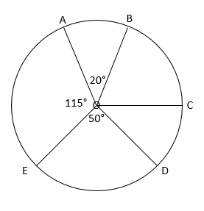
- Find the Area of Sector AOB:
Radius: 8

- Find the arc length of $\hat{BCD}$

Exit Ticket:
Radius: 7

