Chart Title:
What’s your favorite:  __________________ | Number of Students who selected each item | Arc Length | Area of Sector
1.
2.
3.
4.
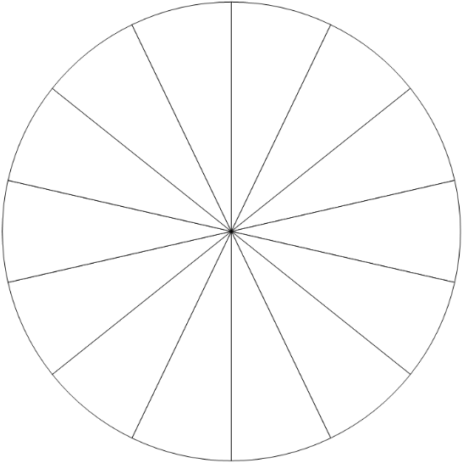

Key

Name: ___________________________________________________ Date: ______________
Arc Length & Area of Sector Project
For today’s project, you must come up with a topic (Favorite shape, food, holiday, etc.) and four possible choices (Square, hexagon, rectangle, and triangle). You must answer the question yourself and then ask 13 other classmates (you can include me) for a total of 14 answers.
After you have collected your data, color in the circle accordingly (i.e. two people picked your first choice, color in two sectors of the circle). After your circle is colored in you must find the arc length and the area of each category.
And of course, coloring & creativity will be part of your grade!
SHOW ALL WORK: USE A RAIDUS OF 5
ARC LENGTH
1. 2. 3. 4.

AREA OF SECTOR
1. 2. 3. 4.

What is the difference between the longest and shortest arc length?

What is the difference between the largest area and the smallest area?

