Name: ____________________________________________________ Date: _______
Arc Length & Area of Sector Worksheet
Find the length of the arc or area of the shaded region.
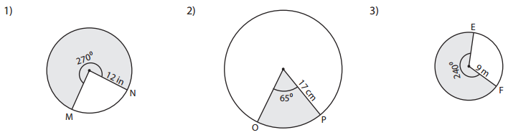

Arc Length: _____________ Area: _____________ Arc Length: _____________

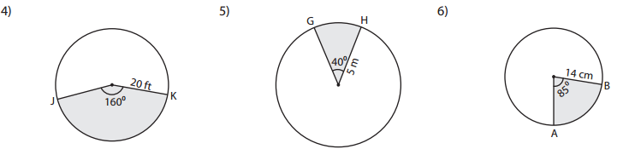

Area: _____________ Arc Length: _____________ Area: _____________

Find the length of the arc or area of the NON - shaded region.

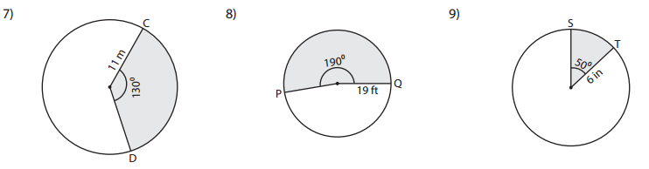
Arc Length: _____________ Area: _____________ Arc Length: _____________
Use the following circle to answer questions 10-14:
N
J
145°
85°
10°
L
M
K
O
Radius: 20

10) Find the area of sector LOM:

11) Find the area of sector JON:

12) Find the arc length of$\hat{ LM}$:

13) Find the arc length of$\hat{ LMN}$:

14) Find the arc length of$\hat{ LKJ}$:

