1. You work 37 1 —2 hours and earn $352.50. What is your hourly wage?

2. You drive 1244.5 miles and use 47.5 gallons of gasoline. What is your car’s gas mileage (in miles per gallon)?

3. You drive 236 miles in 4.6 hours. At the same rate, how long will it take you to drive 450 miles?

4. A recording studio charges musicians an initial fee of $50 to record an album. Studio time costs an additional $75 per hour.
a. Write a linear model that represents the total cost of recording an album as a function of studio time (in hours).

b. Is it less expensive to purchase 12 hours of recording time at the studio or a $750 music software program that you can use to record on your own computer? Explain.

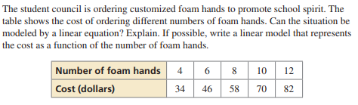
5.

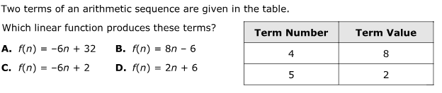
6.

