Name: ___________________________________
Atmosphere Exam Review

1. What is the most abundant element in the Earth’s atmosphere?
- Argon
- Carbon Dioxide
- Nitrogen
- Oxygen

2. What is the correct order of Earth’s atmospheric layers from bottom to top?
- Stratosphere, Mesosphere, Troposphere, Thermosphere
- Stratosphere, Troposphere, Mesosphere, Thermosphere
- Troposphere, Mesosphere, Stratosphere, Thermosphere
- Troposphere, Stratosphere, Mesosphere, Thermosphere

3. Which layer of the atmosphere contains the ozone layer?
- Mesosphere
- Stratosphere
- Mesopause
- Thermosphere

4. The highest temperatures are typically found in the:
A) stratosphere.
B) troposphere.
C) mesosphere.
D) thermosphere.

5. Volcanic eruptions can disrupt climate by
A) blocking the sunlight, which increases temperatures
B) blocking the sunlight, which decreases temperatures
C) releasing greenhouse gases, which increases temperatures
D) releasing greenhouse gases, which decreases temperatures

6. What causes the Coriolis effect?
- Ocean currents
- Clockwise rotation of the earth
- Counterclockwise rotation of the earth
- Trade winds

7. If it is summer in the northern hemisphere, which statement is true?
A Earth has changed the tilt of its axis by 20 degrees due to its revolution.
B It is winter in the southern hemisphere due to the tilt of Earth’s axis.
C It is summer in the southern hemisphere due to the tilt of Earth’s axis.
D Earth has reached its closest point to the sun due to its revolution.

8. What is the reason for increased precipitation at the equator?
A Hot air sinks, causing condensation and precipitation as it cools
B Hot air rises, causing condensation and precipitation as it cools
C Cool air sinks, causing condensation and precipitation as it warms
D. Cool air rises, causing condensation and precipitation as it warms

9. How is climate different from weather?
A Climate is constantly changing, whereas weather changes slowly over time.
B Climate influences people’s daily activities, whereas weather influences people’s seasonal activities.
C Climate refers to the atmospheric conditions on a given date, whereas weather refers to the atmospheric conditions during a given season.
D Climate is based on observations made for a region over several years, whereas weather is based on day-to-day observations made for a region

10. What is obliquity?
A. The measure of the tilt of the Earth
B. The change in the shape of Earth’s orbit around the sun
C. The change in the orientation of Earth’s axis
D. The measure of solar intensity of the sun

11. Many clouds have a high albedo and therefore tend to ____.
A absorb sunlight
B transmit sunlight
C reflect sunlight
D radiate sunlight

12. If you live in the Southern Hemisphere, during which months does autumn occur?
A. December, January, February
B. June, July, August
C. March, April, May
D. September, October, November

13. Polar and tropical regions maintain fairly constant average temperatures because ____.
A the Sun always strikes these regions at the same angle
B air masses remain stationary near the poles and equator
C Earth radiates extra energy back into space
D the continual motion of air and water reallocates heat energy throughout Earth

14. What would be the effect of changing the tilt of the earth from 23 degrees to only 5 degrees?
A. Winter in the northern hemisphere would be longer
B. Summer in the northern hemisphere would be longer
C. There would be fewer differences in the temperatures of seasons within the same hemisphere
D. There would be more differences in the temperatures of seasons within the same hemisphere
15. Drawing a horizontal lines to show the borders between the layers of the atmosphere. Label the spaces between each of the lines you drew at mesosphere, stratosphere, thermosphere, or troposphere.
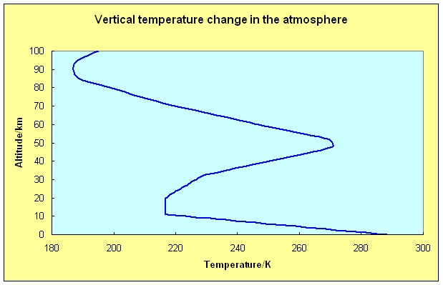

16. Label the correct seasons for the Earth for EACH hemisphere at EACH location. You should have 8 labels total at ½ point each = 4 pts
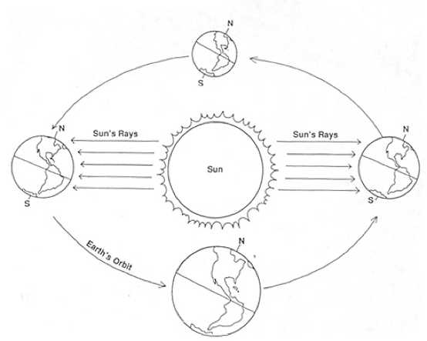

17.
- Fill in the missing arrowheads on the diagram below showing wind patterns on the Earth due to the Coriolis Effect.
- Circle “High” or “Low” at the correct latitudes to indicate air pressure changes due to the Coriolis Effect
- Next to where you circled High or Low, write “Dry” or “Rainy” to indicate the typical precipitation patterns caused by high and low pressure

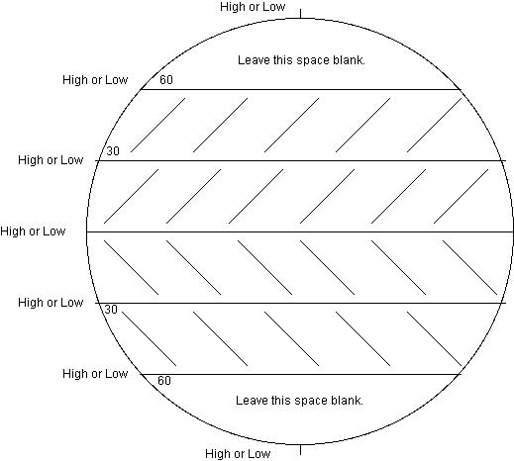

18. Use the diagram to answer the question below

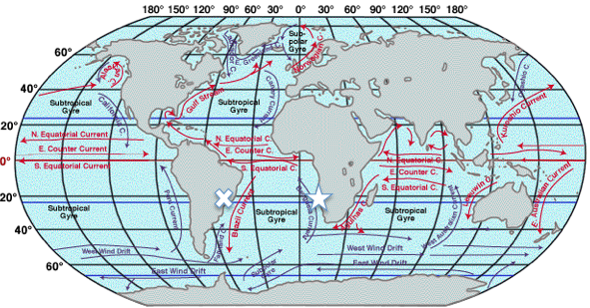

Predict the differences in temperature between “star city” and “x-city” based on the adjacent ocean currents. Be sure to explain WHY you predicted those specific differences (HINT – look at the direction of the current – where is it coming from? Where is it going?). 4 pts

_______________________________________________________________________________________________________________________
_______________________________________________________________________________________________________________________
_______________________________________________________________________________________________________________________
_______________________________________________________________________________________________________________________
_______________________________________________________________________________________________________________________
_______________________________________________________________________________________________________________________
_______________________________________________________________________________________________________________________

19. Explain what Greenhouse Effect is, what causes it, and whether it should be considered “good” or “bad.”

_______________________________________________________________________________________________________________
_______________________________________________________________________________________________________________
_______________________________________________________________________________________________________________
_______________________________________________________________________________________________________________
_______________________________________________________________________________________________________________
_______________________________________________________________________________________________________________
_______________________________________________________________________________________________________________
_______________________________________________________________________________________________________________
_______________________________________________________________________________________________________________
_______________________________________________________________________________________________________________

_______________________________________________________________________________________________________________

_______________________________________________________________________________________________________________

_______________________________________________________________________________________________________________

20. A friend tells you that humans are adding more carbon into the carbon cycle, which is causing the global climate to warm. Explain how he is misrepresenting the flow of carbon in the carbon cycle and describe a better way for him to explain what is really occurring.

_______________________________________________________________________________________________________________
_______________________________________________________________________________________________________________
_______________________________________________________________________________________________________________
_______________________________________________________________________________________________________________
_______________________________________________________________________________________________________________
_______________________________________________________________________________________________________________

_______________________________________________________________________________________________________________

_______________________________________________________________________________________________________________

_______________________________________________________________________________________________________________

_______________________________________________________________________________________________________________

_______________________________________________________________________________________________________________

_______________________________________________________________________________________________________________

