Name:____________________________________ Period:________
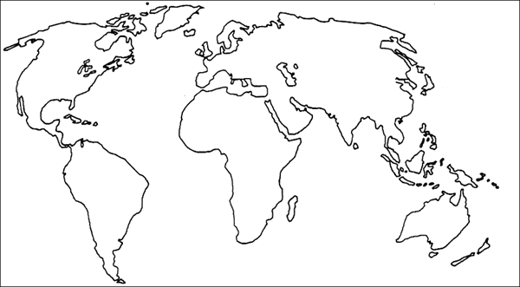
Directions: Color the biome map using page 143 in your textbook. You may use any colors that you chose, however you are expected to create a key.

