**Biomes**

I.A biome is a group of \_\_\_\_\_\_ that have similar \_\_\_\_\_\_, soil, plants, and animals.

A. These are **two** types of Biomes

1. Terrestrial

2. \_\_\_\_\_\_\_\_\_\_\_\_\_

B.There are \_\_\_ Major Terrestrial Biomes

* 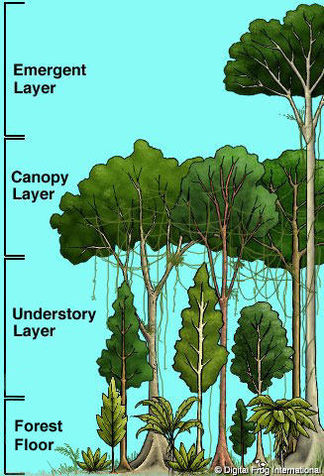c:\Program Files\Microsoft Office\Clipart\Pub60Cor\mp00646_.wmf

2. **Tropical Rainforest**

* Hot, humid biome near the \_\_\_\_\_\_\_\_\_\_\_\_\_
* A lot of rainfall
* Biodiverse
* \_\_\_\_\_\_\_\_ Soil

**Animals of the TR**

* More \_\_\_\_\_\_\_\_ of insects, reptiles, and amphibians than any place else
* Monkeys and sloths
* Colorful \_\_\_\_\_\_\_\_ like parrots and macaws

**Plants of the TR**

* Orchids
* \_\_\_\_\_\_\_\_\_\_
* Pineapples
* Chocolate
* Coffee

3. **Temperate Deciduous Forest**

* A forest biome with many kinds of \_\_\_\_\_\_\_ that lose their \_\_\_\_\_\_\_\_ each autumn
* \_\_\_\_\_\_\_\_\_\_\_ climate
  + Warm, wet summers
  + C:\Program Files\Microsoft Office\Clipart\standard\stddir1\AN02162_.wmfCold, dry winters
* Found N and S of \_\_\_\_\_\_\_\_\_\_

**Animals of the TDF**

* Large \_\_\_\_\_\_\_\_\_\_ like wolves, deer, bears
* \_\_\_\_\_\_\_\_\_ mammals like fox, squirrels, raccoons, and rabbits
* Birds
* Frogs and snakes
* 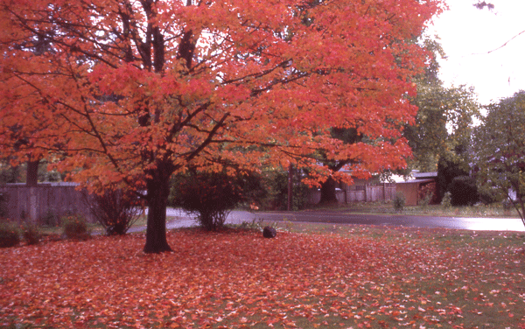\_\_\_\_\_\_\_\_\_\_ like ticks, mosquitoes, and grasshoppers

**Plants of the TDF**

* Birch, \_\_\_\_\_\_\_\_\_ and Oak Trees
* Ferns
* Poison Ivy

**4. Taiga**

* A cool forest biome of conifer trees
* \_\_\_\_\_\_\_, long winters, \_\_\_\_\_\_\_\_\_ summers with \_\_\_\_\_\_\_\_\_\_\_ growing season
* \_\_\_\_\_\_\_\_ of the Equator and the \_\_\_\_\_\_\_\_\_\_\_\_\_\_\_\_\_\_\_\_\_\_\_\_\_\_\_\_\_\_\_\_\_\_\_
* \_\_\_\_\_\_\_\_ Soil

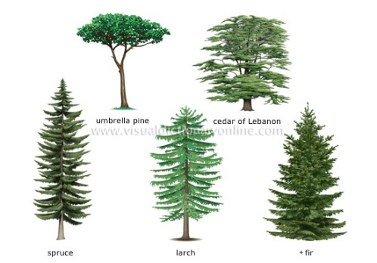**Animals of the Taiga**

* C:\Program Files\Microsoft Office\Clipart\standard\stddir2\BD07345_.WMFRodents
* \_\_\_\_\_\_\_\_\_\_\_ hares
* Lynx
* \_\_\_\_\_\_\_\_\_\_\_\_
* Bear
* Wolves
* Birds in \_\_\_\_\_\_\_\_\_\_\_\_\_

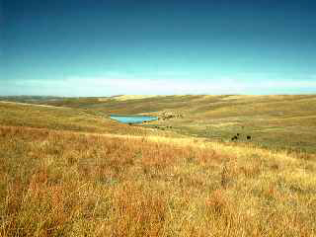**Plants of the Taiga**

* Tall \_\_\_\_\_\_\_\_\_\_\_\_ trees whose \_\_\_\_\_\_\_\_ are in cones

5. **Temperate Grassland**

* A biome where \_\_\_\_\_\_\_\_\_\_ are the main \_\_\_\_\_\_\_\_\_ life.
* Hot \_\_\_\_\_\_\_\_\_\_\_, cold \_\_\_\_\_\_\_\_\_\_ and little rain
* \_\_\_\_\_\_\_\_\_ soil
* Grass fires are \_\_\_\_\_\_\_\_\_\_\_\_

**Animals in the Grassland**

* Large mammals like antelope and bison
* Small \_\_\_\_\_\_\_\_\_\_ like prairie dogs, \_\_\_\_\_\_\_ and badgers
* C:\Program Files\Microsoft Office\Clipart\standard\stddir1\AN04304_.WMFSnakes
* \_\_\_\_\_\_\_\_\_
* Various birds

**Plants of the Grassland**

* Grasses
* \_\_\_\_\_\_\_\_\_\_\_\_\_\_\_\_
* Shrubs
* Few trees

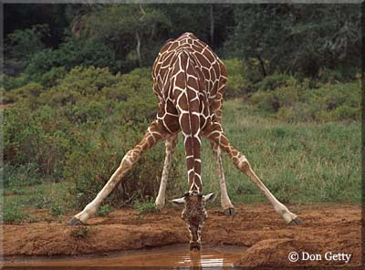6. **Savanna**

* Hot tropical region
* Dry \_\_\_\_\_\_\_\_ and a wet season
* 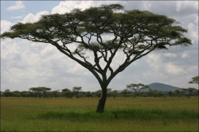Near equator

**Animals of the Savanna**

* Elephants, lions, zebras, \_\_\_\_\_\_\_\_, rhino, and tigers

**Plants in the Savanna**

* Grasses
* Few \_\_\_\_\_\_\_ and shrubs

7. **Chaparral**

* Warm \_\_\_\_\_\_\_\_\_, mild winters
* Dry, but \_\_\_\_\_\_\_\_\_\_ then deserts
  + Not enough water to support large trees
* Fires naturally occur

**Animals in the Chaparral**

* 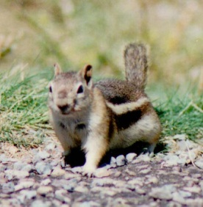Chipmunks
* 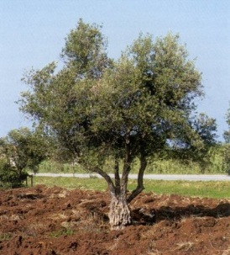Mule Deer
* \_\_\_\_\_\_\_\_\_\_
* Quail

**Plants in the Chaparral**

* \_\_\_\_\_\_\_\_ trees
* Evergreen shrubs
* Small \_\_\_\_\_\_\_\_\_
* Herbs

8. **Desert**

* A sandy or \_\_\_\_\_\_\_ biome, with little \_\_\_\_\_\_\_\_\_\_\_\_\_ and little plant life
* Can be \_\_\_\_\_\_ or \_\_\_\_\_\_\_\_

Animals of the Desert

* 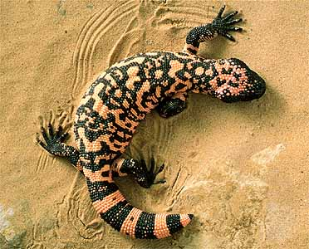Rodents
* Snakes
* Lizards
* Tortoises
* 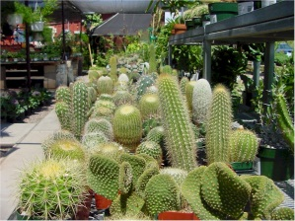Insects
* Birds

Plants of the Desert

* Cactus

9. **Tundra**

* A \_\_\_\_\_\_\_ biome in the far \_\_\_\_\_\_\_\_\_\_\_
* The ground is \_\_\_\_\_\_\_ except in summer when a thin layer called \_\_\_\_\_\_\_\_\_ defrosts enough to support \_\_\_\_\_\_\_\_ plants
* \_\_\_\_\_\_\_\_ \_\_\_\_\_\_\_\_\_\_ winters, short summers
* A lot of snow

**Animals of the Tundra**

* Musk \_\_\_\_\_\_
* Caribou
* 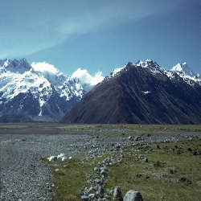\_\_\_\_\_\_\_\_\_\_ \_\_\_\_\_\_\_\_\_\_\_
* 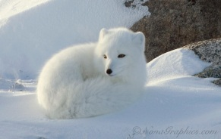Owls
* Rodents
* Moose

**Plants of the Tundra**

* Mosses
* Lichens
* Low \_\_\_\_\_\_\_ plants
* Dwarf trees