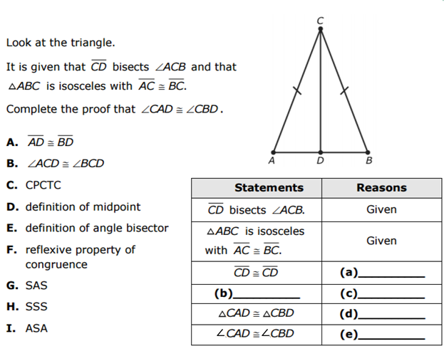
Name: _______________________________________________ Date: _________________________
Bisector Proofs Worksheet

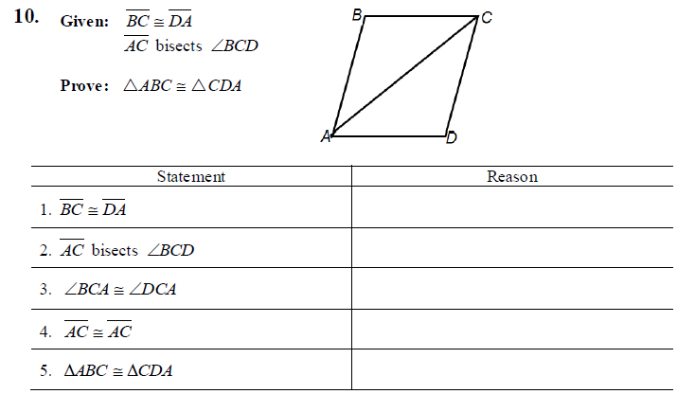
4.

5. The construction below shows the bisection of $∠A$.
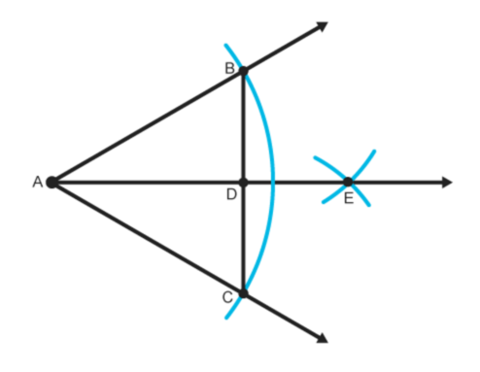
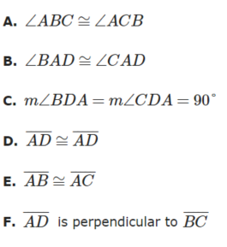
Which of the following can be used to prove that $∆ABD≅∆ACD$ by the SAS theorem? Select all
that apply. Justify each selection.

6. The construction below shows $\overset{⃡}{DC}$ as the perpendicular bisector of $\overline{AB}.$
Which of the following statements can be used to prove $∆ADM≅∆BDM$ by the SAS triangle
congruence theorem? Select all that apply. Justify each selection.
