Name: ____________________________________________ Date: ___________________________

Perpendicular & Angle Bisector Worksheet

2. What type of construction is shown above?

1. Altitude
2. Angle Bisector
3. Median
4. Perpendicular Bisector

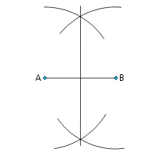

1. What type of construction is shown above?

1. Altitude
2. Angle Bisector
3. Median
4. Perpendicular Bisector

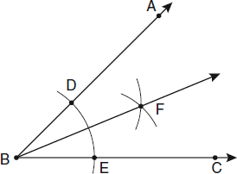

3. Given the above construction, select all that must be true.

1. AO $≅$ OB
2. AB $≅$ CD
3. AO $≅$ OC
4. $∠$ AOC is a right angle
5. $∠$ AOB is a right angle
6. $∠$ DOB is a right angle
7. CD is a perpendicular bisector
8. AB is a perpendicular bisector

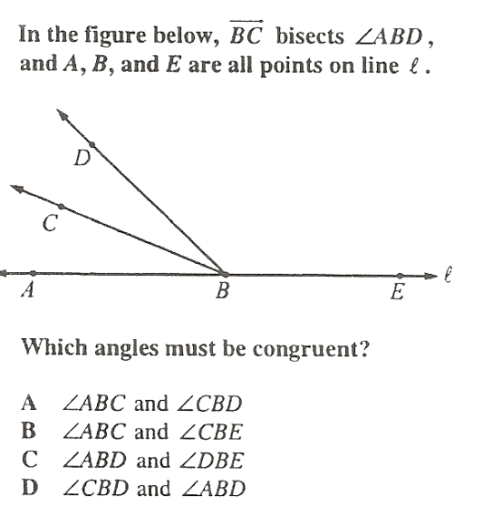

4.

For each of the following, write an equation and solve to find the value of x.

5. is an Angle Bisector 6.

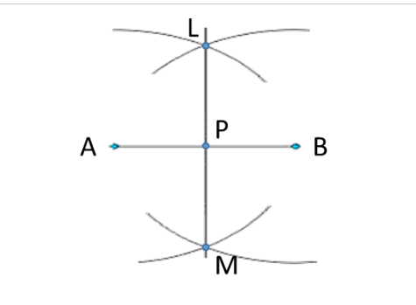

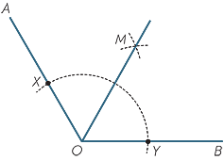

7. 8. AB bisects CAD

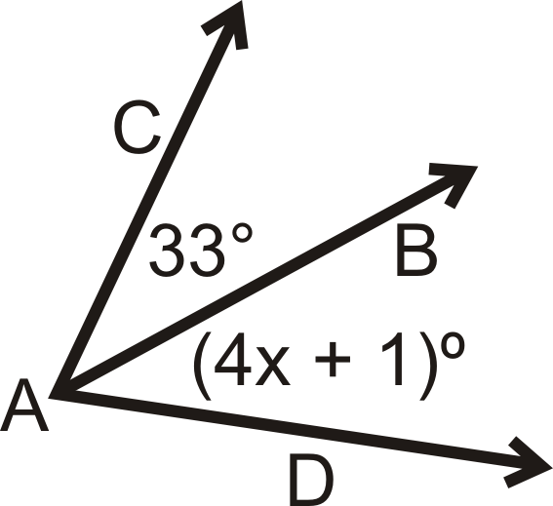



10. QU bisects TUV

TUQ =

QUV =

9. 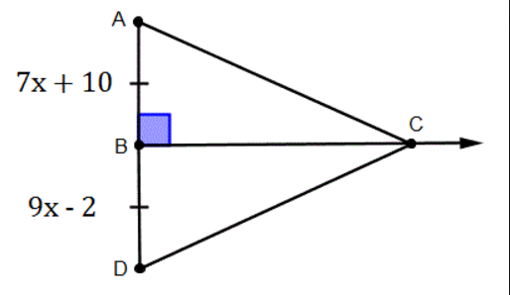is an altitude of $∆ACD$

U

T

V

Q