Name: ________________________________________ Date: _____________________

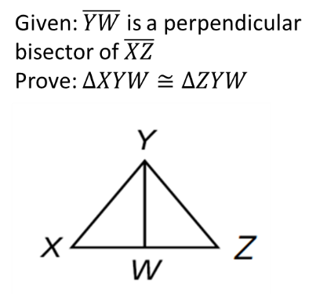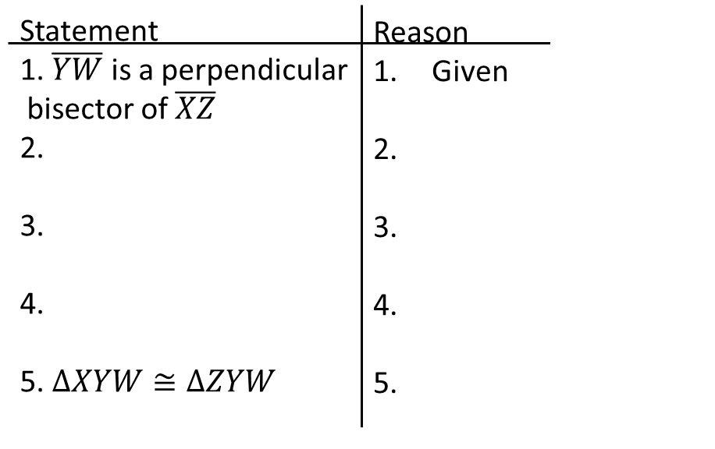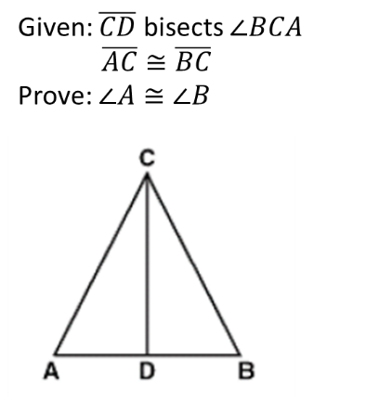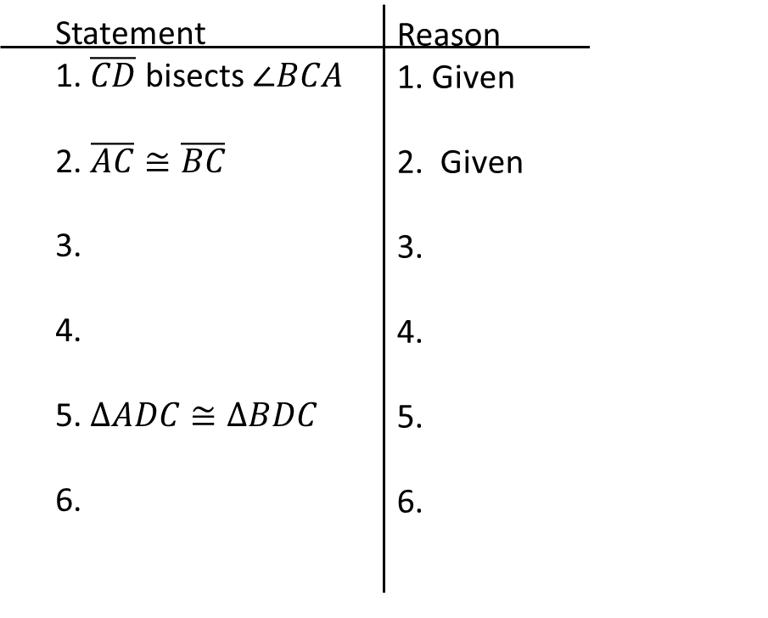

Screen Clipping

Name: ________________________________________ Date: _____________________



Screen Clipping

