Black Leaders During Reconstruction By History.com,
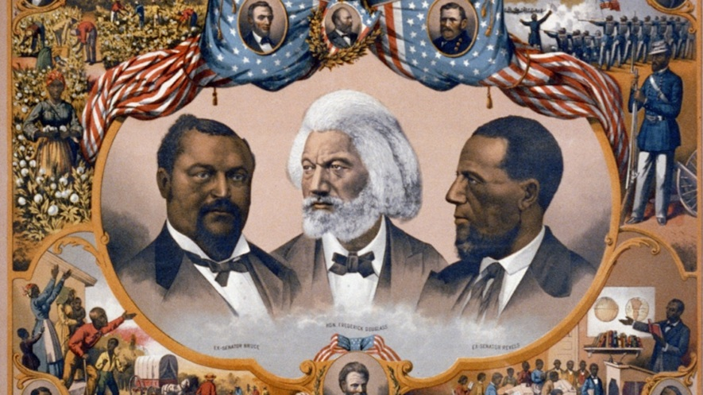“Heroes of the Colored Race,” a print published by J. Hoover of Philadelphia in 1881, pictured (from left) Senator Blanche K. Bruce of Mississippi, orator Frederick Douglass and Senator Hiram Revels of Mississippi. The vignettes depicted scenes from African-American life as well as portraits of other members of Congress: John Lynch of Mississippi, Joseph Rainey of South Carolina, Charles Nash of Louisiana and Robert Smalls of South Carolina. Picture from Library of Congress

Reconstruction was the period after the Civil War when Congress ordered that the South be rebuilt, former Confederate states be brought back into the Union, and rights given to former slaves. It lasted from 1865 to 1877. During Reconstruction, African-Americans actively participated in the political, economic and social life of the South. The era was marked by their quest for freedom and equal rights, both as individuals and for the black community. During Reconstruction, about 2,000 African-Americans held public office, from the local level all the way up to the U.S. Senate. However, they never served in government in proportion to their numbers.
Before the Civil War began, African-Americans had only been able to vote in a few northern states. There were just about no black officeholders. In the months after the Union victory, the black community organized many meetings, parades and petitions calling for their rights, especially the all-important right to vote. During the first two years of Reconstruction, blacks organized Equal Rights Leagues throughout the South. The group held meetings to protest discrimination and the right to vote, and call for equality before the law.

Opposition to Johnson's policies
Andrew Johnson became president after Abraham Lincoln was assassinated. He felt that it should be left up to the states if African-Americans can vote. State legislatures in the South began passing “black codes” that restricted the lives of the freed men and women. African-American activists bitterly fought these discriminatory laws. This, as well as growing opposition to Johnson’s policies in the North, led to a Republican victory in the U.S. congressional elections of 1866. It began a new phase of Reconstruction that would give African-Americans a more active role in the South.
During Reconstruction, Congress granted African-American men citizenship, including the right to vote. Beginning in 1867, branches of the Union League spread throughout the South. The group encouraged African- Americans to be politically active. During the state constitutional conventions held in 1867 to 1869, blacks and white Americans worked side by side on political matters for the first time in the U.S. to rewrite state constitutions.

Black politicians on the rise
Blacks made up almost all the voters for the Republican Party in the South. They worked together with “carpetbaggers” and “scalawags.” These were insulting terms referring to recent arrivals from the North and southern white Republicans. A total of 265 African-Americans participated in these constitutional conventions, more than 100 of whom had been born into slavery. Almost half of the elected black delegates served in South Carolina and Louisiana. In most other states, African-Americans were underrepresented compared to their population. In all, 16 African-Americans served in the U.S. Congress during Reconstruction. More than 600 more were elected to the state legislatures, and hundreds more held local offices across the South.
Many black leaders during Reconstruction had gained their freedom before the Civil War. They were able to buy themselves out of slavery, or they were freed after an owner died. They had worked as skilled slave craftsmen or had served in the Union Army. Many black political leaders worked as ministers during slavery or in the early years of Reconstruction when the church served as the center of the black community. Hiram Revels was the first African-American elected to the U.S. Senate. He took the Senate seat from Mississippi, which had been formerly occupied by Jefferson Davis who had become the president of the Confederacy when Mississippi seceded from the U.S.

New leaders unlike most blacks
Revels was born free in North Carolina and attended college in Illinois. He worked as a preacher in the Midwest in the 1850s and as a church chaplain to a black regiment in the Union Army before going to Mississippi in 1865 to work for the Freedmen’s Bureau. Blanche K. Bruce, elected to the Senate in 1875 from Mississippi, had been a slave but also received some education. The background of these men was typical of the leaders that emerged during Reconstruction but was greatly different from that of the majority of the African-American population.
The opponents of Reconstruction were extremely hostile to the political activism of the African-American community. Southern whites were enraged with policies giving former slaves the right to vote and hold office. They reacted with threats and violence to affirm white supremacy. The Ku Klux Klan attacked local Republican leaders and blacks who challenged their white employers. At least 35 black officials were murdered by the Klan and other white supremacist groups during the Reconstruction era.

Question 1. Which two of the following selections from the article BEST support its CENTRAL ideas?

- During Reconstruction, African-Americans actively participated in the political, economic and social life of the South.
- The era was marked by their quest for freedom and equal rights, both as individuals and for the black community.
- Before the Civil War began, African-Americans had only been able to vote in a few northern states.
- At least 35 black officials were murdered by the Klan and other white supremacist groups during the Reconstruction era.
A 1 and 2
B 2 and 3
C 3 and 4
D 1 and 4

Question 2: HOW does the section "Black politicians on the rise" reflect the CENTRAL ideas of the article?

A by predicting the future effects Reconstruction would have on the South
B by outlining the continuing impact of slavery on the South
C by highlighting the fact that black leaders had often worked as ministers
D by exploring the benefits of Reconstruction for African-Americans

Question 3: HOW does the article MOSTLY develop the idea that the Reconstruction era was marked by the African-American quest for equal rights?

A by describing laws that were enacted to protect the rights of blacks
B by explaining that the goal of Reconstruction was to rebuild the South after the Civil War
C by describing the various ways that African-Americans became involved in politics after the Civil War ended
D by explaining how black leaders emerged during Reconstruction

Question 4: Which of the following statements BEST represents the beliefs of the opponents of Reconstruction?

A They believed that African-Americans were vital to rebuilding the South.
B They believed that the constitutions of the southern states should be rewritten.
C They believed that African-Americans should not be participating in politics.
D They believed that "black codes" were discriminatory and should not have been passed.

