Name _______________________________________________ Date ________________ Period ______________

**Cell Membrane and Transport Webquest**

**Part I: Cell Membranes**

**Link 1-Structure and Function of the cell membrane**: [www.biology4kids.com/files/cell_membrane.html](http://www.biology4kids.com/files/cell_membrane.html)

1. How is the cell membrane similar to a plastic bag with tiny holes?

2. What two components make up the cell membrane?

A. What are their functions?

3. What is the fluid mosaic model?

4. DRAW a picture of the cell membrane and label the following parts: heads, tails, hydrophobic, hydrophilic and protein channels.

**Part II: Cellular Transport**

**Link 2 – Cell Transport Overview and Membranes:** <http://www.wiley.com/legacy/college/boyer/0470003790/animations/membrane_transport/membrane_transport.htm>

1. What is meant by **cell transport?**

2. *Defend this statement:* living organisms must be able to transport materials in and out of the cell in order to live.

3. Whether or not a molecule can pass through the cell membrane is determined by…..

4. How are **smaller molecules** like O2 and CO2 able to pass through the openings of the cell membrane?

**Link 3 – Online Textbook Diffusion Tutorial** [**http://highered.mheducation.com/sites/0072495855/student_view0/chapter2/animation__how_diffusion_works.html**](http://highered.mheducation.com/sites/0072495855/student_view0/chapter2/animation__how_diffusion_works.html)

1. If you have them, plug in your headphones. Otherwise, simply read the text and watch the animation. Describe what happens to moving molecules within a solution.

2. In terms of *molecules*, explain what happens to a sugar cube when it is placed into a beaker of water.

3. Define **diffusion**.

4. Using the arrow seen below, illustrate the diffusion of molecules from high concentration to low concentration.

5. What can affect the *rate of diffusion*?

6. **Predict**: what would happen if you drop the sugar cube into a beaker of hot water vs. a beaker of cold water.

**Link 4 - Facilitated Diffusion Tutorial** <http://highered.mheducation.com/sites/0072495855/student_view0/chapter2/animation__how_facilitated_diffusion_works.html>

1. What is **facilitated diffusion?**

2. Explain what it means to say these protein channels are ***selective*** in what they allow into or out of the cell.

3. **Facilitated diffusion** involves the movement of particles ( with / against ) the concentration gradient.

4. In what ways are simple and facilitated diffusion the same?

5. How are they different?

**Link 5 - Online Textbook Osmosis Tutorial** <http://highered.mheducation.com/sites/0072495855/student_view0/chapter2/animation__how_osmosis_works.html>

1. Most __________ molecules cannot freely cross the cell membrane. Is this true for water molecules?

2. Define osmosis.

3. Why did the water molecules move from the left to the right side? Be sure to include the word concentration in your answer.

4. The solution with ( higher / lower ) solutes is hypertonic. The solution with ( higher / lower) solutes is hypotonic.

**Link 6- Omosis Scenarios-** <http://www.glencoe.com/sites/common_assets/science/virtual_labs/LS03/LS03.html>

1. Drag each type of cell into the hypotonic, isotonic and hypertonic solutions. Draw and describe what happens to each type of cell in every solution. Explain why this happens by giving the solution concentrations and discussing the movement of water. Show arrows representing the flow of water into or out of the cell.

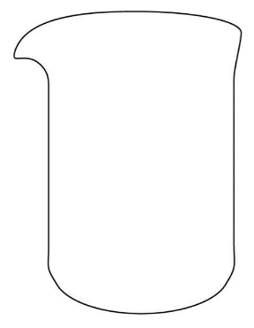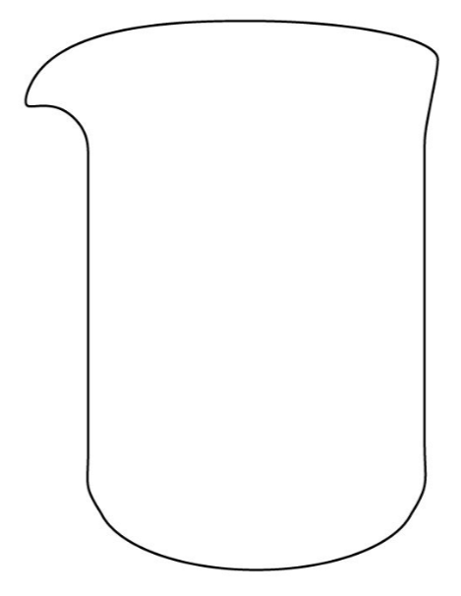

Hypotonic-__________________ Isotonic-____________________ Hypertonic-_______________

___________________________ ____________________________ ________________________

1. Read the “Under what conditions to cells gain or lose water?” and define hypotonic, isotonic and hypertonic solutions above.

**Link 7- Active vs. Passive transport**<http://www.phschool.com/atschool/phbio/active_art/active_transport/index.html>

1. What is the difference between passive and active transport? _______________________________________

__________________________________________________________________________________________

1. What is endocytosis? What particles are moved using this process? ___________________________________

__________________________________________________________________________________________

1. What is exocytosis? What particles are moved using this process? ____________________________________

__________________________________________________________________________________________

1. Explain how does the cell membrane helps the cell maintain homeostasis? _____________________________

__________________________________________________________________________________________

**Link 8 - Endocytosis and Exocytosis** [**http://highered.mheducation.com/olcweb/cgi/pluginpop.cgi?it=swf::535::535::/sites/dl/free/0072437316/120068/bio02.swf::Endocytosis%20and%20Exocytosis**](http://highered.mheducation.com/olcweb/cgi/pluginpop.cgi?it=swf::535::535::/sites/dl/free/0072437316/120068/bio02.swf::Endocytosis%20and%20Exocytosis)

1. Draw and summarize the process of ***endocytosis***.

  

Beginning Middle End

1. Draw and summarize the process of ***exocytosis***.

  

Beginning Middle End