Introduction:
A disease is any breakdown in the structure or function of an organism. Scientists who study a particular disease gather information about how that disease affects the organism. They look at all levels of the organism, from molecules and cells to organs and the whole organism. Some scientists, like cell biologists, use microscopes to study the structure and function of cells in a full array of organisms, from humans to plants to insects to microbes. A microbe is a microscopic cellular organism or a virus, and some microbes cause infectious diseases. One way to detect and study many diseases is to compare blood from healthy and sick individuals under a microscope. In this activity, you will examine sample of blood from healthy and diseased people.

Part 1: Use your textbook and a laptop with internet access to research the four red blood cell disorders. Good sources for this chart include WebMd and Mayo Clinic.
Disorder | Cause | Symptoms | Picture of Disorder
Polycythemia Vera
Sickle Cell Disease
Spherocytosis
Malaria

Part 2: Take on the role of an epidemiologist, and determine the diagnosis of the following two patients.
Normal/Healthy Individual | Patient #1 | Patient #2
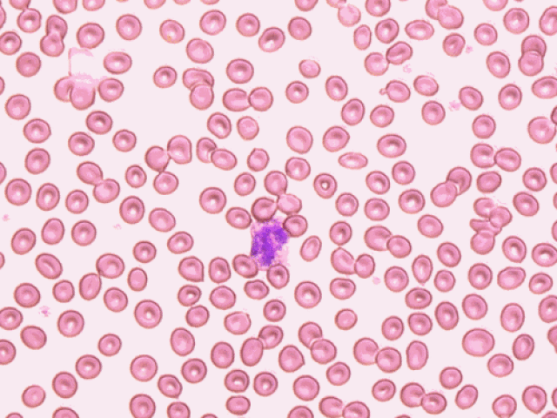 | 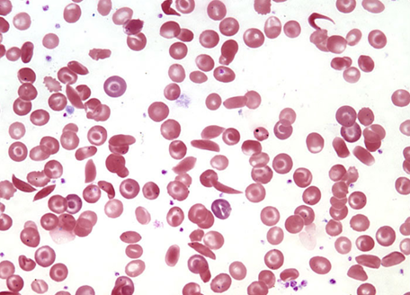 | 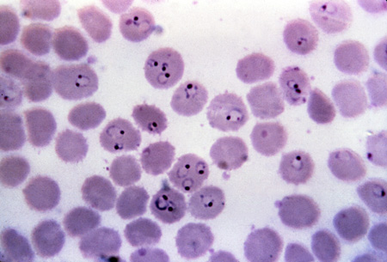

Patient 1: Came into the hospital complaining of dizziness and join pain. Also, has been falling asleep at school regularly.
What abnormalities do you see with these cells?

Based on your observations, which disease does this patient have? How do you know?

Patient 2: Just got back from vacation, is feeling tired and nauseous. Has a slight fever.
What abnormalities do you see with this cell?

Based on your observations, which disease does this patient have? How do you know?

Part 3: Use the Read, Think, and Take Note Guidelines (page 165) while you read pages 167-170. Use the text material and your annotated notes to answer the analysis questions.

Read, Think, Take Note/Annotations:
__________________________________________________________________________________________________________________________________________________________________________________________________________________________________________________________________________________________________________________________________________________________________________________________________________________________________________________________________________________________________________________________________________________________________________________________________________________________________________________________________________________________________________________________________________________________________________________________________________________________________________________________________________________
Analysis Questions:
- How do microscope observations of cells help doctors and scientists diagnose and study diseases? Give specific examples from this activity.

- A trade-off is an exchange of one thing in return for another. What would the trade-offs be of using insecticides to kill thee mosquitos?

- What are the benefits of using insecticides to kill mosquitoes that might be carrying Plasmodium?

- Based on the malaria case, how does resistance develop in a population of disease -causing microbes?

