Name: ___________________________________________________________ Date: ________

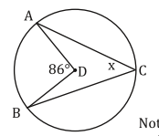

Find the missing measures:

$$\hat{AB}=$$

$$∠ADB=$$

$$∠ACB=$$

Find the missing measures:



$$\hat{AB}=$$

$$∠ADB=$$

$$∠ACB=$$

Find the missing measures:

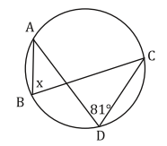

Find the missing measures:



$$\hat{AC}=$$

$$∠ABC=$$

$$∠ADC=$$

Find the missing measures:



Find the missing measures:

Find the missing measures:



$$\hat{AB}=$$

$$∠ADB=$$

$$∠ACB=$$

Find the missing measures:

$$\hat{ADC}=$$

$$∠ABC=$$

$$∠ADC=$$

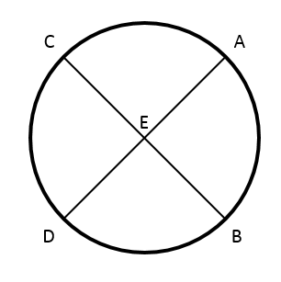

Find the missing measures:

$$\hat{AC}=$$

$$∠AEC=$$

$$∠DEB=$$

$$\hat{DB}=$$

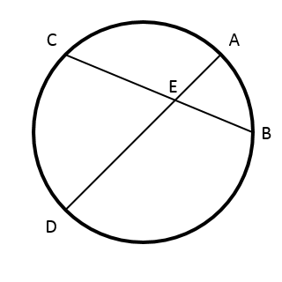

Find the missing measures:



$$\hat{AC}=$$

$$∠AEC=$$

$$∠DEB=$$

$$\hat{DB}=$$

Find the missing measures:

$$\hat{CD}=$$

$$∠CED=$$

$$∠AEB=$$

$$\hat{AB}=$$

Exit Ticket:

