Name: ______________________________________________ Date: ______________

Central, Inscribed and Vertical Angles Worksheet

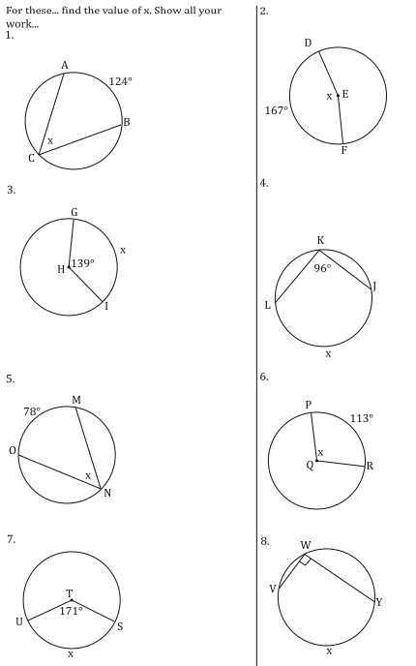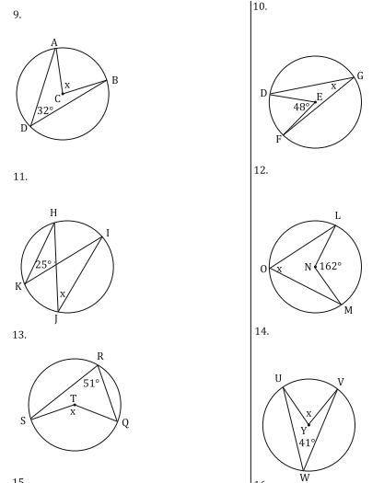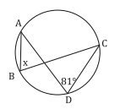

15. For each of the following, find the measure of angle 1.

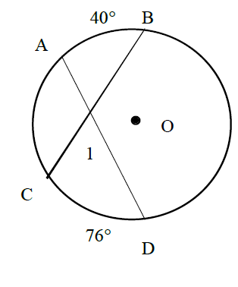

17°

46°



45°

72°



30°

86°