Checkpoint 11.1 Name_________________

Read the “Declaration of Independence.” Then answer the questions that follow.

Declaration of Independence
by Thomas Jefferson
IN CONGRESS, July 4, 1776.
The unanimous Declaration of the thirteen United States of America,
[1] When in the course of human events, it becomes necessary for one people to dissolve the political bands which have connected them with another, and to assume among the powers of the earth, the separate and equal station to which the Laws of Nature and of Nature's God entitle them, a decent respect to the opinions of mankind requires that they should declare the causes which impel them to the separation.
[2] We hold these truths to be self-evident, that all men are created equal, that they are endowed by their Creator with certain unalienable Rights, that among these are Life, Liberty, and the pursuit of Happiness. — That to secure these rights, Governments are instituted among Men, deriving their just powers from the consent of the governed, — That whenever any Form of Government becomes destructive of these ends, it is the Right of the People to alter or to abolish it, and to institute new Government, laying its foundation on such principles and organizing its powers in such form, as to them shall seem most likely to effect their Safety and Happiness. Prudence, indeed, will dictate that Governments long established should not be changed for light and transient causes; and accordingly all experience hath shewn, that mankind are more disposed to suffer, while evils are sufferable, than to right themselves by abolishing the forms to which they are accustomed. But when a long train of abuses and usurpations, pursuing invariably the same Object evinces a design to reduce them under absolute Despotism, it is their right, it is their duty, to throw off such government, and to provide new Guards for their future security. — Such has been the patient sufferance of these Colonies; and such is now the necessity which constrains them to alter their former Systems of Government. The history of the present King of Great Britain is a history of repeated injuries and usurpations, all having in direct object the establishment of an absolute Tyranny over these States. To prove this, let Facts be submitted to a candid world.
[3] He has refused his Assent to Laws, the most wholesome and necessary for the public Good.
[4] He has forbidden his Governors to pass Laws of immediate and pressing importance, unless suspended in their operation till his Assent should be obtained; and when so suspended, he has utterly neglected to attend to them.
[5] He has refused to pass other Laws for the accommodation of large districts of people, unless those people would relinquish the right of Representation in the Legislature, a right inestimable to them and formidable to tyrants only.
[6] He has called together legislative bodies at places unusual, uncomfortable, and distant from the depository of their public Records, for the sole purpose of fatiguing them into compliance with his measures.
[7] He has dissolved Representative Houses repeatedly, for opposing with manly firmness his invasions on the rights of the people.
[8] He has refused for a long time, after such dissolutions, to cause others to be elected; whereby the Legislative powers, incapable of Annihilation, have returned to the People at large for their exercise; the State remaining in the mean time exposed to all the dangers of invasion from without, and convulsions within.
[9] He has endeavoured to prevent the population of these States; for that purpose obstructing the Laws for Naturalization of Foreigners; refusing to pass others to encourage their migrations hither, and raising the conditions of new Appropriations of Lands.
[10] He has obstructed the Administration of Justice, by refusing his Assent to Laws for establishing Judiciary powers.
[11] He has made Judges dependent on his Will alone, for the tenure of their offices, and the amount and payment of their salaries.
[12] He has erected a multitude of New Offices, and sent hither swarms of Officers to harrass our people, and eat out their substance.
[13] He has kept among us, in times of peace, Standing Armies without the Consent of our legislatures.
[14] He has affected to render the Military independent of and superior to the Civil power.
[15] He has combined with others to subject us to a jurisdiction foreign to our constitution, and unacknowledged by our laws; giving his Assent to their Acts of pretended Legislation.
[16] For Quartering large bodies of armed troops among us:
[17] For protecting them, by a mock Trial, from punishment for any Murders which they should commit on the inhabitants of these States:
[18] For cutting off our Trade with all parts of the world:
[19] For imposing Taxes on us without our Consent:
[20] For depriving us in many cases, of the benefits of Trial by Jury:
[21] For transporting us beyond Seas to be tried for pretended offences:
[22] For abolishing the free System of English Laws in a neighbouring Province, establishing therein an Arbitrary government, and enlarging its Boundaries so as to render it at once an example and fit instrument for introducing the same absolute rule into these Colonies:
[23] For taking away our Charters, abolishing our most valuable Laws, and altering fundamentally the Forms of our Governments:
[24] For suspending our own Legislature, and declaring themselves invested with power to legislate for us in all cases whatsoever.
[25] He has abdicated Government here, by declaring us out of his Protection and waging War against us.
[26] He has plundered our Seas, ravaged our Coasts, burnt our towns, and destroyed the lives of our people.
[27] He is at this time transporting large Armies of foreign Mercenaries to complete the works of death, desolation, and tyranny, already begun with circumstances of Cruelty & perfidy scarcely paralleled in the most barbarous ages, and totally unworthy the Head of a civilized nation.
[28] He has constrained our fellow Citizens taken Captive on the high Seas to bear Arms against their Country, to become the executioners of their friends and Brethren, or to fall themselves by their Hands.
[29] He has excited domestic insurrections amongst us, and has endeavored to bring on the inhabitants of our frontiers the merciless Indian Savages, whose known rule of warfare, is an undistinguished destruction of all ages, sexes and conditions.
[30] In every stage of these Oppressions We have Petitioned for Redress in the most humble terms: Our repeated Petitions have been answered only by repeated injury. A Prince whose character is thus marked by every act which may define a Tyrant, is unfit to be the ruler of a free people.
[31] Nor have We been wanting in attentions to our British brethren. We have warned them from time to time of attempts by their legislature to extend an unwarrantable jurisdiction over us. We have reminded them of the circumstances of our emigration and settlement here. We have appealed to their native justice and magnanimity, and we have conjured them by the ties of our common kindred to disavow these usurpations, which, would inevitably interrupt our connections and correspondence. They too have been deaf to the voice of justice and of consanguinity. We must, therefore, acquiesce in the necessity, which denounces our Separation, and hold them, as we hold the rest of mankind, Enemies in War, in Peace Friends.
[32] We, therefore, the Representatives on the United States of America, in General Congress, Assembled, appealing to the Supreme Judge of the world for the rectitude of our intentions, do, in the Name, and by Authority of the good People of these colonies, solemnly publish and declare, That these United Colonies are, and of Right ought to be Free and Independent States; and they are Absolved from all Allegiance to the British Crown, and that all political connection between them and the State of Great Britain, is ought to be totally dissolved; and that as Free and Independent States, they have full Power to levy War, conclude Peace, contract Alliances, establish Commerce, and to do all other Acts and Things which Independent States may of right do. And for the support of this Declaration, with a firm reliance on the protection of divine Providence, we mutually pledge to each other our Lives, our Fortunes and our sacred Honor.
"Declaration of Independence" by Thomas Jefferson — Public Domain

Question 1
Part A: Which statement expresses a general principle that serves as a foundational basis for the argument Jefferson sets forth in “Declaration of Independence?”
- The king is guilty of crimes against the colonies.
- The king’s government should be abolished.
- Governments that abuse people’s rights should be transformed or removed.
- Colonists have a right to exist free and independent of Great Britain.

Part B: Which quotation from the “Declaration of Independence” best supports the answer to Part A?

- “…a decent respect to the opinions of mankind requires that they should declare the causes which impel them to separation.” (paragraph 1)
- “…That whenever a Form of Government becomes destructive of these ends, it is the Right of the People to alter or to abolish it, and to institute new Government…” (paragraph 2)
- “We have reminded them of the circumstances of our emigration and settlement here.” (paragraph 31)
- “…that all political connection between them and the State of Great Britain, is and ought to be totally dissolved…” (paragraph 32)
Question 2
Part A: Jefferson begins the majority of the paragraphs in the “Declaration of Independence” with the words “He has.” Why is this structure effective in helping Jefferson make his argument?

- It enables the reader to determine which of the king’s offenses are the most severe.
- It emphasizes the king’s role in inflicting multiple forms of injustice.
- It contrasts the king’s behavior with that of his deputies.
- It proposes a clear series of actions to oppose the king’s mistreatment.

Part B: Which aspect of the “Declaration of Independence” provides support for the answer to Part A?
- The metaphor of “political bands” (paragraph 1)
- The reference to “a long train of abuses and usurpations” (paragraph 2)
- The reference to “native justice and magnanimity” (paragraph 31)
- The appeal to “the protection of divine Providence” (paragraph 32)

Question 3
Part A: The transcript refers to the fact that Jefferson expunged the word “subject” from an early draft of the “Declaration of Independence.” What does the word expunged mean in this context?
- Deleted
- Directed
- Recopied
- Emphasized
Part B: Which word from paragraph 2 of the transcript best supports the answer to Part A?
- Referred
- Revising
- Overwriting
- Obliterate

Transcript of “From Subjects to Citizens”
by the Kettering Foundation

1 New advances in science have uncovered a fascinating twist in the writing of the Declaration of Independence, one that’s still of interest to the Kettering Foundation today.

2 Spectral imaging technology shows that in writing the Declaration of Independence, Thomas Jefferson had first referred to the American colonists as “subjects.” But, in the course of revising the document, he then carefully expunged the word, smearing the ink and overwriting it with the word “citizens,” so as to completely obliterate the original word.

3 The sentence in which Jefferson made the change didn’t make it into the final document, but the word “citizens” is also used elsewhere in the final Declaration, while “subjects” is not.

4 This finding reveals an important shift in the Founders’ thinking: that the people’s allegiance was to one another, not to a distant king.

5 That change in thinking, from “subject” to “citizen,” is the starting point for Kettering Foundation’s view of democracy
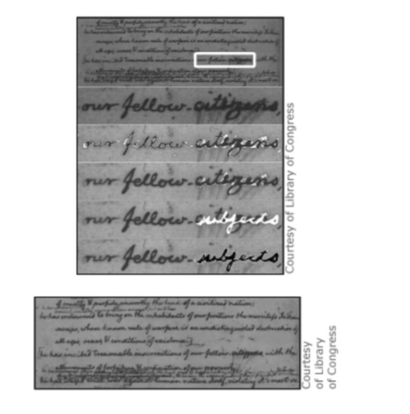
Question 4
Part A : Paragraph 4 of the transcript contains the claim that the discovery "reveals an important shift in the Founders' thinking that the people's allegiance was to one another." Which quotation from the "Declaration of Independence" best illustrates this view of "the Founders' thinking"?
- "...Our repeated Petitions have been answered only by repeated injury." (paragraph 30)
- "We have reminded them of the circumstances of our emigration and settlement here." (paragraph 31)
- "...that as Free and Independent States, they have full Power to levy War, conclude Peace, contract Alliances, establish Commerce, and to do all other Acts and Things which Independent States may of right do." (paragraph 32)
- "...with a firm reliance on the protection of divine Providence, we mutually pledge to each other our Lives, our Fortunes and our sacred Honor." (paragraph 32)
Part B : Which paragraph most directly reflects "the Founders' thinking" as discussed in the video?
- paragraph 5
- paragraph 7
- paragraph 26
- paragraph 28

Read the article “The Signers of the Declaration: Historical Background.” Then answer the questions that follow.
The Signers of the Declaration: Historical Background
from the National Park Service
1 AT PHILADELPHIA in the summer of 1776, the Delegates to the Continental Congress courageously signed a document declaring the Independence of the Thirteen American Colonies from Great Britain. Not only did the Declaration of Independence create a Nation, but it also pronounced timeless democratic principles. Enshrined today in the National Archives Building at Washington, D.C., it memorializes the founding of the United States and symbolizes the eternal freedom and dignity of Man.
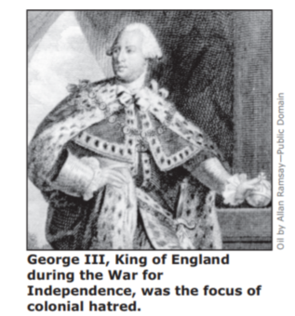

2 By the time the Continental Congress adopted the Declaration in July 1776, the War for Independence had been underway for more than a year. Failing to obtain satisfactory redress from the mother country for their economic and political grievances during the previous decade, the colonists had finally resorted to armed conflict.
3 These grievances had come to a head shortly after the French and Indian War (1754-63). Long and costly, the war depleted the royal treasury and added the financial burden of administering the vast territory acquired from France. Britain levied new, direct taxes in the Colonies and tightened customs controls.
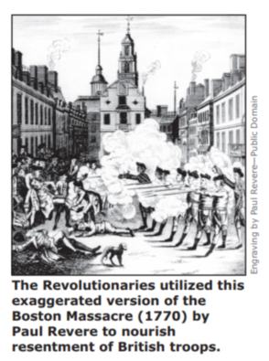

4 The colonists, accustomed to considerable economic freedom, resented these measures. A number of Americans also felt that some sort of conspiracy existed in England to destroy their liberties and self-government. They believed that the mission of the large force of redcoats assigned to the Colonies actually was internal suppression rather than protection from a nonexistent external threat, especially since the French had been expelled. Particularly aggravating was the realization that the new tax levies supported the force. Some of the discontent was regional in nature. Indebtedness to British creditors irritated Southern planters. Commercial interests in the Middle Colonies disliked the prohibition on manufacturing certain products. Frontier settlers and speculators were irked at restrictions on westward expansion and the Indian trade.
5 In various places, peaceful protest and harassment of tax and customs collectors gave way to rioting and mob violence. In New York and Massachusetts, clashes with British troops culminated in bloodshed. Realizing that some of these disturbances stemmed from agitation in the colonial assemblies, which had enjoyed wide autonomy, the Crown tightened its control over them. Disputes between legislators and the King’s officials, once spasmodic, became commonplace. In some instances, notably in Virginia and Massachusetts, the Royal Governors dissolved the assemblies. In these and a few other provinces the Whigs separated from their Tory, or Loyalist, colleagues, met extralegally, and adopted retaliatory measures. Nearly all the Colonies formed special “committees of correspondence” to communicate with each other—the first step toward unified action.
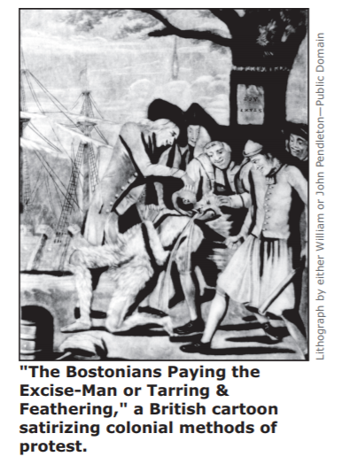
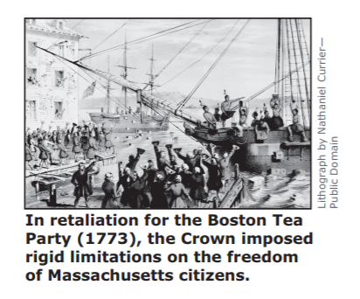

6 In May 1774, in retaliation for the “Boston Tea Party,” Parliament closed the port of Boston and virtually abolished provincial self-government in Massachusetts. These actions stimulated resistance across the land. That summer, the Massachusetts lower house, through the committees of correspondence, secretly invited all 13 Colonies to attend a convention. In response, on the fifth of September, 55 Delegates representing 12 Colonies, Georgia excepted, assembled at Philadelphia. They convened at Carpenters’ Hall and organized the First Continental Congress.
7 Sharing though they did common complaints against the Crown, the Delegates propounded a wide variety of political opinions. Most of them agreed that Parliament had no right to control the internal affairs of the Colonies. Moderates, stressing trade benefits with the mother country, believed Parliament should continue to regulate commerce. Others questioned the extent of its authority. A handful of Delegates felt the answer to the problem lay in parliamentary representation. Most suggested legislative autonomy for the Colonies. Reluctant to sever ties of blood, language, trade, and cultural heritage, none yet openly entertained the idea of complete independence from Great Britain.
8 After weeks of debate and compromise, Congress adopted two significant measures. The first declared that the American colonists were entitled to the same rights as Englishmen everywhere and denounced any infringement of those rights. The second, the Continental Association, provided for an embargo on all trade with Britain. To enforce the embargo and punish violators, at the behest of Congress counties, cities, and towns formed councils, or committees, of safety—many of which later became wartime governing or administrative bodies. When Congress adjourned in late October, the Delegates resolved to reconvene in May 1775 if the Crown had not responded by then.
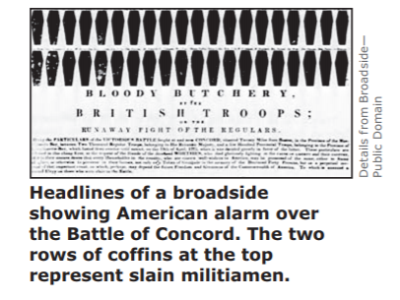
9 In a sense the Continental Congress acted with restraint, for while it was in session the situation in Massachusetts verged on war. In September, just before Congress met, British troops from Boston had seized ordnance supplies at Charlestown and Cambridge and almost clashed with the local militia. The next month, Massachusetts patriots, openly defying royal authority, organized a Revolutionary provincial assembly as well as a military defense committee. Whigs in three other colonies—Maryland, Virginia, and New Hampshire—had earlier that year formed governments. By the end of the year, all the Colonies except Georgia and New York had either set up new ones or taken control of those already in existence. During the winter of 1774-75, while Parliament mulled over conciliatory measures, colonial militia units prepared for war.
10 The crisis came in the spring of 1775, predictably in Massachusetts. Late on the night of April 18 the Royal Governor, Gen. Thomas Gage, alarmed at the militancy of the rebels, dispatched 600 troops from Boston to seize a major supply depot at Concord. Almost simultaneously the Boston council of safety, aware of Gage’s intentions, directed Paul Revere and William Dawes to ride ahead to warn militia units and citizens along the way of the British approach, as well as John Hancock and Samuel Adams, who were staying at nearby Lexington. Forewarned, the two men went into hiding.
11 About 77 militiamen confronted the redcoats when they plodded into Lexington at dawn. After some tense moments, as the sorely outnumbered colonials were dispersing, blood was shed. More flowed at Concord and much more along the route of the British as they retreated to Boston, harassed most of the way by an aroused citizenry. What had once been merely protest had evolved into open warfare; the War for Independence had begun.
The Signers of the Declaration: Historical Background by the National Park Service—Public Domain

Question 5
Part A : Which idea introduced in the first two paragraphs is developed throughout the article?
- The delegates to the Continental Congress acted heroically when they signed the Declaration of Independence.
- The Declaration of Independence expresses timeless democratic principles.
- The War for Independence followed years of conflict that colonists could not resolve peacefully with England.
- The War for Independence began two years before the Declaration of Independence was created.
Part B: Which detail best supports the answer to Part A?
- “In May 1774, in retaliation for the ‘Boston Tea Party,’ Parliament closed the port of Boston and virtually abolished provincial self-government in Massachusetts.” (paragraph 6)
- “The first declared that the American colonists were entitled to the same rights as
Englishmen everywhere and denounced any infringement of those rights.” (paragraph 8)
- “In a sense the Continental Congress acted with restraint, for while it was in session the situation in Massachusetts verged on war.” (paragraph 9)
- “During the winter of 1774-75, while Parliament mulled over conciliatory measures, colonial militia units prepared for war.” (paragraph 9)

Question 6
Part A: What does the use of the word extralegally in paragraph 5 indicate about colonial activities in the period before the American Revolution?
- Colonists first attempted to voice their complaints through legitimate political means.
- Colonists wanted to gain European support for their independence from England.
- Colonists were able to gain unanimous support for their demands to the English monarchy.
- Colonists acted in ways to hide their actions from the British.
Part B: Which statement is evidence of the behavior identified in Part A?
- Settlers were disgruntled with limitations on the frontier. (paragraph 4)
- The Massachusetts lower house secretly invited all 13 colonies to attend a convention. (paragraph 6)
- Colonists disagreed on the validity of English taxes and laws. (paragraph 7)
- Violators of the embargo were punished and ridiculed. (paragraph 8)

Question 7
Part A: According to the author of this article, what resulted from the meeting of the First Continental Congress?
- A focus on using economic power to force the British government to treat colonists as if they were English citizens living in Great Britain
- The belief that the colonies benefited from their ties with Great Britain and therefore would have to accept their limited political rights
- A decision that colonists’ next step should be to dissolve their local governments and demand colonial representation in the Parliament of Great Britain
- An acknowledgement that political and financial remedies had been exhausted and that the next step would have to be military action
Part B: Which two pieces of evidence best support the answer to Part A?
- “Reluctant to sever ties of blood, language, trade, and cultural heritage, not yet openly entertained the idea of complete independence….” (paragraph 7)
- “…the Continental Association, provided for an embargo on all trade with Britain.” (paragraph 8)
- “…at the behest of Congress counties, cities, and towns formed councils, or committees, of safety….” (paragraph 8)
- “…the Continental Congress acted with restraint, for while it was in session the situation in Massachusetts verged on war.” (paragraph 9)

Question 8
Part A: According to the article, why did the British fear local colonial governments in the buildup to the Revolutionary War?
- Colonial governments actively resisted British policies.
- Colonial governments allied themselves with Britain’s enemies on the western frontier.
- Colonial governments threatened British self-government.
- Colonial governments seized British military supplies.
Part B: Which piece of evidence best supports the evidence to Part A?
- “Frontier settlers and speculators were irked at restrictions on westward expansion and the Indian trade.” (paragraph 4)
- “Sharing though they did common complaints against the Crown, the Delegates propounded a wide variety of political opinions.” (paragraph 7)
- “Reluctant to sever ties of blood, language, trade, and cultural heritage, none yet openly entertained the idea of complete independence from Great Britain.” (paragraph 7)
- “The next month, Massachusetts patriots, openly defying royal authority, organized a Revolutionary provincial assembly as well as a military defense committee.” (paragraph 9)

Question 9
Part A: How does the author structure the article in order to highlight the growing tension between the English and the colonists?
- by providing the colonists’ perspective on events and then contrasting them with British views of the same events
- by chronologically presenting most of the events in the conflict
- by alluding to the final cost of the Revolutionary War in human lives on both sides
- by comparing the build-up to the Declaration of Independence to similar conflicts around the globe
Part B: Which analysis best supports the answer to Part A?
- the idea that the first paragraph describes an event from 1776 and the last paragraph describes an event from 1775
- the repeated references to bloodshed in paragraph 9 and the pictures of coffins in the last illustration
- the explanation in paragraph 5 of why the British tightened their control over the colonial assemblies
- the fact that paragraphs 3–11 describe a chain of events beginning with the French and Indian War and ending with the Battle of Concord

Question 10
Part A: How does the article highlight the importance of the Declaration of Independence?
- by noting that the Declaration was written after the start of the American Revolution
- by citing other documents created by American patriots
- by recognizing the Declaration as a significant American symbol
- by explaining what occurred at the First Continental Congress
Part B: What piece of evidence from the article supports the answer to Part A?
- “. . . the Delegates to the Continental Congress courageously signed a document . . . .” (paragraph 1)
- “. . . it memorializes the founding of the United States . . . .” (paragraph 1)
- “. . . the War for Independence had been underway for more than a year.” (paragraph 2)
- “. . . the colonists had finally resorted to armed conflict.” (paragraph 2)

