Chemistry Honors Uncertainty in Measurement
Using a Ruler: Reading Between the Lines
We must visualize 10 small graduations between the two markings between 1.0 cm and 1.1 cm so that we can estimate length to the hundredths place.

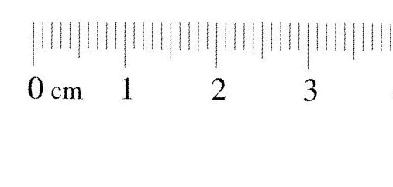
The digit that we estimate to is the uncertain digit.
All measured values have one uncertain digit that is estimated.
Try measuring these lines with estimation of the last digit:
1. __________ 2. ________________ 3. ______________________ 4. ________________________________ 5. _______

