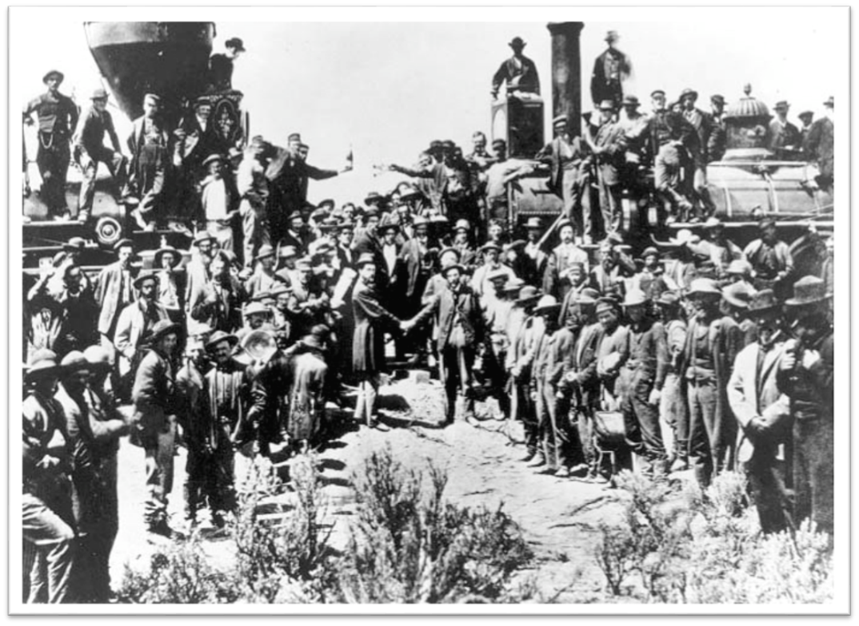
Golden Spike Ceremony at Promontory Point, Utah ____________

- During the Civil War, the ____________ passed laws that helped ___________, because the Southern representatives couldn’t block them
- Congress passed the Pacific Railway Act of ____________: the government would give railroad companies free __________ and loan them ____________ to build the transcontinental railroad. Afterward, the railroad companies were supposed to sell the land on both sides of the track and pay back the ____________________ but they _____________ did that.
- Two companies competed to get the most land and money: __________________ (built tracks from East to West) and ___________________________ (built tracks from West to East).
- On May 10, 1869, the Central Pacific railway met the Union Pacific Railway in Promontory Point, _______________, marking the completion of the _____________________________ railroad.
- Two groups who were discriminated against, the _____________ and the ___________, found jobs constructing the Railroad.
- The ___________________ built from the Pacific towards the interior, using ___________________ to blast through mountains to form ________________.

