**Wie spät ist es?**

**Look at the following times. Match the times to the clocks shown below. Then work with a partner to identify the patterns you see for telling time.**

1. 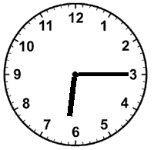 2. 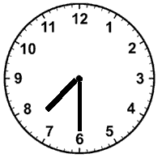 3. 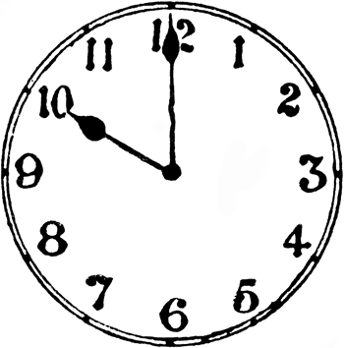

_____________________ ______________________ _____________________

_____________________ ______________________

4. 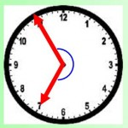 5. 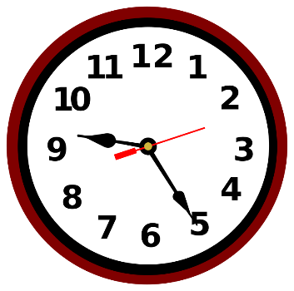 6. 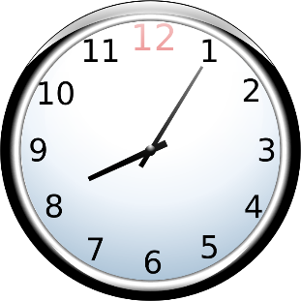

______________________ ______________________ _______________________

7. 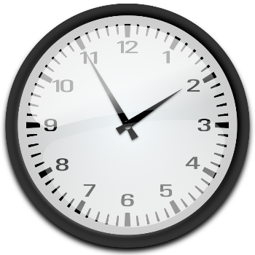 8. 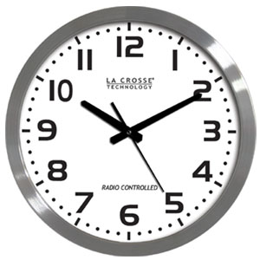 9. 

  



