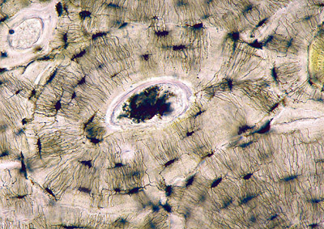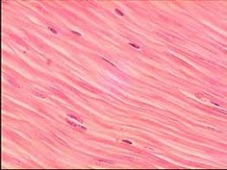

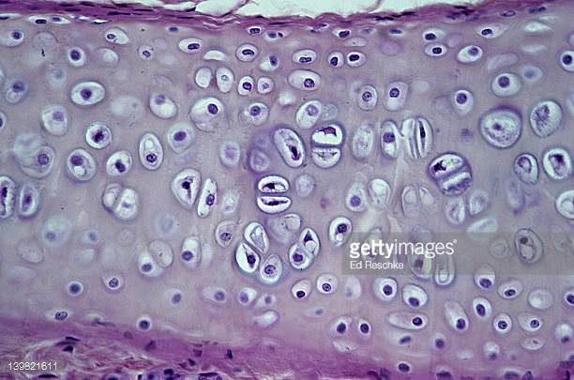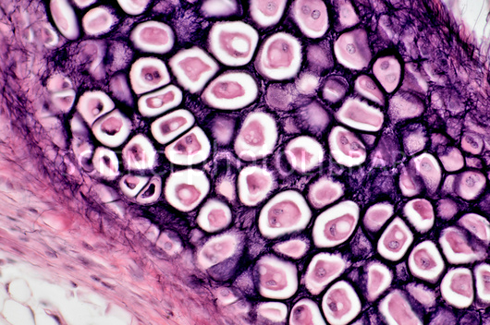

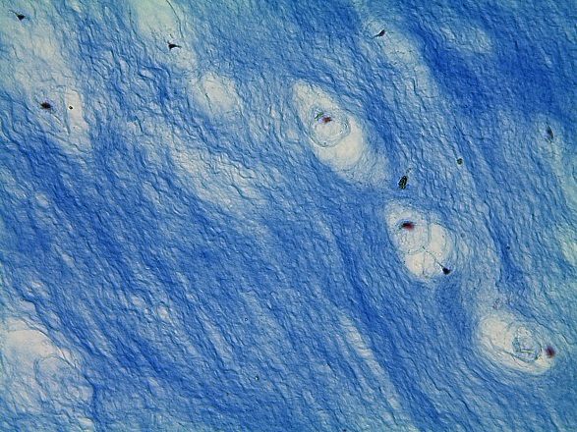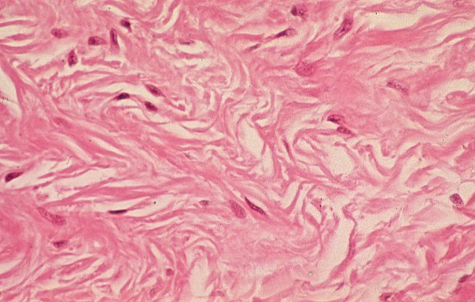

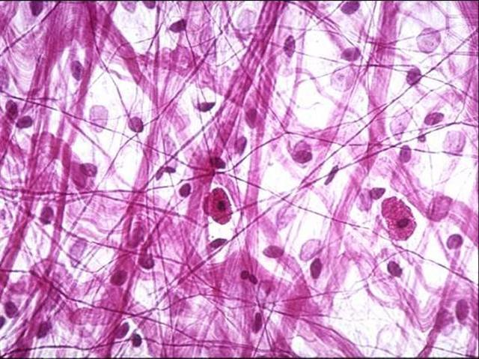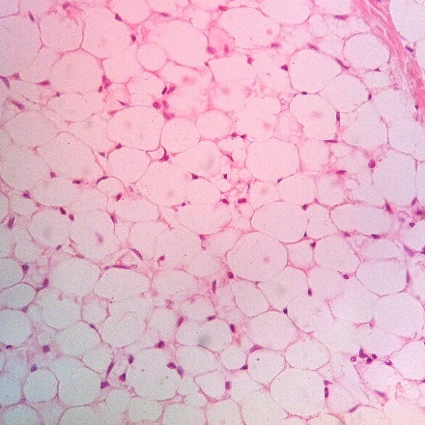

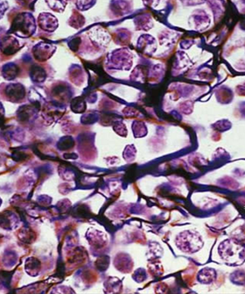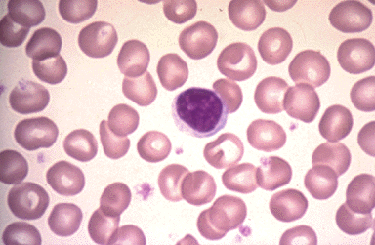
Collagen fibers | Hard
Collagen fibers | Rubbery
Elastic fibers | Rubbery
Collagen fibers | Rubbery
Collagen fibers, few elastic | Mostly fibers
Collagen fibers, few elastic | Mostly fibers
Collagen, elastic and reticular fibers | Gel-like
Collagen, elastic and reticular fibers | Gel-like
Reticular fibers | Gel-like
Collagen are visible when clotting | Fluid
Osteocyte | Transport
Chondrocyte | Shock Absorption
Chondrocyte | Protection and Support
Chondrocyte | Insulation, protection and energy storage
Fibrocyte | Forms supporting framework
Fibrocyte | Cushions and absorbs fluid
Fibrocyte | Attachment
Adipocyte | Support and reinforcement
Blood cells | Attachment
Red and white blood cells | Flexibility
Inside blood vessels | Ear
Abdomen, behind eyes, breast tissue | Knee, intervertebral discs
Skeleton | Dermis of skin
Spleen, lymph nodes | Widely distributed
Tendons, ligaments | Trachea, ends of long bones, fetal skeleton

