Name: ________________________________________ Date: _____________________
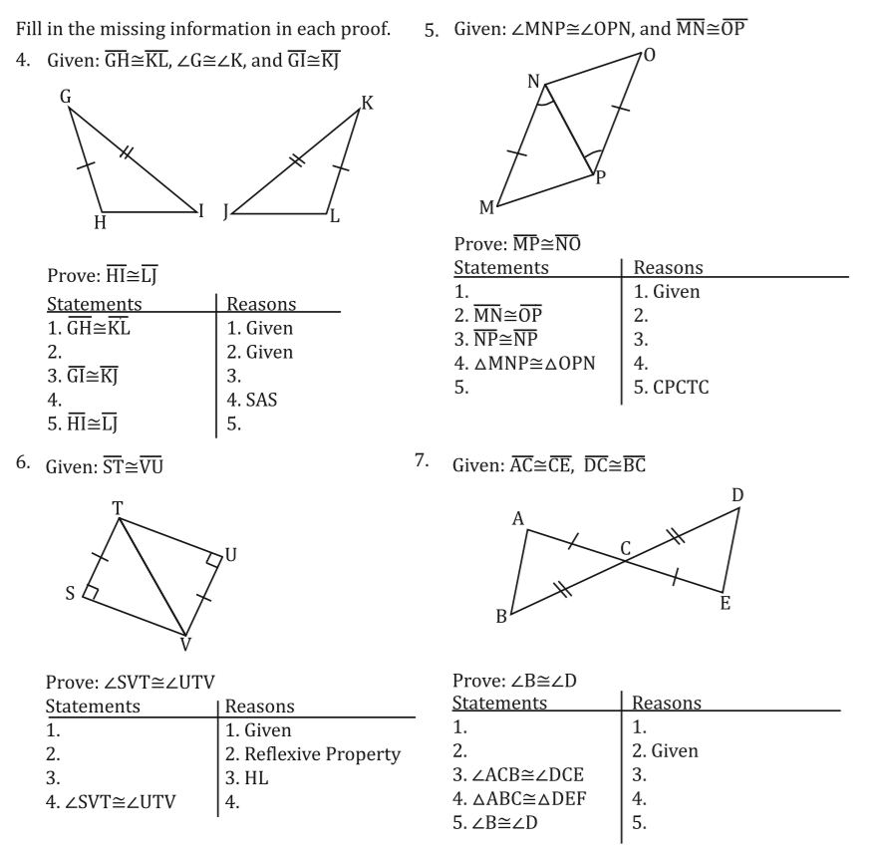
Corresponding Parts of Congruent Triangles are Congruent Worksheet

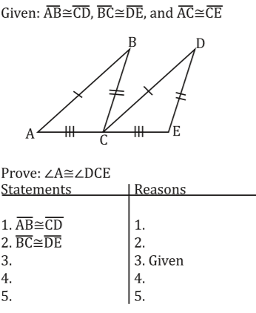
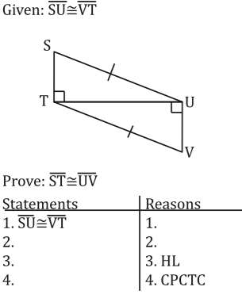

Given: Isosceles $∆PRQ$.
$\overline{RM }$ is the median of $∆PRQ$
$∠RMP≅ ∠RMQ$
Prove: Both properties of isosceles triangles.
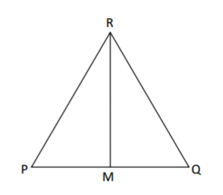

Property 1: ___________________________ Property 2: ___________________________
Proof 1: Proof 2:

