- Civil War – ____________________________
  - The war started with the secession of Southern States following the _______________ of President Abraham Lincoln and the __________ on Fort Sumter
    - __________________ – to leave; southern states seceded from the Union to form the ________________ States of America, a separate country
      - Jefferson ___________________ was the President of the Confederacy
      - States that seceded
        - Georgia
        - South Carolina
        - North Carolina
        - Virginia
        - Alabama
        - Louisiana
        - Mississippi
        - Florida
        - Texas
        - Arkansas
        - Tennessee
    - Fort Sumter
      - Military _____________ in Charleston, SC
      - Held by USA forces, until South Carolina’s soldiers fired on the fort
      - The actions at Fort Sumter sent the nation into the Civil War
  - Causes – The arguments surrounding the causes of the Civil War essentially revolve around a state’s right to determine its _______________ system and laws. The Southern economy relied on ________________________.
    - “increasing hostility on the part of the non-slaveholding States to the Institution of Slavery ...” – Declaration of the Immediate Causes Which Induce and Justify the Secession of South Carolina
    - “A House Divided”- What were the differences between the North and the South?
North:

South:

  - Key Battles
    - _______________________
      - July 1-3, 1863
      - Casualties: 46,000-51,000
      - Gettysburg Address by President Lincoln
        - “Four score and seven years ago our fathers brought forth on this continent, a new nation, conceived in Liberty, and dedicated to the proposition that all men are created equal. Now we are engaged in a great civil war, testing whether that nation, or any nation so conceived and so dedicated, can long endure. We are met on a great battle-field of that war. We have come to dedicate a portion of that field, as a final resting place for those who here gave their lives that that nation might live. It is altogether fitting and proper that we should do this. But, in a larger sense, we can not dedicate—we can not consecrate—we can not hallow—this ground. The brave men, living and dead, who struggled here, have consecrated it, far above our poor power to add or detract. The world will little note, nor long remember what we say here, but it can never forget what they did here. It is for us the living, rather, to be dedicated here to the unfinished work which they who fought here have thus far so nobly advanced. It is rather for us to be here dedicated to the great task remaining before us—that from these honored dead we take increased devotion to that cause for which they gave the last full measure of devotion—that we here highly resolve that these dead shall not have died in vain—that this nation, under God, shall have a new birth of freedom—and that government of the people, by the people, for the people, shall not perish from the earth.”
        - What founding documents come from the time period that Lincoln refers to “Four score and seven years ago”? ________________________________________________________________________________________________________________________________________________________________________________________________________________
        - What federal holidays carry the spirit of this speech? ________________________________________________________________________________________________________________________________________________________________________________________________________________________
    - _________________ – September 17, 1862
      - Battle of Sharpsburg between Lee’s Army of Northern Virginia and McClellan’s Army of the Potomac
      - Significance: first civil war battle to take place on _____________ soil – Maryland was a Union state
      - ______________________ day of the Civil War
        - 22,000 casualties
        - “Bloody Lane” and Burnside’s Bridge are two important locations in the battle
    - Bull Run/ Manassas
      - July 21, 1861
        - First land battle of the war; neither side was prepared
        - Victory for the Confederacy
        - Sometimes referred to as the ____________ Battle
          - Spectators came from Washington DC (7 hours by carriage) to watch what they thought would be the _______ skirmish of the Civil War
            - Mostly politicians and journalists fled when the battle turned extremely bloody
      - August 28-30, 1862
        - Confederate victory that opened the ________ up to a Confederate invasion
    - ___________________________
      - April 1865
      - Final battle before General Lee surrenders his army to General Grant and ends civil war
  - Emancipation Proclamation
    - Comes five days after Antietam on September 22, 1862
    - ____________________ Order from Union President Lincoln
    - Freed all slaves owned by ______________ sympathizers/states
    - ________________ sympathizing states still owned their slaves
    - Union armies were authorized to secure “__________________” - slaves that had been forced to assist the Confederacy and put them to use in Union Camps
    - Analyze the painting below by D. G. Blythe.

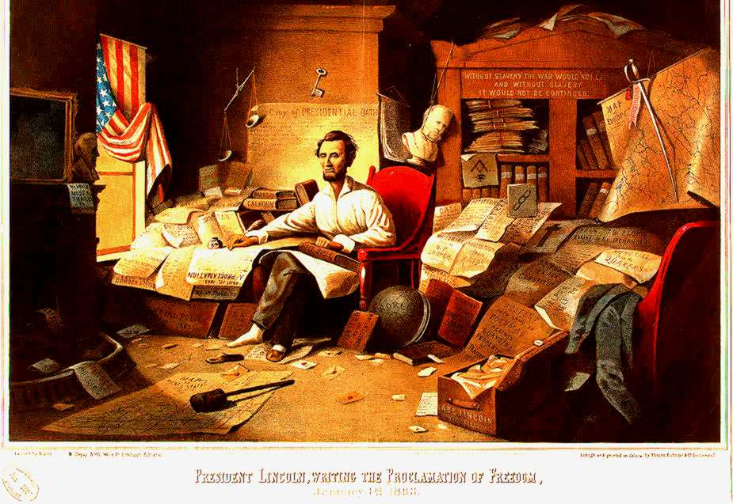
  - Generals
    - _________________
      - George T. _________________
        - General; Known for his March to the Sea (November -December 1864) In an attempt to defeat the South, Sherman took his troops from Northwest Georgia to the Atlantic and burned everything in his path to devastate the heart of the South
      - Ulysses S. __________________
        - General; accepted Lee’s surrender at Appomattox Courthouse April 9, 1865; later becomes 18th President of the USA
    - Confederacy
      - Stonewall ________________
        - General; he had been a US officer until Virginia seceded, when he flipped to the Confederacy. Played a key role in many major battles
      - Robert E. __________________
        - Head of the Confederate army; once he surrendered at Appomattox, he never wore his Confederate uniform again; his _________ flag is the flag commonly known as the Confederate Flag
- Reconstruction
  - _________________________________ – time period following the war that rebuilt the South and United States
  - Amendments
    - ____________________Amendment – ____________ slavery in America forever; extended Emancipation Proclamation; Established _________________________ Bureau to help former slaves – many remained in near-slavery through sharecropping
    - ________________ Amendment- guaranteed _____________ citizenship and rights to everyone born in US, including former slaves; was intended to block Southern States trying to discriminate; when Reconstruction Era was over, they passed laws to get around this amendment
    - ______________Amendment- guaranteed that no male could be denied the right to ______ based on “race, color, or previous condition of servitude.” Soon after Civil War, some African Americans were elected to government offices. Southern States used _____________ taxes, ______________ test to disenfranchise African Americans
  - Reconstruction Plans
    - Abraham _________________ Plan
      - Known as the ______________ plan because it only required 10% of a state’s population to swear allegiance to the Union before it could rejoin. Relatively ______________ on the South
    - ________________ Republican Plan
      - Says _____________% of each rebelling state must take oath of allegiance. Passed both chambers of Congress, ____________ by Lincoln
    - Andrew _________________________ Plan
      - Calls for state conventions to repeal _________________; eventually allows Southern States to rejoin Union; radicals felt he was too ______________
- The Death of Lincoln
  - Ford’s Theatre
    - A conspiracy to ________________ President Lincoln, Vice President Johnson, and Secretary of State Seward
    - _______________________ shot Lincoln in the theatre, jumped from the balcony where Lincoln sat, and ran.
    - ____________ by a Union soldier who was tracking him
    - Other conspirators were caught and _____________
  - Walt Whitman’s “Oh Captain, My Captain”
O Captain! my Captain! our fearful trip is done,
The ship has weather’d every rack, the prize we sought is won,
The port is near, the bells I hear, the people all exulting,
While follow eyes the steady keel, the vessel grim and daring;
But O heart! heart! heart!
O the bleeding drops of red,
Where on the deck my Captain lies,
Fallen cold and dead.
O Captain! my Captain! rise up and hear the bells;
Rise up—for you the flag is flung—for you the bugle trills,
For you bouquets and ribbon’d wreaths—for you the shores a-crowding,
For you they call, the swaying mass, their eager faces turning;
Here Captain! dear father!
This arm beneath your head!
It is some dream that on the deck,
You’ve fallen cold and dead.
My Captain does not answer, his lips are pale and still,
My father does not feel my arm, he has no pulse nor will,
The ship is anchor’d safe and sound, its voyage closed and done,
From fearful trip the victor ship comes in with object won;
Exult O shores, and ring O bells!
But I with mournful tread,
Walk the deck my Captain lies,
Fallen cold and dead.
Based on Whitman’s poem, what was the response of the people to the assassination of Abraham Lincoln?

  - Primary Source Cartoon
    - Immediately after the Civil War, there was an upswing of pride and patriotism among some Americans, especially in the North. President Lincoln’s famous “Gettysburg Address” spoke of how the war was meant to ensure that ____________ and _____________ lived on. The cartoon below was drawn by Thomas _______________ and published November 22, 1869. It endorsed the 15th Amendment and showed America’s ethnic __________________. Fill in the concerns that the various groups would have had.

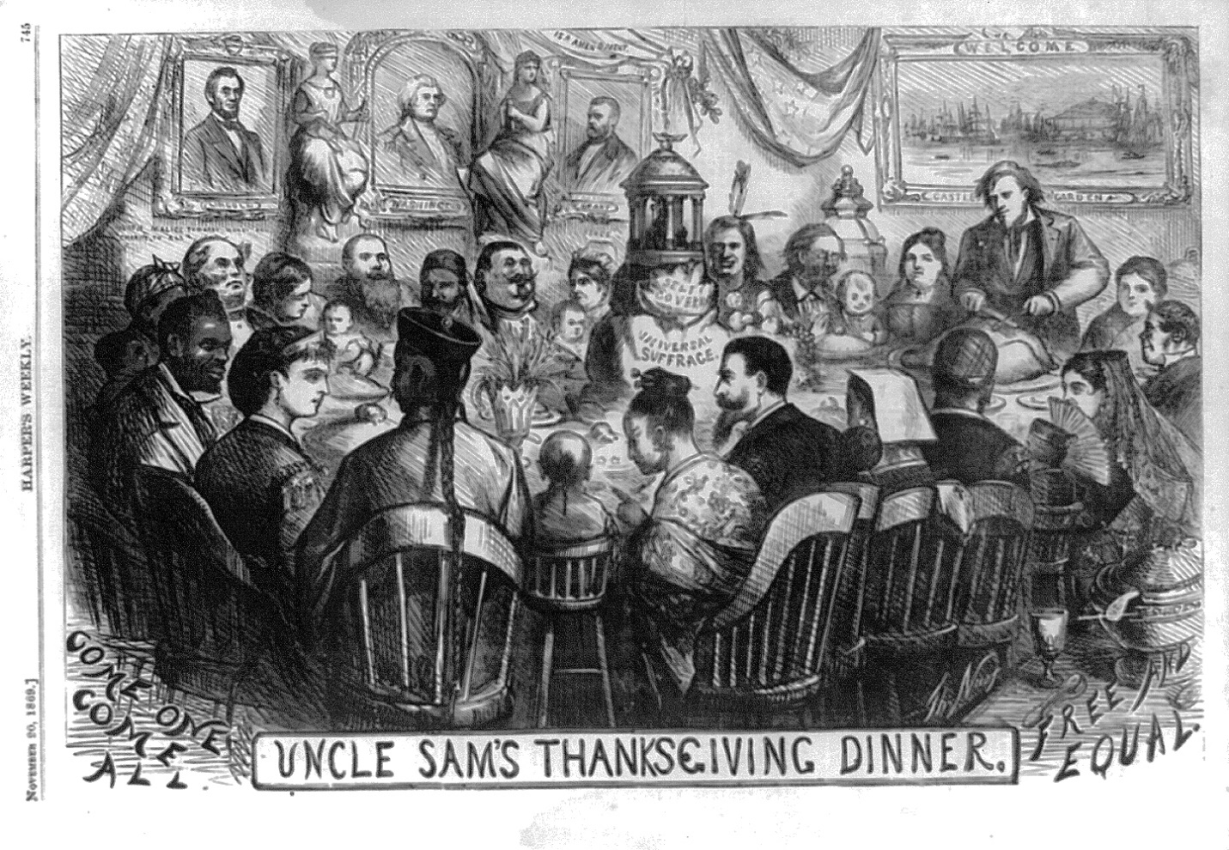
      - African Americans

      - Native Americans

      - Asian Americans

      - Women

USE THE ARTICLE BELOW TO COMPLETE THE VENN DIAGRAM AND TABLE
Carpetbaggers v Scalawags
Carpetbaggers Effect on the South Scalawags
I
I
I
I
I
CARPETBAGGERS & SCALAWAGS
During and immediately after the Civil War, many northerners headed to the southern states, driven by hopes of economic gain, a desire to work on behalf of the newly emancipated slaves or a combination of both. These “carpetbaggers”–whom many in the South viewed as opportunists looking to exploit and profit from the region’s misfortunes–supported the Republican Party, and would play a central role in shaping new southern governments during Reconstruction. In addition to carpetbaggers and freed African Americans, the majority of Republican support in the South came from white southerners who for various reasons saw more of an advantage in backing the policies of Reconstruction than in opposing them. Critics referred derisively to these southerners as “scalawags.”
REPUBLICAN RULE IN THE SOUTH
In the two years following the assassination of President Abraham Lincoln and the end of the Civil War in April 1865, Lincoln’s successor Andrew Johnson angered many northerners and Republican members of Congress with his conciliatory policies towards the defeated South. Freed African Americans had no role in politics, and the new southern legislatures even passed “black codes” restricting their freedom and forcing them into repressive labor situations, a development they strongly resisted. In the congressional elections of 1866, northern voters rejected Johnson’s view of Reconstruction and handed a major victory to the so-called Radical Republicans, who now took control of Reconstruction.
Did You Know? African Americans made up the overwhelming majority of southern Republican voters during Reconstruction. Beginning in 1867, they formed a coalition with carpetbaggers (one-sixth of the electorate) and scalawags (one-fifth) to gain control of southern state legislatures for the Republican Party.
Congress’ passage of the Reconstruction Acts of 1867 marked the beginning of the Radical Reconstruction period, which would last for the next decade. That legislation divided the South into five military districts and outlined how new state governments based on universal (male) suffrage–for both whites and blacks–were to be organized. The new state legislatures formed in 1867-69 reflected the revolutionary changes brought about by the Civil War and emancipation: For the first time, blacks and whites stood together in political life. In general, the southern state governments formed during this period of Reconstruction represented a coalition of African Americans, recently arrived northern whites (“carpetbaggers”) and southern white Republicans (“scalawags”).
CARPETBAGGERS
In general, the term “carpetbagger” refers to a traveler who arrives in a new region with only a satchel (or carpetbag) of possessions, and who attempts to profit from or gain control over his new surroundings, often against the will or consent of the original inhabitants. After 1865, a number of northerners moved to the South to purchase land, lease plantations or partner with down-and-out planters in the hopes of making money from cotton. At first, they were welcomed, as southerners saw the need for northern capital and investment to get the devastated region back on its feet. They later became an object of much scorn, as many southerners saw them as low-class and opportunistic newcomers seeking to get rich on their misfortune.
In reality, most Reconstruction-era carpetbaggers were well-educated members of the middle class; they worked as teachers, merchants, journalists or other types of businessmen, or at the Freedman’s Bureau, an organization created by Congress to provide aid for newly liberated black Americans. Many were former Union soldiers. In addition to economic motives, a good number of carpetbaggers saw themselves as reformers and wanted to shape the postwar South in the image of the North, which they considered to be a more advanced society. Though some carpetbaggers undoubtedly lived up to their reputation as corrupt opportunists, many were motivated by a genuine desire for reform and concern for the civil and political rights of freed blacks.
SCALAWAGS
White southern Republicans, known to their enemies as “scalawags,” made up the biggest group of delegates to the Radical Reconstruction-era legislatures. Some scalawags were established planters (mostly in the Deep South) who thought that whites should recognize blacks’ civil and political rights while still retaining control of political and economic life. Many were former Whigs (conservatives) who saw the Republicans as the successors to their old party. The majority of the scalawags were non-slaveholding small farmers as well as merchants, artisans and other professionals who had remained loyal to the Union during the Civil War. Many lived in the northern states of the region, and a number had either served in the Union Army or been imprisoned for Union sympathies. Though they differed in their views on race—many had strong anti-black attitudes—these men wanted to keep the hated “rebels” from regaining power in the postwar South; they also sought to develop the region’s economy and ensure the survival of its debt-ridden small farms.
The term scalawag was originally used as far back as the 1840s to describe a farm animal of little value; it later came to refer to a worthless person. For opponents of Reconstruction, scalawags were even lower on the scale of humanity than carpetbaggers, as they were viewed as traitors to the South. Scalawags had diverse backgrounds and motives, but all of them shared the belief that they could achieve greater advancement in a Republican South than they could by opposing Reconstruction. Taken together, scalawags made up roughly 20 percent of the white electorate and wielded a considerable influence. Many also had political experience from before the war, either as members of Congress or as judges or local officials.

THE COMPROMISE OF 1877
Directions: The presidential election of 1876 was one of the closest in history. The ensuing Compromise of 1877 brought about the end of Reconstruction. Read about the election and compromise below and complete the graphic organizer.
Election of 1876
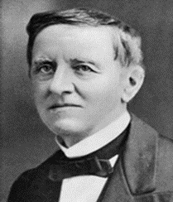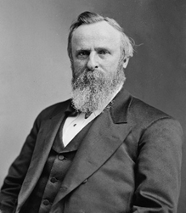
Democratic Candidate: Republican Candidate:

Supported by: Supported by:

Initial Results of the Election:

The Compromise of 1877
Winner/New President? ________________________
What deal was made?

How did this affect the South?

Do you feel this was a good deal for both sides? What about for America as a whole? Explain.

Hayes-Tilden Election (1876)
In 1876, the two major candidates running for President were Rutherford B. Hayes, a Republican, and Samuel J. Tilden, a Democrat. The first returned indicated a victory for Tilden, who had won the popular vote with 4,284,020 votes to Hayes’s 4,036,572. But Tilden’s 184 electoral votes – the votes that would decide the Presidency – were still one short of a majority, while Hayes’s 165 electoral votes left him 20 ballots away. The votes of three Southern States and one Western state still had not been counted. The 20 electoral votes remaining in dispute were one from Oregon and 19 from the three Southern States that still retained Republican controlled electoral boards – Florida (4), Louisiana (8), and South Carolina (7). What complicated the matter was that Democrats in these states had won the state elections, mostly by violence and fraud. Both parties claimed victory. The Republicans, who still held a majority on the electoral boards that would certify the election results, claimed that Hayes was elected because the Democrats used fraud, violence, and intimidation in the Southern States. They “threw out” enough Democratic votes for Hayes to win in all three states. The Democrats submitted their own list for Tilden. In Oregon, Hayes had clearly won but the Democratic governor had managed to confuse things by sending one elector in Tilden’s favor. The conflict raged because the Constitution did not provide for a way of resolving the dispute.
The electoral college controversy would drag on for months, not reaching resolution until almost the eve of the scheduled inauguration on March 5, 1877. To break the deadlock, Congress appointed an Electoral Commission, made up of five Senators, five members of the House of Representatives, and five Supreme Court justices. Congress originally hoped to have seven Republican members of the Commission, seven Democrats, and one Independent. As it turned out, however, the actual membership turned out to consist of eight Republicans, and seven democrats. The commission voted along straight party lines 8 to 7 to accept all of Hayes’s electoral votes and reject the Democrats’ claims. The night before President Grant’s term expired, the Senate announced Hayes had been elected President. The deadlock was broken behind closed doors when Southern Democrats agreed to support Hayes’s claim for the Presidency if he would support increased funding for Southern internal improvements and agree to end Reconstruction, thus guaranteeing home rule – meaning white control – in the South. Hayes became President and the Southern Democrats could reverse with impunity the gains that African Americans had made during Reconstruction.

