Name: _____________________________________________________ Date: ____________
Dilations Notes Day 2
Warm-Up:
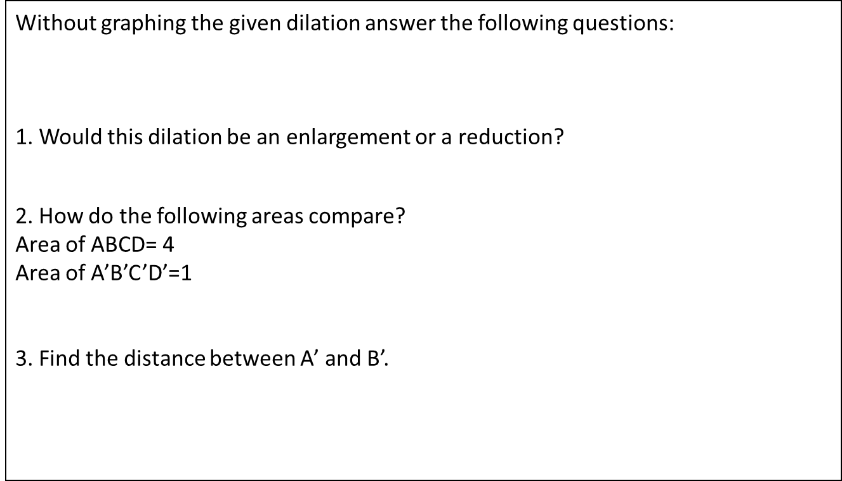

Given the point and its image, determine the scale factor:
A(3,6) A’(9, 18)

G’(3,6) G(1.5,3)

B(8,6) B’(2,1.5)

State whether the following is an enlargement or Exit Ticket:
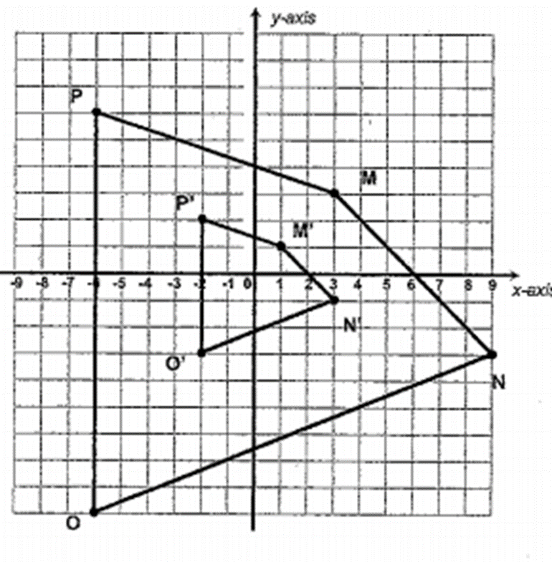
reduction and find the scale factor. 1.
2.
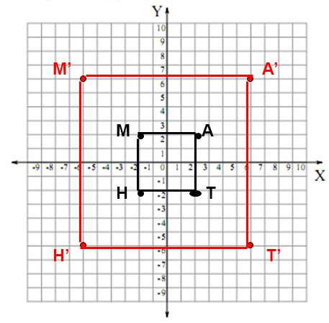
3 3.

Dilate the following triangle using a scale factor of 1/3 and a scale factor of 1.5

