Name: ________________________________________________________ Date: ________
Dilations Worksheet
Given a square with vertices A (2, 2) B (4, 2) C (4, 4) D (2, 4). Dilate square ABCD using a scale factor of 2.
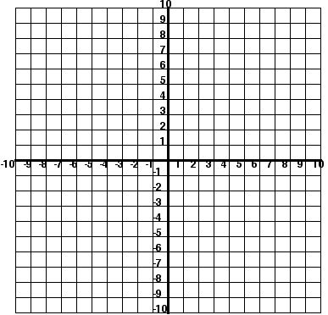1. What is the area of your original square?

2. What is the area of the new square?

3. How do these areas compare?

Given a square with vertices A (3, 6) B (-6, 6) C (-6, -3) D (3, -3). Dilate ABCD using a scale factor of $\frac{1}{3}$.
4. What is the area of your original square?

5. What is the area of the new square?

6. How do these areas compare?

