Name: ________________________________________________________ Date: ________
Dilations Worksheet
State whether the dilation with the given scale factor is a reduction or an enlargement.
1. $k=3$ 2. $k=\frac{1}{3}$ 3. $k=\frac{5}{4}$ 4. $k=0.93$

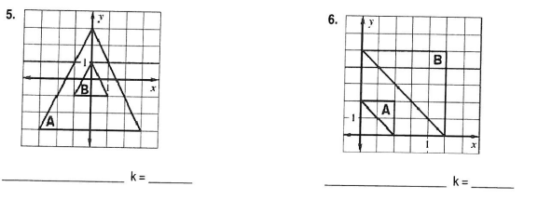
Determine whether the dilation from figure A to figure B is a reduction or enlargement. Then find its
scale factor.
5. 6.

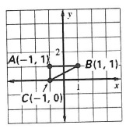
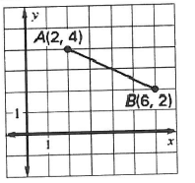
Draw a dilation of the figure using the given scale factor.
7. $k=\frac{1}{2}$ 8. $k=3$

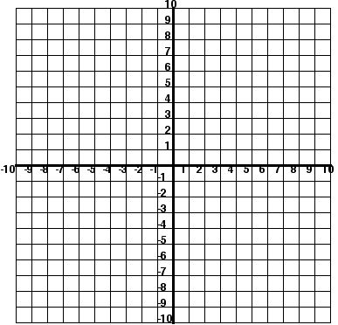
9. Given a square with vertices A (3, 6) B (-6, 6) C (-6, -3) D (3, -3). Dilate ABCD using a scale factor of $\frac{2}{3}$.
Graph the dilation, then write a sentence
explaining how the areas compare.

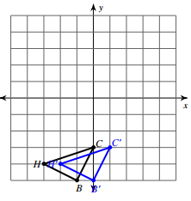
For the following, identify the type of transformation and write the rule.
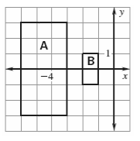
10. 11.

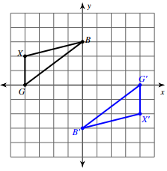
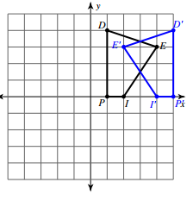
12. 13.

For the following graph the image of the figure using the transformation given.
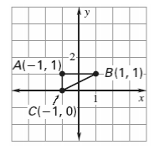
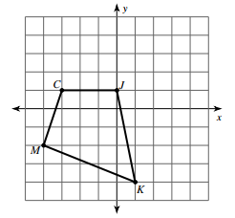
14. Reflection across the line $y=x$ 15. Rotate 90° CCW

17. $\left(x,y\right)→(x+4, y-1)$ 18. Dilate $k=4$

