Name: _________________________________________________ Date: _____________________
Distance Formula Mall Project
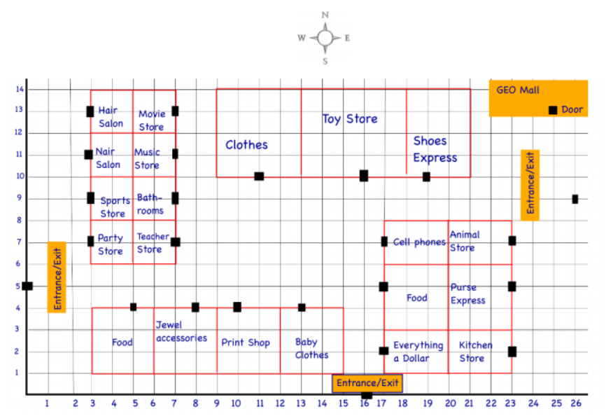
Travis and Janelle want to take a trip to the mall to buy a toy for a friend who is moving. However, they have a very short time to shop for their friend. Janelle printed a layout of the mall to map out their route. Use the map to answer the following questions. Show all computations that lead up to your solutions.

Janelle wants to not only go to the toy store, but wants to stop at a couple other stores. She goes to the mall before Travis to meet up with him later. Janelle goes to the animal store and is looking around for a while, when Travis calls to make arrangements to meet.
- Janelle isn’t done at the Animal Store yet, so Travis plans to meet her there. However, he parked on the west side of the mall and must use the West entrance. From the entrance, what is the shortest distance Travis would have to walk?

- After meeting at the Animal Store, they decided to go to the Clothes store. How far must they walk to get to the Clothes store?

- From the Clothes store, Travis and Janelle decide to get some food before shopping for a toy. They couldn’t decide what they wanted to eat so they decide to go to the closest Food place. Which Food store is the closest? Justify your answer using mathematics.

- Travis then exits from the West entrance. Find the total distance Travis walked between the entrances and the stores during his visit to the mall.

- Create your own trip to the mall. Pick one entrance to enter and leave from. You must stop at a minimum of 3 locations that were not visited by Travis. Draw out your path on the given map.
Calculate the total distance of your trip.

- Entrance: ____________________

- Location 1: ___________________

- Location 2: ___________________

- Location 3: ___________________

- Exit: _________________________

Additional Locations:

- Total: ____________________

