Name: _____________________________________________ Date: ______________
Distance Formula Worksheet
- Find the length of the line segment whose endpoints are $\left(-8,7\right)$ and $(6,4)$.

- Find the distance between the points $(3,5)$ and $(12,2)$.

- The point $(-3,-6)$ lies on a circle. What is the length of the radius of this circle if the center is located at $(9,-2)$.

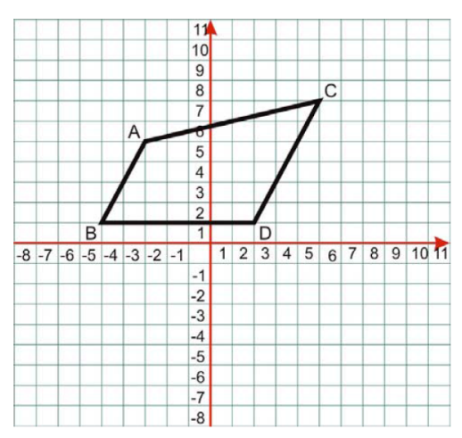
Use the following diagram for problems 4-7
- Find the distance of line segment $AC$.

- Find the length of line segment $AB$.

- Find the distance of line segment $BD$.

- Find the length of line segment $BC$.
Cumulative Review

Set up and solve an equation to solve for the given variable. Justify your equation.
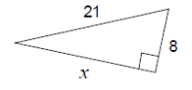
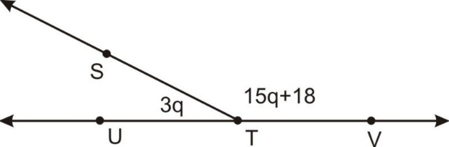

- Given: AC = 39 m
.
A
B
2x-8
x+17
C

