DNA Replication Notes: Honors
- DNA Replication is the process where DNA is copied producing two identical daughters from one parent. Each of the two original parental strands serve as templates for 2 new or daughter strands.
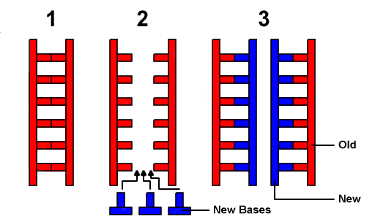
- DNA replication is necessary for growth and repair of an organism’s cells.
- Steps in DNA Replication:
- DNA breaks apart with the help of the enzyme helicase which breaks the hydrogen bonds between the strands of DNA causing it to unwind.
- Free floating DNA nucleotides form complimentary base pairs to each of the original strands of DNA with the help of the enzyme DNA Polymerase III
  - DNA can only be copied in one direction 3’ 5’, so the two strands must be copied differently.
    - The Leading strand (3’5’) is copied in one continuous strand.
      - DNA Polymerase III moves down the strand (toward helicase) and forms complementary base pairs to the original strand.
    - The Lagging strand (5’3’) is copied discontinuously in segments called Okazaki Fragments.
      - RNA primase adds a RNA primer (on the end of the strand closest to helicase and the replication fork) and then DNA polymerase III works in the correct direction (3’5’).
      - DNA polymerase I then replaces the RNA primer.
      - DNA Ligase joins each of the segments to form one strand of DNA that is complementary to the original strand.

