Ecological Succession Name __________________________________
A)Ecological succession - Bozeman Science
1. Succession is a series of steps by which _________________________________________________________.
2.Succession occurs at a _______________________rate.
3.Primary succession starts with ____________________________________.
4.In secondary succession the _______________________ remains.
5.The first organisms to colonize an area are _______________________ species.
6.Two examples are _______________________ and _________________________________.
7.What adaptation allows the lodgepole pine to colonize the area?

8. The final stage of succession is the ___________________________community.
Forest Succession:
1.bare rock
2.mosses
3. ________________
4. shrubs
5.fast growing trees
6.mature forest

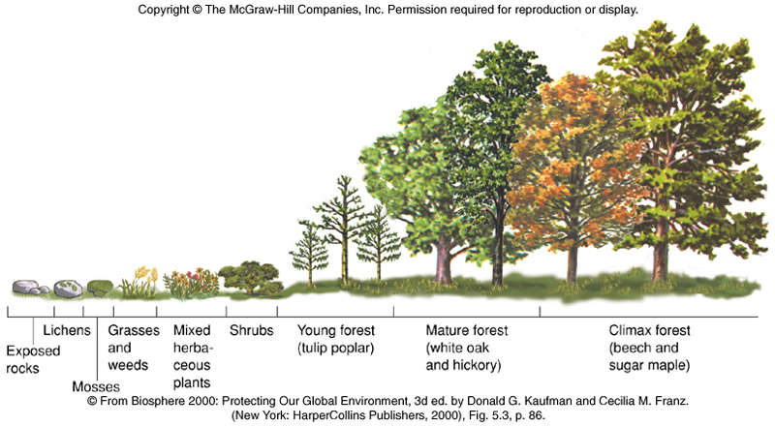

B)Stages of Primary Succession on a Lava Flow

Stage 1 ____________________________________________

Stage 2 _____________________________________________

Stage 3 _____________________________________________

Stage 4 _____________________________________________

C)Primary vs Secondary Succession

1.What is the main feature of Primary Succession? _______________________________________

2.The first organisms to colonize an area are _______________________ species.
3.Two examples are _______________________ and _________________________________.
4.There are 3 steps to soil formation:
- Lichens create soil by secreting ____________________________________

- Rocks are worn down by _________________________and _______________________________

- Mosses and lichens ____________________________________________________

5.Secondary succession occurs after ______________________________________________.
6.Two examples are ___________________________and __________________________________.
7.Why is secondary succession faster than primary succession?

8.What is the main difference between primary and secondary succession?

