Name:_________________________
Ecology SGI Quiz #1 Study Guide
- Define Each of the Following:
  - Carnivore
  - Omnivore
  - Herbivore
  - Producer
  - Consumer
  - Decomposer
  - Abiotic Factor
  - Biotic Factor
  - Population
  - Ecosystem
  - Invasive Species
- Competition exists between organisms in an ecosystem. Identify factors within an ecosystem that would promote competition.

- What service does a decomposer provide to an ecosystem?

- Describe the Tragedy of the Commons.

- Identify factors that define a biome. List the biomes that we’ve discussed in class.

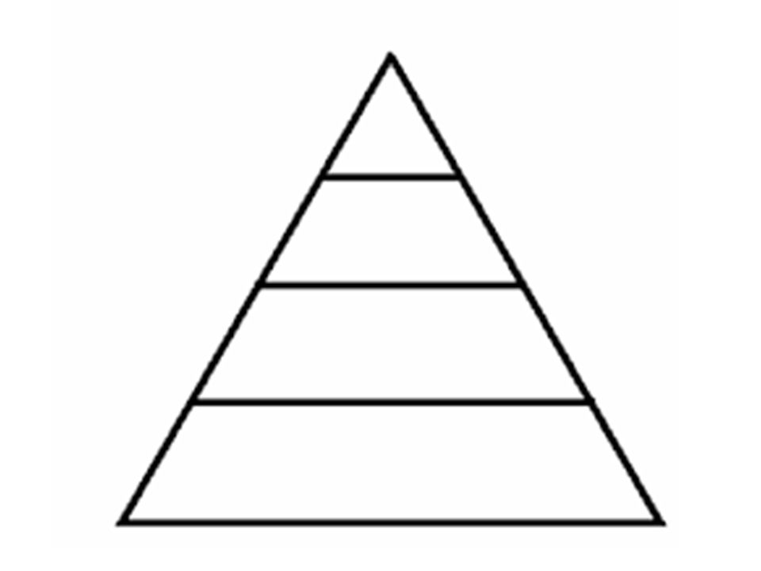
- Use the following information to complete the Trophic Level Pyramid above.

- Producer, Primary, Secondary, and Tertiary.
- Illustrate the 10% Rule. How does this determine the number of organisms found on each level? Provide an example.
- Explain/Illustrate how energy enters the 1st trophic level and then travels up through the additional trophic levels.

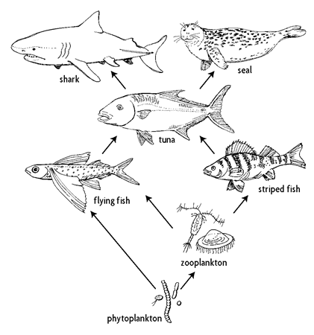
- Use the above diagram to answer the following questions
  - Identify short term effects on this ecosystem if phytoplankton decreased.

  - Identify long term effects on this ecosystem if phytoplankton decreased.

  - Identify the producer/s in this ecosystem.

  - Identify the primary, secondary, and tertiary consumers in this ecosystem.

- How can human activity decrease Biodiversity.

