The Living Earth

How is Earth different from the other planets in the solar system? One difference is that Earth supports living organisms! The part of Earth with life is called the biosphere. The biosphere includes the top part of the crust, the oceans, and the atmosphere.
The biosphere is made of many different environments. The environments on Earth are home to many different kinds of organisms. For example, the Rio Grande Valley receives very little rain. Cacti, lizard, coyotes, javelinas and many other organisms live in this type of environment. On the other hand, rain forests receive plenty of rain. Parrots, monkeys, large trees, and thousands of others live in the
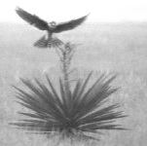
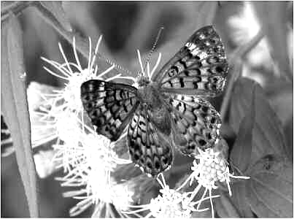
rain forest. There are many other environments all over the world.
If you visit Laguna Atascosa National Wildlife Refuge, you
might see something like the pictures. A hawk lands on a plant. The
hawk lives off of snakes in the grass. A butterfly pollinates the plant.
These pictures are part of an ecosystem. An ecosystem includes all of
the living and non-living things in an area. In the pictures, the plant,
hawk, butterfly, water, sunlight, soil and air are all part of the desert
ecosystem. Ecology is the study of how organisms and non-living things interact in an environment. Ecologist are scientists who study ecosystems.
Imagine you are an ecologist. You might study how cougars move from place to place and how they care for their young. You would be studying the members of a population. A population is made of all the
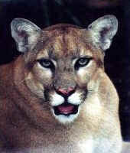
organisms in an ecosystem that are from the same species (the same type of organism). For example, all the hawks in Laguna Atascosa make up one population. All the monarch butterflies make up another population. All the border lilies make up yet another population.
Another ecologist might be studying how butterflies pollinate border lilies. Another ecologist might be studying how the snake population reacts to an increase in the hawk population. These ecologists are studying how different populations interact. They are studying a community. A community is made of all the populations in an ecosystem. This means that it includes all living organisms in the ecosystem. A rainforest community would include all the parrots, monkeys, trees, and other living organisms in the rainforest. An arctic community might include populations of fish, seals that eat the fish, and polar bears that eat the seals.
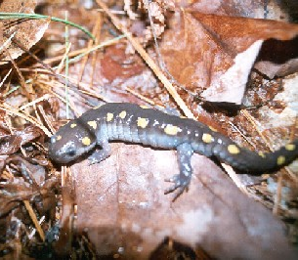
Every organism in an ecosystem needs a place to live. The place where an
organism lives is its habitat. The salamander in the picture is in its habitat.
Salamanders avoid sunlight and seek damp, dark places. They eat worms, insects,
and slugs. An organism’s habitat provides food, shelter, and the appropriate amount
of heat and moisture.
Name___________________
Date____________________
The Living Earth
Directions: Use the reading to answer the questions below.

- The biosphere is ____________________________________________________________.
- An ecosystem is ____________________________________________________________.
- Ecology is _________________________________________________________________.
- A population is _____________________________________________________________.
- A community is ____________________________________________________________.
- A habitat is ________________________________________________________________.
- What is the difference between a community and a population? _________________________
____________________________________________________________________________
- Give one example of a community: _______________________________________________
____________________________________________________________________________
- Give one example of a population: _______________________________________________
____________________________________________________________________________
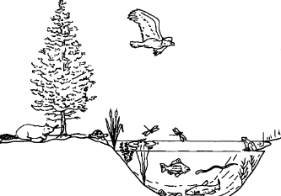
- Look at the picture. List ALL the populations
you see in the picture.

- Look at the picture. Describe one interaction that might occur between populations.

- Look at the picture. What things are NOT part of the community?

- Look at the picture. What is the snake’s habitat?

Interactions in Ecosystems

How does an eagle affect a snake? How does a deer affect grass? You might answer that eagles eat snakes, and deer eat grass. All living things have to get their food somehow. You’ve learned that plants make their own food in a process called photosynthesis. In comparison, animals have to get their food by eating other living things. Living things that make their own food are called producers. All plants, some bacteria, and some protists are producers. Organisms that get their food from other living things are consumers. All animals, all fungi, some bacteria, and some protists are consumers.
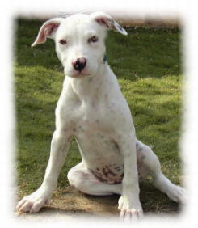
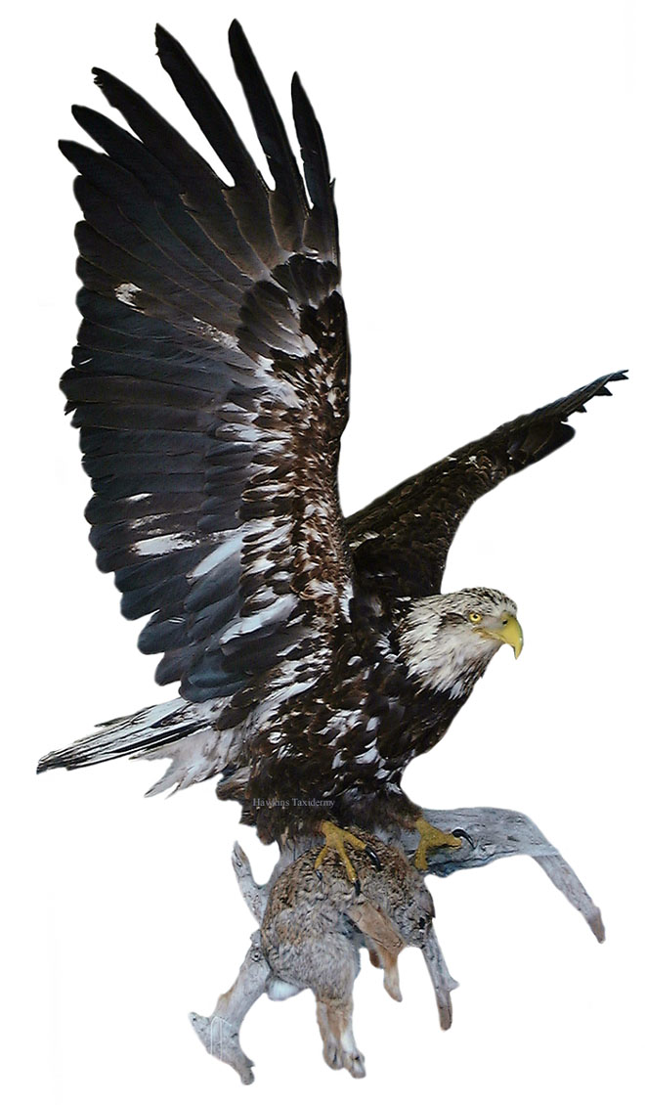
Producers and consumers interact, or affect one another, in complicated ways. When you think about the savannah in Africa, you might imagine a gazelle running away from a lion. This is a predator-prey relationship. The predator is a consumer that captures and eats another consumer. The prey is the consumer that gets eaten. When you think of how organisms interact, you probably think of predator-prey relationships. However, there are many other ways that organisms affect each other! A close relationship between two species is called symbiosis. There are three types of symbiosis: parasitism, commensalism, and mutualism.
If you have a dog or cat, it may have gotten worms at some point. Worms attach themselves to your pet’s intestines and eat its food. When a puppy gets worms it can get bad pain, diarrhea, and may die. This type of relationship is called parasitism. Parasitism is when one organism benefits but the other is harmed.
If you have ever watched small birds, you may have seen them hide in bushes. They fly out to get their food, and then return to the bush to hide from predators. In this situation, the birds are benefiting from the bushes. The bushes are not helped or hurt. A symbiosis where one organism benefits and the other are not affected is called commensalism.
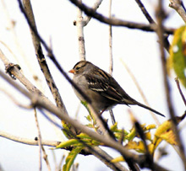
Your body cannot digest most of your food on its own! There are lots and lots of bacteria that live in your intestines. The bacteria get their food from the food that your body can’t eat. Then, they turn it into food your body can digest. This type of symbiosis is called mutualism. Mutualism is when both organisms benefit.
All of the relationships between different organisms and non-living things combine to create an ecosystem. Each species has its own place in the ecosystem. This place is called a niche. A species’ niche includes how the species survives, how it gets food and shelter, how it reproduces, and how it stays safe.

Food webs show direct relationships in ecosystems, like predator-prey relationships.
They DO NOT show symbioses.

To read the food web: The arrows show what each organism eats and the flow of energy. The arrow points to the organism that does the eating and who GETS the energy. Ex: the snowy owl eats the artic hare and the lemming. The owl gets its energy from the hare and the lemming.

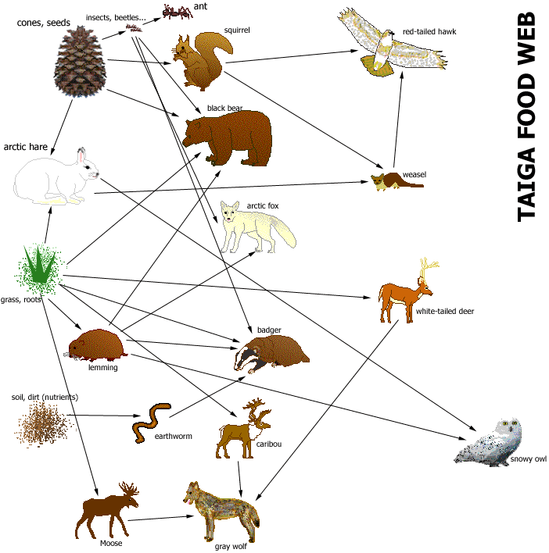

Bacteria, dead organisms in soil

Decomposer—Organism that gets food by breaking down dead organisms into small molecules.
Herbivores—An organism that eats only plants.
Carnivore—An organism that eats only other animals.
Omnivore—An organism that eats both plants and animals.

Name_________________________
Date____________________

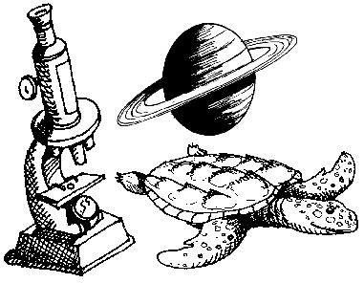
Interactions in Ecosystems

DIRECTIONS: Use the reading and your prior knowledge to answer the questions.

- A producer is ________________________________________________________________.
- A consumer is ________________________________________________________________.
- A predator-prey relationship is ___________________________________________________.
- Symbiosis is _________________________________________________________________.
- Parasitism is _________________________________________________________________.
- Commensalism is _____________________________________________________________.
- Mutualism is _________________________________________________________________.
- A niche is ___________________________________________________________________.
- What are the three types of symbiosis?
________________________ _______________________ __________________________
- Mosquitoes get their food by sucking other animal’s blood, sometimes giving it disease. What type of symbiosis is this? _____________________________________________________
- Lichens are crusty things that grow on trees and rocks. They are a combination of two organisms. One is a fungus and the other is a bacteria. The bacteria do photosynthesis and makes food for itself and for the fungus. The fungus provides protection for the bacteria. What type of symbiosis is this? ___________________________________________________
- Sea anemones have long, stinging tentacles. Clown fish are bright fish that live in coral reefs and are not harmed by anemone stings. They hide in the tentacles of anemones without harming the anemones. What type of symbiosis is this? ______________________________
- Weasels eat arctic hares. Which is the predator? _____________________________________
- Gray wolves eat caribou. Which is the prey? ________________________________________
Name_________________________
Date____________________

Reading a Food Web
DIRECTIONS: Use the “Taiga Food Web” to answer the questions.
- Badgers eat __________________________________________________________________.
- Wolves eat __________________________________________________________________.
- Bears eat ____________________________________________________________________.
- Owls eat ____________________________________________________________________.
- Deer eat ____________________________________________________________________.
- Ants eat _____________________________________________________________________.
- Categorize ALL the organisms in the food web. Use the definitions to help.
Decomposer Herbivore Carnivore Omnivore
Squirrel

- Cones and seeds get eaten by ____________________________________________________.
- Weasels get eaten by __________________________________________________________.
- Lemmings get eaten by ________________________________________________________.
- Moose get eaten by ____________________________________________________________.
- Predict what would happen to the ecosystem if all the insects and beetles died.
The number of ants would ___________________________________________________.
The number of seeds and cones would __________________________________________.
The number of bears would __________________________________________________.
- Predict what would happen to the ecosystem if all the black bears died.
______________________________________________________________________________
_______________________________________________________________________________
_______________________________________________________________________________
_______________________________________________________________________________
Name________________
Date____________

Ecology Quiz

Directions: Use the chart below to answer the questions.
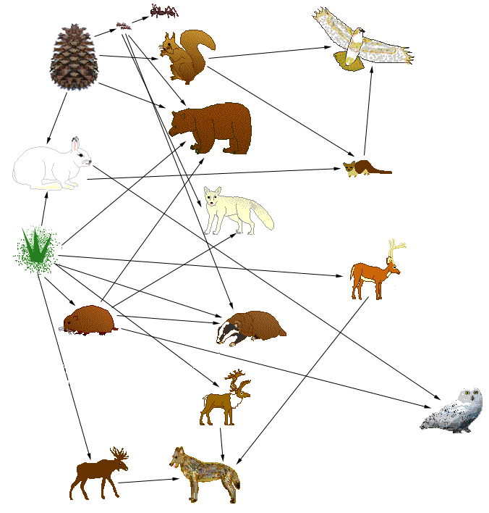
cones, seeds insects ant
squirrel hawk

bear
rabbit
weasel

fox

grass
badger deer

lemmings

caribou

snowy owl

moose wolf

- What is this chart called? ______________________________________________________
- List everything the wolf eats: ___________________________________________________
- List all the producers: _________________________________________________________
- List all the herbivores: ________________________________________________________
- List all the omnivores: ________________________________________________________
- List all the carnivores: ________________________________________________________
- What would happen to lemmings if all the grass disappeared? _________________________
- What would happen to hawks if all the weasels disappeared? _________________________
___________________________________________________________________________
- What would happen to hawks if rabbits disappeared? ________________________________
___________________________________________________________________________
Directions: Match the vocabulary word to its definition.
- ______ Ecology A. An organism’s environment
- ______ Consumer B. An animal that eats both plants and animals
- ______ Symbiosis C. The study of how living and non-living things interact
- ______ Herbivore D. Relationship where both species benefit
- ______ Habitat E. An animal that eats only plants
- ______ Commensalism F. A close relationship between two organisms
- ______ Omnivore G. Relationship where 1 benefits and the other is unaffected
- ______ Mutualisms H. An organism that eats other organisms
Directions: Label the pictures as ecosystem, community, organism, population.
- Label the pictures as ecosystem, community, organism, population in the blanks.
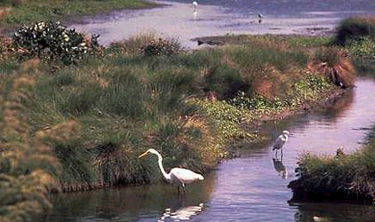
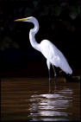

_______________________
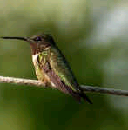

_________________
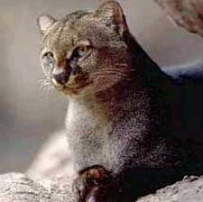
______________
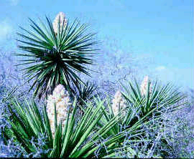

________________________
Directions: Answer the questions below.
- Explain the three types of symbiosis. ____________________________________________
___________________________________________________________________________
___________________________________________________________________________
___________________________________________________________________________

- List the levels of ecological organization in order from smallest to largest._______________
___________________________________________________________________________

