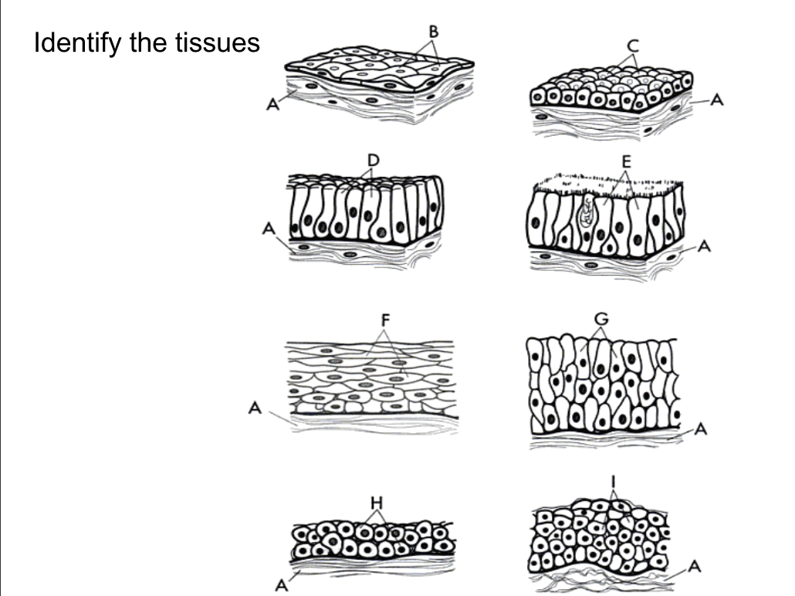

A.

B.

C.

D.

E.

F.

G.

H.

I.

[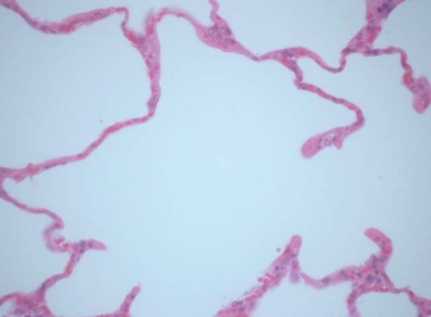](http://www.google.com/url?sa=i&rct=j&q=&esrc=s&frm=1&source=images&cd=&cad=rja&docid=VZmmdIjKjm_0SM&tbnid=DfkDsLHngPQ-WM:&ved=0CAUQjRw&url=http%3A%2F%2Fwww.dorenarode.com%2Fanatomy%2Fopenlab.htm&ei=Oo1lUsXtB9ep4AOi_IGgAw&bvm=bv.54934254,d.dmg&psig=AFQjCNEPp8rtVPEt0O7wBV4_rixBKxIS1g&ust=1382473337102574) [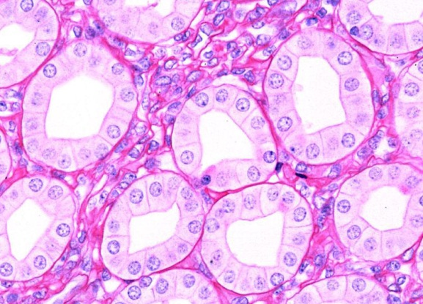](http://www.google.com/url?sa=i&rct=j&q=&esrc=s&frm=1&source=images&cd=&cad=rja&docid=TIPPZWV7wpElDM&tbnid=1oD81SlbWHNafM:&ved=0CAUQjRw&url=http%3A%2F%2Fmedcell.med.yale.edu%2Fsystems_cell_biology%2Fepithelium%2Fsimple_cuboidal.php&ei=fI1lUs3ZBO784APv2oDIDg&bvm=bv.54934254,d.dmg&psig=AFQjCNEPp8rtVPEt0O7wBV4_rixBKxIS1g&ust=1382473337102574)

[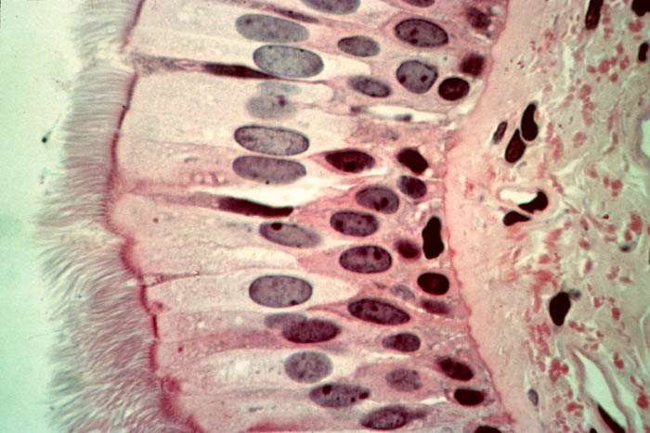](http://www.google.com/url?sa=i&rct=j&q=&esrc=s&frm=1&source=images&cd=&cad=rja&docid=zzo5U1wNvNEXtM&tbnid=MX0RRUBmo4fC2M:&ved=0CAUQjRw&url=http%3A%2F%2Fwww.stegen.k12.mo.us%2Ftchrpges%2Fsghs%2Fksulkowski%2FTissueSlides.htm&ei=mY1lUvy-K8_54APfsoGIAw&bvm=bv.54934254,d.dmg&psig=AFQjCNEPp8rtVPEt0O7wBV4_rixBKxIS1g&ust=1382473337102574) [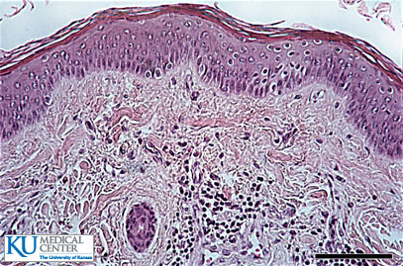](http://www.google.com/url?sa=i&rct=j&q=&esrc=s&frm=1&source=images&cd=&cad=rja&docid=UgCKWuYn1SfqWM&tbnid=Eg1e5AeXp9XtqM:&ved=0CAUQjRw&url=http%3A%2F%2Fwww.kumc.edu%2Finstruction%2Fmedicine%2Fanatomy%2Fhistoweb%2Fepithel%2Fepith14.htm&ei=Mo5lUobkJNWo4APW94GYCw&bvm=bv.54934254,d.dmg&psig=AFQjCNG1nIQe3IP77k3GEcOsnBpjvyE3yA&ust=1382473627723483)

[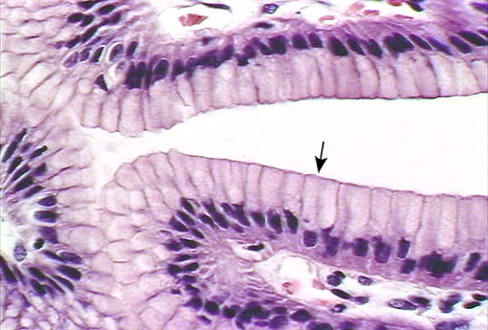](http://www.google.com/url?sa=i&rct=j&q=&esrc=s&frm=1&source=images&cd=&cad=rja&docid=6xXN7_kvfkqgnM&tbnid=tk_HOETTuHqM3M:&ved=0CAUQjRw&url=http%3A%2F%2Fcytochemistry.net%2Fcell-biology%2Fmedical%2Fpractice_lab_exam_epithelium.htm&ei=5Y1lUtfSC-3E4AORy4DgAQ&bvm=bv.54934254,d.dmg&psig=AFQjCNEPp8rtVPEt0O7wBV4_rixBKxIS1g&ust=1382473337102574) [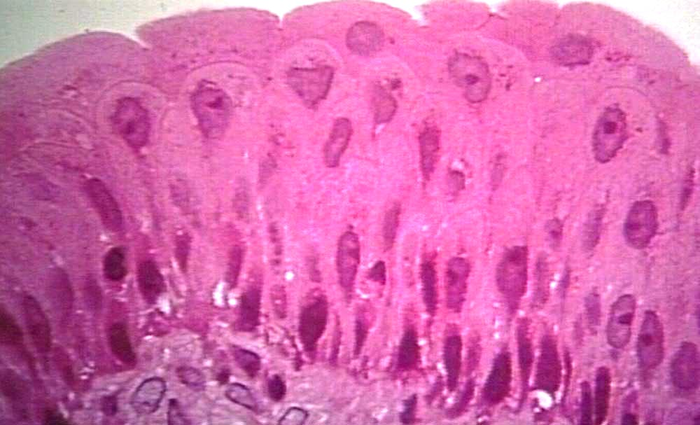](http://www.google.com/url?sa=i&rct=j&q=&esrc=s&frm=1&source=images&cd=&cad=rja&docid=9NZLSu-cq5n6mM&tbnid=OnKMhuJeKEl94M:&ved=0CAUQjRw&url=http%3A%2F%2Fwww.pathguy.com%2Flectures%2Fbladder.htm&ei=fI5lUqqqMqL-4AOpxoHwBQ&bvm=bv.54934254,d.dmg&psig=AFQjCNGZHa3311hZUReYMyBQiqZLro9O_g&ust=1382473693103110)

[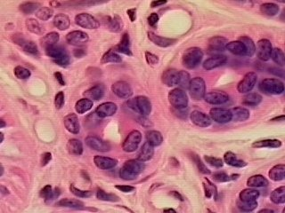](http://www.google.com/url?sa=i&rct=j&q=&esrc=s&frm=1&source=images&cd=&cad=rja&docid=1CZ3vliXxWU_aM&tbnid=cBMSSH-jiMuUMM:&ved=0CAUQjRw&url=http%3A%2F%2Fnext.hurley.k12.wi.us%2Fgroups%2Ftypesoftissue%2Frevisions%2F253b3%2F12%2F&ei=zo5lUviJCZO24AOPhIDoBQ&bvm=bv.54934254,d.dmg&psig=AFQjCNGyVJ9Dz2RoKbsNCFCuINoYtiJeXA&ust=1382473791404221) [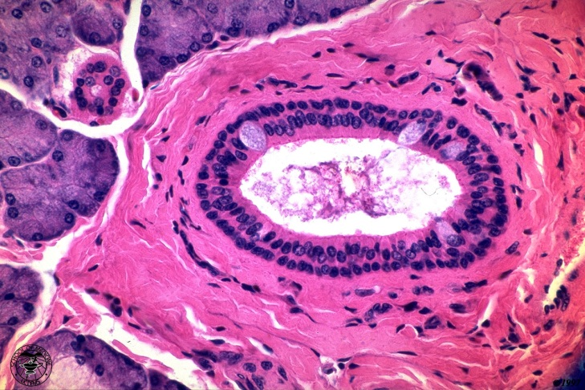](http://www.google.com/url?sa=i&rct=j&q=&esrc=s&frm=1&source=images&cd=&cad=rja&docid=xw38iUm-OEhLcM&tbnid=JW8FMZG1kKQgTM:&ved=0CAUQjRw&url=http%3A%2F%2Fnh-chs-anatomy.pbworks.com%2Fw%2Fpage%2F68951036%2FEpithelial%2520Tissues%2520(Malone%2C%2520Williams)&ei=JI9lUpi3CM-p4APf9YCYCg&bvm=bv.54934254,d.dmg&psig=AFQjCNEv1Ms8sRI4Ijj9t_ytruufs-aSaA&ust=1382473838439421)