Formative Assessment
- What type of Epithelial tissue is shown? ______________________________________________
- On the picture below, label the following: Connective Tissue, Apical Surface, Basement Membrane and Lumen
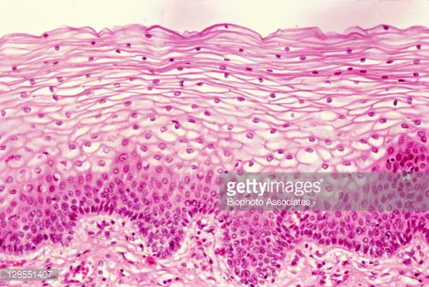

Formative Assessment
- What type of Epithelial tissue is shown? ______________________________________________
- On the picture below, label the following: Connective Tissue, Apical Surface, Basement Membrane and Lumen

