Name: ____________________
Period: ___________________
Date: _____________________
Epithelial Tissue Warm-up
Label each of the following as Columnar, Cuboidal or Squamous.
Side View
Top Down View

Side View Top Down View

Label each of the following as Simple or Stratified.
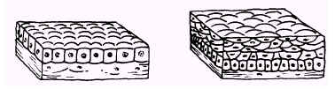

Label each of the following as Simple, Stratified, Pseudostratified or Transitional AND as Squamous, Cuboidal or Columnar.
