CREATE YOUR OWN CONCEPT MAP ON EPITHELIAL TISSUES
- Start with your center concept – “Epithelial Tissue”
- Draw 8 arrows connecting to the names of the 8 types of epithelial tissues found in the body
- For each- you want to include linked concepts that describe the tissue type including; 1) Where it is located? (found in), 2) Which of the 4 functions of epithelial tissue does it perform? (functions to), 3) What does this tissue look like? (looks like). Be sure to describe the number of layers and the shape of the cells found in that tissue type. You could also include a drawing but you must use words as well to describe the structure.
This image might help get you started, but notice it does not include enough arrows for the 8 types of epithelial tissue. You will need to copy this onto your own paper (lined) and complete it. Be sure to copy your final draft on to plain white paper.
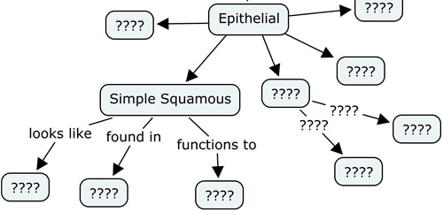

Name: |  |  |  |  | Points possible: | 34
 | 8 | 7 | 6 | 5 | 4 | 3 | 2 | 1 | 0
Tissue Types
Tissue Function
Tissue Appearance
Tissue Location
Epithelial Tissue Concept Map Submitted | X | X | X | X | X | X

