Figurative Language Project
Due: Monday, February 1st
Summative Grade: 100 points (Late Penalty: 10 points per day)

Option A:
Write a two-page description of an event that happened to you that had a strong emotional effect on you. The emotion could be sadness, anger, confusion, happiness, hilarity, or any other emotion. Use past tense to tell the story, and use at least five strong similes or metaphors, as well as three other types of figurative language (your choice). Underline or highlight each example of figurative language that you have included.
Note: Your description could be exaggerated to make it a better story, but it should still mostly true. Some ideas include:

A Birthday
First day of high school
Sad event in family
First Day at a Job
Strange day
Funny event with friends
First sports events or music performance.

Option B:
Create a PowerPoint (or a series of printed posters) that provides two lyrical examples for each type of figurative language that is listed below. This means that you will probably get to listen to a lot of music while you do your homework! When you finish, you should have at least 12 slides. Feel free to include the definition of each type of figurative language, if you think that it might make your project more attractive. The list of devices includes:
Simile Metaphor
Onomatopoeia Alliteration
Hyperbole Personification
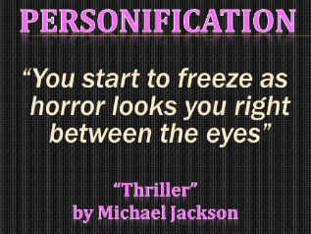

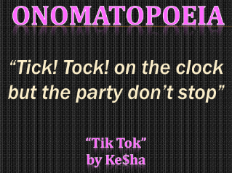

Option C:
Alliteration is the repetition of the same consonant sound at the beginning of words. Create an ABC book (from A-Z) that includes alliteration. Regardless of whether you produce your book by computer or hand, illustrations are required.
Keep in mind: A, E, I, O, and U are vowels; therefore, repetition of them is not alliteration. However, for the sake of this project, we are going to approach them in the same manner.
Example:

Two tremendously tough turtles tango in Texas by the tumbleweeds.

