Name: ____________________________________________ Date: ______________

Final Review: Units 5-7

1. A 50-meter-tall building casts a shadow 300 meters long. At the same time a pole 15 meters tall casts a shadow 90 meters long. Sketch a diagram and state whether the triangles are similar given that buildings and poles meet the ground at a 90° angle.
2. Given that the two triangles formed are similar. A 12-ft. ladder leaning against a wall hits the wall at 7 ft. At what height will a 10-ft. ladder hit?
3. Points A and B are located almost at opposite ends of a bridge. A survey crew plotted lines AE and BD such that DE is parallel to AB and made the measurements shown on the diagram. The diagram is not drawn to scale. Can we prove that these triangles are similar? Explain. If so, set up and solve a proportion to find the length of the bridge.

BridgeBridgeBridgeBridge

D

E

C

B

A

32.6 m

35.3 m

34.7 m

46.6 m

1. A 15-centimeter rod is held parallel between a flashlight and a wall as shown. Explain why the two triangles created are similar. Find the length of the shadow on the wall.

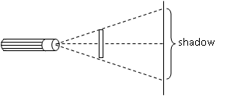

13 cm

20 cm

1. Draw the dilation of $∆PQR$ with a scale factor of 2/5 with original coordinates of P(-5,10),

Q (10,5), and R (0,-5). Label your coordinates appropriately.

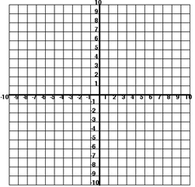

1. Given a rectangle with sides of 12 cm and 9 cm dilate the figure by a scale factor of 3. What is the area of the new rectangle?
2. Set up and solve an equation to find the value of $x$, given that $\overline{MN}$ is a midsegment.

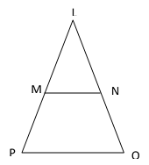

|  |  |
| --- | --- |
| **Statement** | **Reason** |
| $\overline{DE}∥\overline{AB}$ | Given |
|  | Alternate Interior Angles |
| $$∠ECD ≅∠ACB$$ |  |
| $$∆DCE \sim ∆BCA$$ |  |
|  | CSSTP |

1. Given: $\overline{DE}∥\overline{AB}$

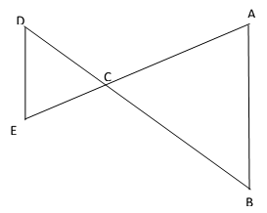Prove: $\frac{DC}{BC}=\frac{EC}{AC}$

|  |  |
| --- | --- |
| **Statement** | **Reason** |
| $\overline{TV}$ is the midsegment of $∆USW$ | Given |
| $$\frac{UT}{US}=\frac{}{}$$ |  |
| $$\frac{UV}{UW}=\frac{}{}$$ |  |
| $$\frac{UT}{US}=\frac{UV}{UW}$$ | Substitution |
| $$∠U ≅∠U$$ |  |
| $$∆UTV \sim ∆USW$$ |  |
| $$∠UTV≅∠USW$$ | CASTC |
| $$\overline{TV}∥\overline{SW}$$ |  |

1. Given: $\overline{TV}$ is the midsegment of $∆USW$

Prove: $\overline{TV}∥\overline{SW}$

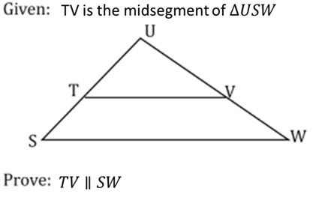

1. Identify the three similar triangles: $∆_________________\sim ∆_________________\sim ∆_________________$

Solve for x.

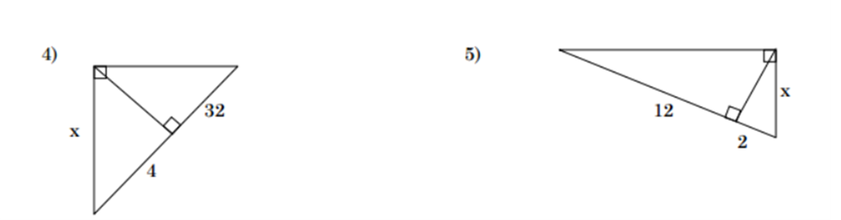

P

R

S

T

1. Identify the three similar triangles: $∆_________________\sim ∆_________________\sim ∆_________________$

Solve for *x*.

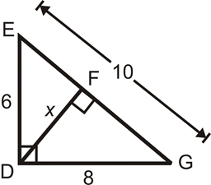

1. Identify the three similar triangles: $∆_________________\sim ∆_________________\sim ∆_________________$

Solve for *x*, *y*, and *z*.

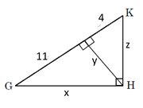

J

1. Given sin $y=\frac{3}{5}$, find the following:

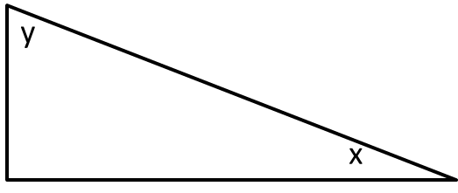sin *x* = cos *y* =

tan *x* = cos *x* =

tan *y* =

1. Given that sin *B* = $\frac{12}{20}$, find the following:

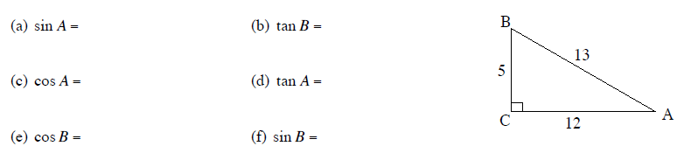

1. A guy wire is 15 meters long. It supports a vertical television tower. The wire is fastened to the ground 9.6 meters out from the base of the tower. Calculate the angle formed by the guy wire and the ground.
2. A roller coaster climbs vertically 60 meters at an angle of 30° from the lowest to the highest point of the track. It then plunges over the high point to begin the ‘fun part’. Calculate the length of the track from the bottom of the hill to the very top.
3. A truck travels 8km up a mountain road. The change in height from the bottom to the top is 1.4 km. Find the angle of inclination of the road.
4. 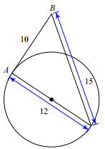Determine if line AB is tangent to the circle. Explain why or why not and make sure to show all work.

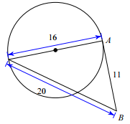

13

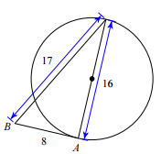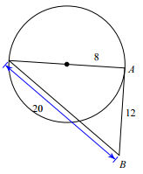

1. Graph each circle.

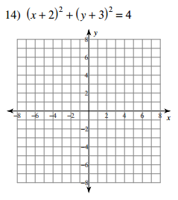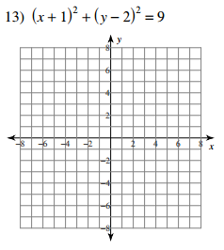

1. 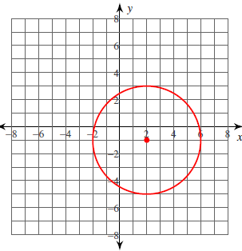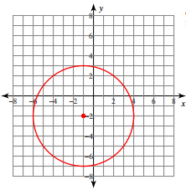Write the equation of the following circles.

1. 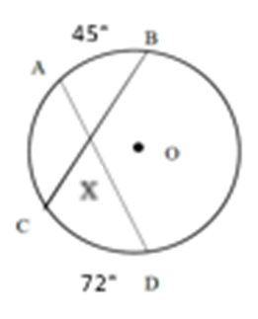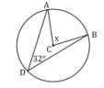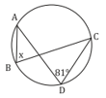For the following, find the value of x.

1. 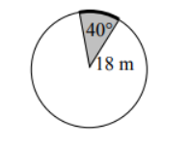Find the arc length of the non-shaded region.
2. Find the area of the shaded sector.
3. Find the arc length of the shaded region.
4. Find the area of the non-shaded sector.