Name: _________________________________________________ Date: ______________
Final Review: Units 1 and 2
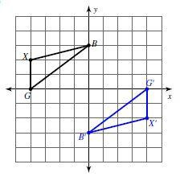
- Write a rule for the following transformations and explain how you know the two shapes are congruent.
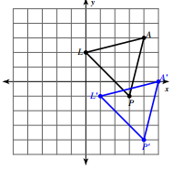

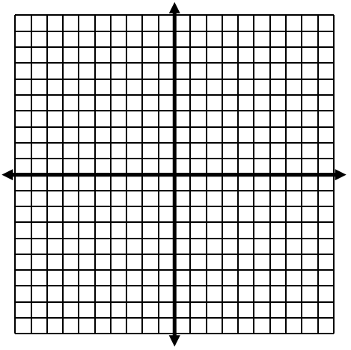
- Given point J is (2, -3), point A is (2, 5), and point B is (4, 4), reflect $∆JAB$ over the line y=x.

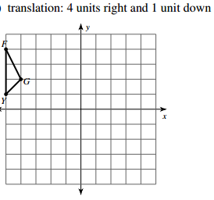
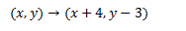
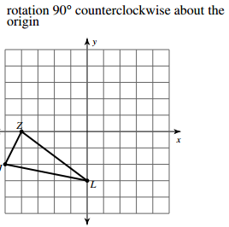
- Complete the following transformations.

- What sequence of transformations will carry the pre-image to the final image in the drawing?

- First Transformation: __________________________ Rule: _________________

- Second Transformation: _______________________ Rule: _________________
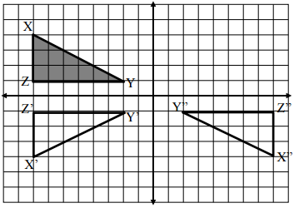
- Label the quadrants on the
graph.

- Which quadrant is the only
one that does not contain
a triangle?

For numbers 7 & 8, use what you know about isometric transformations to find all missing measurements.
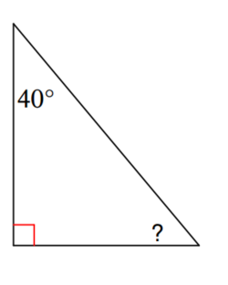
Q
P
12cm
P’
15cm
R
R’
Q’

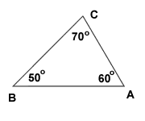
A’
B’
C’
11
7
13
52°

47°

- For the following diagrams. Set up an equation to solve for x. Write a justification for your equation.
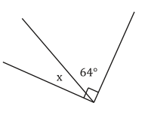
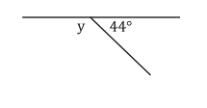

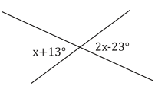
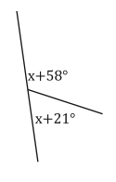

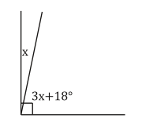
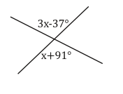

- For the following diagrams. Set up an equation to solve for x. Write a justification for your equation.

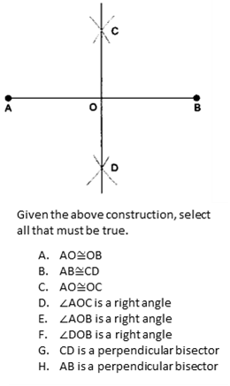
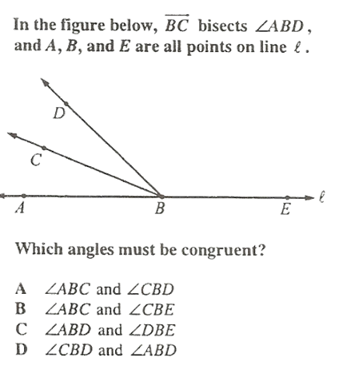
- 12.

- $\overline{LM}$ is the perpendicular bisector of $\overline{AB}$. Find the values of x and y.
$AP=4x+42$
$BP=9x-3$ x=_________________
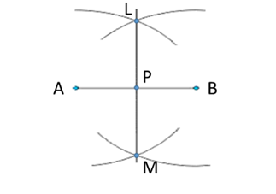
$∠APM=2y+16$
y=_________________

- $\overline{MO}$ bisects $∠$AOB. Find the values of p, ∠AOM, ∠MOB, and ∠AOB.
∠MOB = 3p+6 p=_________________
∠AOM= 4p-18
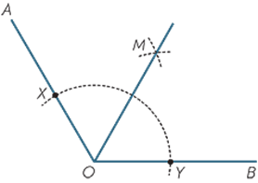
∠AOM= ___________

∠MOB= ___________

∠AOB= ___________

