Name: ________________________________________________ Date: ________
Final Review: Units 3 and 4

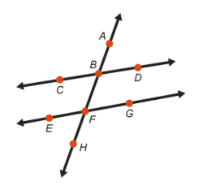
- Nicole constructed two lines cut by a transversal. She wants to verify that $\overline{CD}$ and $\overline{EG}$ are parallel. Which statement would prove that $\overline{CD}$ and $\overline{EG}$ are parallel?

  - $∠CBF$ and $∠FBD$ are supplementary.
  - $∠ABD$ and $∠BFE$ are congruent.
  - $∠CBF$ and $∠BFG$ are congruent.
  - $∠CBF$ and $∠ABD$ are congruent.

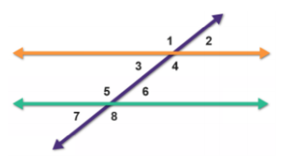
Use the diagram below to answer questions 2 & 3.

- The diagram shows two parallel lines cut by a transversal. Fill in the blanks to complete the statements.
In the diagram, there are two parallel lines intersected by a transversal.
- Angles 3 and ____________________________ are consecutive interior angles.
- Because $∠7$ is a corresponding angle to $∠$_______________ and because $∠7$ forms a linear pair with $∠5$ we know $m∠5+m∠3=$_______________.

- The diagram shows two parallel lines cut by a transversal. Fill in the blanks to complete the statements below.
- In the diagram, $∠3$ and $∠6$ are ________________________ interior angles.
- Because angle 6 is a corresponding angle with $∠$_______________,
- You can use the transitive property to show that $∠3$ and $∠6$ are __________________
- The following diagrams contain lines $m$ and $n$ and a transversal line. Given $m∥n$ solve for x and justify your reasoning.
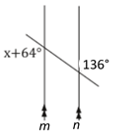
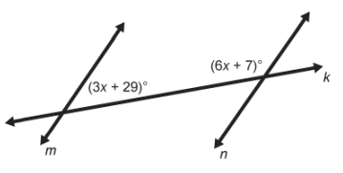

- For the following problems, choose the correct answer and justify why you picked that answer.
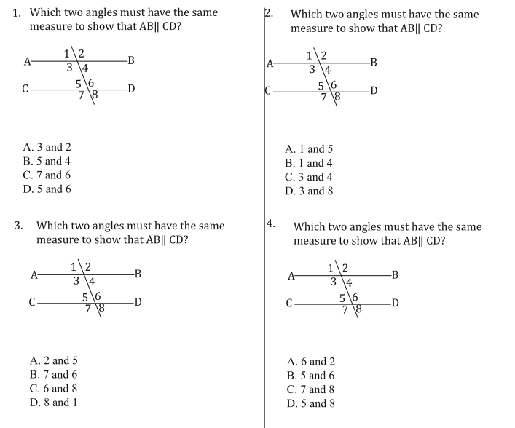

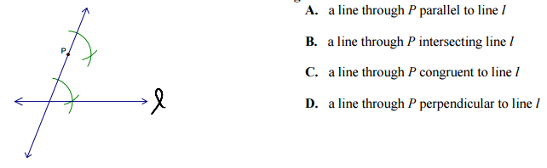
- Nicole is working on the following construction with her compass and straightedge. Which best describes the construction that Nicole is doing?

- Complete the construction in #6 by drawing in the last step.

- Milon is working on the following construction with his compass and straightedge. What is he constructing?
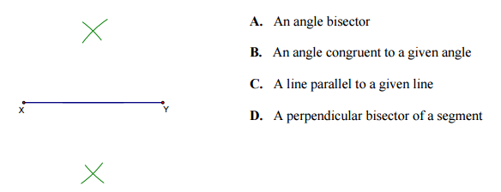

- Complete the construction in #8 by drawing in the last step.

- Javion is working on the following construction with his compass and straightedge. What is he constructing?
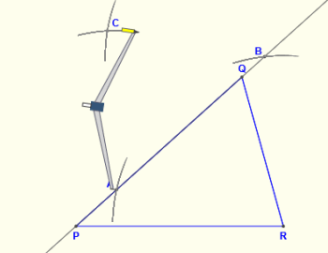
- A perpendicular bisector.
- An angle bisector.
- An altitude
- A line parallel to line $\overline{PQ}$

- Complete the construction in #10 by drawing the last step.
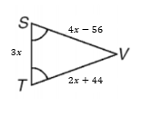
- Set up and solve an equation to find the value of x.
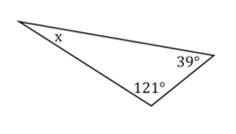

- What are the five different theorems we can use to prove that two triangles are congruent?

- State whether the following diagrams have vertical angles or a reflexive line and write the statement that would go in the proof.
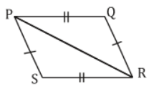
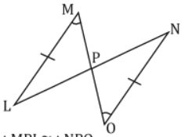

Statement Reason Statement Reason
X Given X Given
____________________ _________________ ____________________

$∆MPL ≅∆OPN$ _________________ $∆PSR≅∆RQP$

