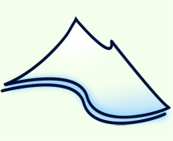
Close – Mini Quiz Exit Pass

- How does a lake become eutrophic?
- What are phytoplankton and what role do they play in aquatic ecosystems?
- Why are estuaries a mineral rich environment?
- How are salt marshes and mangrove swamps different?
- Name two threats to the ocean.

Close – Mini Quiz Exit Pass

- How does a lake become eutrophic?
- What are phytoplankton and what role do they play in aquatic ecosystems?
- Why are estuaries a mineral rich environment?
- How are salt marshes and mangrove swamps different?
- Name two threats to the ocean.

