**Fun Fonts Poster—Typography Project**

Create a poster that utilizes numerous font types—sans serif, serif, script, and decorative/display. The poster should include either a specific theme, lyrics to a poem or song/chorus, or otherwise incorporate something meaningful to you. Other requirements are listed below.

[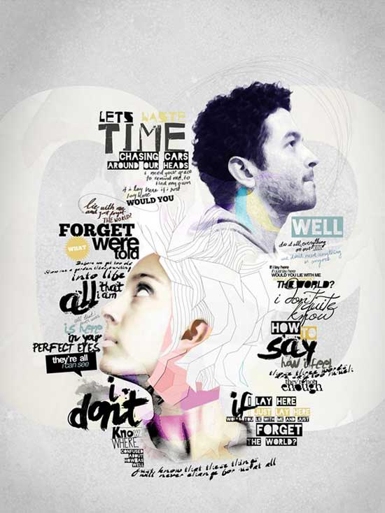](http://www.google.com/url?sa=i&rct=j&q=typography+poster&source=images&cd=&cad=rja&docid=ooypybqmRdj1OM&tbnid=MnqRc_od0C-IOM:&ved=0CAUQjRw&url=http://visionwidget.com/typography-poster-designs.html&ei=nM1IUcCeF4KRrgGE4oCQCQ&bvm=bv.43828540,d.aWM&psig=AFQjCNH4OZQwbLyOEqsPYYkYUwijgL57ZA&ust=1363806630929964)[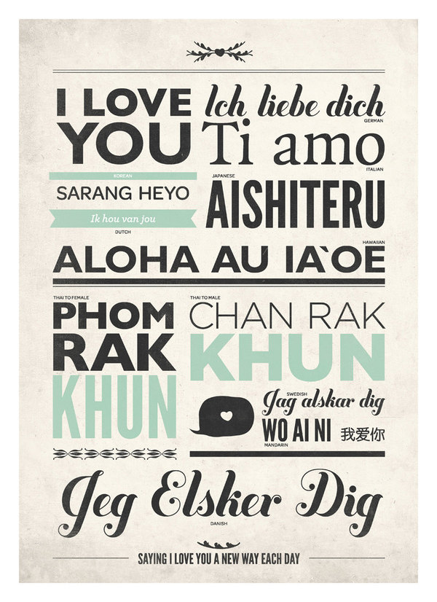](http://www.google.com/url?sa=i&rct=j&q=typography+poster&source=images&cd=&cad=rja&docid=1appRBa8riUFdM&tbnid=OWCyAKoHwMvgrM:&ved=0CAUQjRw&url=http://designspiration.net/image/2632954355246/&ei=881IUee3K8SWrAH8tYDwCw&bvm=bv.43828540,d.aWM&psig=AFQjCNH4OZQwbLyOEqsPYYkYUwijgL57ZA&ust=1363806630929964)[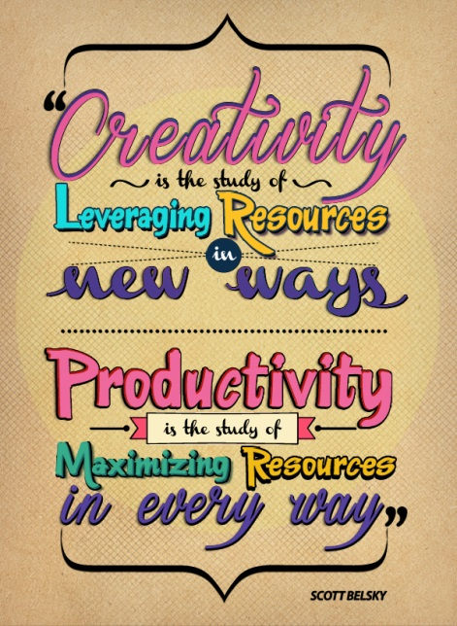](http://www.google.com/url?sa=i&rct=j&q=typography+poster&source=images&cd=&cad=rja&docid=cjP7Nq861sXx-M&tbnid=hWy-jRu6EpozwM:&ved=0CAUQjRw&url=http://www.behance.net/gallery/Typography-poster/5964607&ei=n9BIUYG4B5DsrAGn04HgDQ&bvm=bv.43828540,d.aWM&psig=AFQjCNH4OZQwbLyOEqsPYYkYUwijgL57ZA&ust=1363806630929964)

|  |  |  |
| --- | --- | --- |
| ***Requirement -----Set paper size to 7.5” wide by 10” tall; print at 100% scale in color!*** | ***Points Possible*** | ***Deductions*** |
| Background texture created using:   * Solid color background layer * (higher layer) Custom, loaded brush (cracks, smoke, textures) with blending mode applied | 5 |  |
| Vignette effect around edges; use a soft, big black brush on a layer above the background layers to “burn” the edges/corners (if using a light background, this can be a suitable color for the effect) | 5 |  |
| At least 2 custom shapes (banners, dividers, etc.) OR custom brushes List which were used (loaded from Z drive)🡪 | 8 |  |
| At least FOUR different types of fonts. List the font used for each of these categories. If you used more than one, you do not need to list more than one:   * Sans serif:__________________________________________ * Serif: __________________________________________ * Script/Handwritten/Scribble: __________________________________________ * Display/Decorative: __________________________________________ | 8 |  |
| Character Panel: Modification of text spacing—kerning or tracking—in at least TWO places AND/OR use of horizontal or vertical scale adjustment. List where and whether it was negative or positive🡪   * ____________________________ + - * ____________________________ + - * ____________________________ + - | 4 |  |
| Creative use of fonts that show emotion or tone and use of at least one warped/curved text | 10 |  |
| Professional appearance—remember, that text has to be the focus of this piece, but you can use other images if it does not detract from the focus; utilize rotation, blending modes, clipping masks and layer styles as needed | 10 |  |
| Spelling | 10 |  |
| ***(Save JPG for Web to Portfolio folder and upload!) TOTAL*** | ***60*** |  |