The following list of terms fall into two categories: Defined terms and undefined terms:
Angle, Point, Circle, Complementary, Perpendicular Line, Parallel Line, Line, Line Segment, Plane, Supplementary.
Defined Terms
Undefined terms

Copy down the definitions for the following defined terms
- Angle:
- Circle:
- Complementary:
- Line Segment:
- Perpendicular Line:
- Parallel Line:
- Supplementary:

Name This Angle:
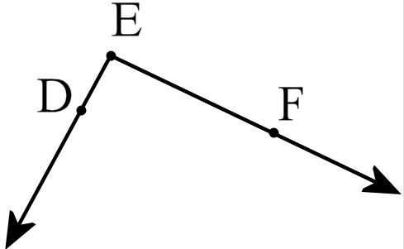
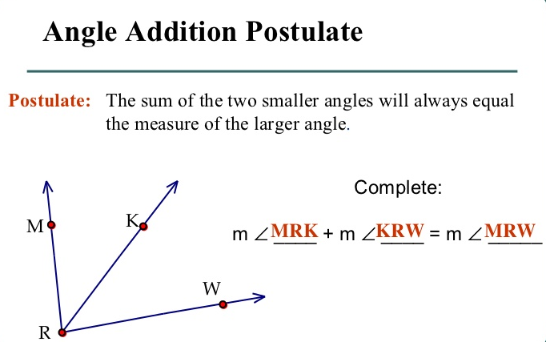

- Type: 2. Type:
AAP: AAP:
Missing Angle: Missing Angle:
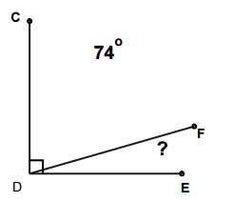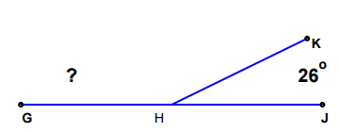
- Type: 4. Type:
AAP: AAP:
Missing Angle: Missing Angle:
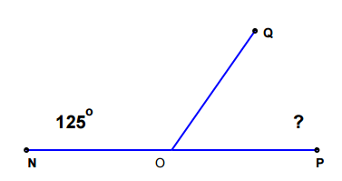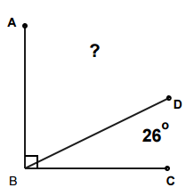
Complementary & Supplementary Angles with Algebra
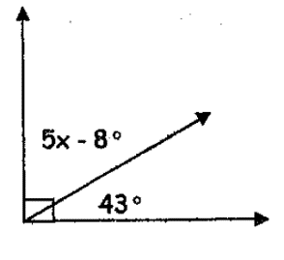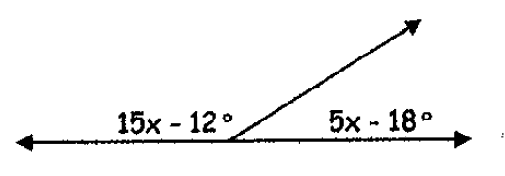

X = _______________ X = _________________
Complementary or Supplementary Complementary or Supplementary

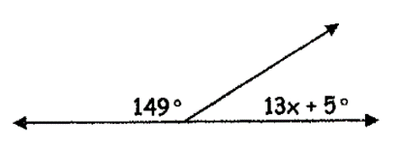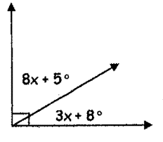

X = _______________ X = _________________
Complementary or Supplementary Complementary or Supplementary

